|  |  |
| --- | --- |
| Gerb-BMSTU_01 | **Министерство науки и высшего образования Российской Федерации**  **Федеральное государственное бюджетное образовательное учреждение**  **высшего образования**  **«Московский государственный технический университет**  **имени Н.Э. Баумана**  **(национальный исследовательский университет)»**  **(МГТУ им. Н.Э. Баумана)** |

ФАКУЛЬТЕТ Информатика и системы управления

КАФЕДРА ИУ6

**РАСЧЕТНО-ПОЯСНИТЕЛЬНАЯ ЗАПИСКА**

***К КУРСОВОМУ ПРОЕКТУ***

***НА ТЕМУ:***

**Разработка макета аналитической системы на основе баз данных NoSQL (вариант № 4)**

***\_\_\_\_\_\_\_\_\_\_\_\_\_\_\_\_\_\_\_\_\_\_\_\_\_\_\_\_\_\_\_\_\_\_\_\_\_\_\_\_\_\_\_\_\_\_***

***\_\_\_\_\_\_\_\_\_\_\_\_\_\_\_\_\_\_\_\_\_\_\_\_\_\_\_\_\_\_\_\_\_\_\_\_\_\_\_\_\_\_\_\_\_\_***

Студент ИУ6-21М\_\_\_\_\_\_\_\_\_ **\_\_\_\_\_\_\_\_\_\_\_\_\_\_\_\_\_ \_\_\_\_Ю.А. Шашкин\_\_**

(Группа) (Подпись, дата) (И.О.Фамилия)

Руководитель курсового проекта **\_\_\_\_\_\_\_\_\_\_\_\_\_\_\_\_\_ \_\_\_\_Ю.А. Григорьев\_**

(Подпись, дата) (И.О.Фамилия)

*2021 г.*

**Министерство науки и высшего образования Российской Федерации**

**Федеральное государственное бюджетное образовательное учреждение**

**высшего образования**

**«Московский государственный технический университет имени Н.Э. Баумана**

**(национальный исследовательский университет)»**

**(МГТУ им. Н.Э. Баумана)**

УТВЕРЖДАЮ

Заведующий кафедрой \_\_\_\_\_\_\_\_\_\_

(Индекс)

\_\_\_\_\_\_\_\_\_\_\_\_\_\_ \_\_\_\_\_\_\_\_\_\_\_\_\_\_\_

(И.О.Фамилия)

« \_\_\_\_\_ » \_\_\_\_\_\_\_\_\_\_\_\_ 20 \_\_\_\_ г.

**ЗАДАНИЕ**

**на выполнение курсового проекта**

по дисциплине «Технология параллельных систем баз данных»

Студент группы ИУ6-21М

\_\_\_\_\_\_\_\_\_\_\_\_\_\_\_\_\_\_\_\_\_\_\_\_\_\_\_\_\_Шашкин Юрий Анатольевич\_\_\_\_\_\_\_\_\_\_\_\_\_\_\_\_\_\_\_\_\_\_\_\_\_\_\_\_\_\_\_

(Фамилия, имя, отчество)

Тема курсового проекта

«Разработка макета аналитической системы на основе баз данных NoSQL (вариант № )»

Направленность КП (учебный, исследовательский, практический, производственный, др.)

исследовательский

Источник тематики (кафедра, предприятие, НИР) кафедра

График выполнения проекта: 25% к 3 нед., 50% к 10 нед., 75% к 13 нед., 100% к 16 нед.

***Задание***

Установить виртуальную машину, системы NoSQL Elasticsearch, Neo4j, Hadoop+Spark. В **Elasticsearch** создать индекс с анализатором и маппингом, проиндексировать json-документы, разработать запросы с вложенной агрегацией, представить результаты в среде Kibana. В **Neo4j** по данным из Elasticsearch заполнить графовую базу данных, разработать и реализовать запрос к этой БД. В **Spark** по данным из Elasticsearch сформировать csv-файлы (с внутренней схемой) таблиц и сохранить их в файловой системе HDFS, написать запрос и реализовать его в Spark, проанализировать процесс выполнения запроса с использованием монитора.

***Оформление курсового проекта:***

Расчетно-пояснительная записка на \_\_\_ листах формата А4.

Перечень графического (иллюстративного) материала (чертежи, плакаты, слайды и т.п.):

1. Название темы КП, задание, описание варианта.

2,3. По Elasticsearch: описание анализатора и маппинга; алгоритм программы индексации документов; тексты запросов, результаты выполнения.

4,5. По Neo4j: алгоритм программы создания и заполнения графовой БД; текст запроса, результат.

5,6,7. По Spark: алгоритм программы создания таблиц и их сохранения в HDFS; скрипт запроса к БД, результат выполнения; результат анализа работы монитора.

Дата выдачи задания « \_\_\_ » \_\_\_\_\_\_\_\_\_\_\_\_ 20\_\_ г.

**Руководитель курсового проекта**  \_\_\_\_\_\_\_\_\_\_\_\_\_\_\_\_\_ \_\_\_Ю.А. Григорьев\_\_\_

(Подпись, дата) (И.О.Фамилия)

**Студент** \_\_\_\_\_\_\_\_\_\_\_\_\_\_\_\_\_ \_\_\_Ю.А. Шашкин\_\_\_\_

(Подпись, дата) (И.О.Фамилия)

Примечание: Задание оформляется в двух экземплярах: один выдается студенту, второй хранится на кафедре.

РЕФЕРАТ

РПЗ 92 с., 36 рис., 3 табл.,15 источн., 2 прил.

АНАЛИТИЧЕСКАЯ СИСТЕМА, БАЗА ДАННЫХ, БОЛЬШИЕ ДАННЫЕ, КЛАСТЕР, ПАРАЛЛЕЛЬНЫЕ СИСТЕМЫ, ELASTICSEARCH, HADOOP, KIBANA, NEO4J, NOSQL, SPARK.

Объектом разработки является макет аналитической системы «Блог».

Цель работы: разработать макет системы с применением указанного стека технологий, выполнить аналитические запросы к данным.

Задачи, решаемые в работе:

* анализ задания;
* установка программных компонентов;
* настройка программных компонентов;
* генерация данных для заполнения БД и кластера;
* проектирование и реализация запросов к данным;
* анализ выполнения запросов.

Материалы работы представлены расчетно-пояснительной запиской, включающей введение, пять глав основной части, заключение, список использованных источников, а также приложения: исходные коды программ, фрагменты сгенерированных документов.

Оглавление

[Введение 5](#_Toc69683124)

[1 Задание и описание варианта КП 7](#_Toc69683125)

[1.1 Elasticsearch. 7](#_Toc69683126)

[1.2 Neo4j. 7](#_Toc69683127)

[1.3 Spark 8](#_Toc69683128)

[2 Установка виртуальной машины, установка пакетов Elasticsearch, Neo4j, Hadoop+Spark, генерация исходных данных 8](#_Toc69683129)

[2.1 Установка виртуальной машины 8](#_Toc69683130)

[2.2 Установка ElasticSearch 10](#_Toc69683131)

[2.3 Установка Neo4j 13](#_Toc69683132)

[2.4 Установка Hadoop 17](#_Toc69683133)

[2.5 Установка Spark 22](#_Toc69683134)

[2.6 Генерация исходных данных 23](#_Toc69683135)

[3 Elasticsearch 24](#_Toc69683136)

[3.1 Индексация документов 24](#_Toc69683137)

[3.1.1 Анализатор 24](#_Toc69683138)

[3.1.2 Маппинг 26](#_Toc69683139)

[3.2 Запросы 31](#_Toc69683140)

[3.2.1 Запрос 1 31](#_Toc69683141)

[3.2.2 Запрос 2 35](#_Toc69683142)

[4 Neo4j 37](#_Toc69683143)

[4.1 Создание и заполнение графовой БД 37](#_Toc69683144)

[4.2 Запрос 40](#_Toc69683145)

[5 Spark 41](#_Toc69683146)

[5.1 Создание и заполнение таблиц 41](#_Toc69683147)

[5.2 Запрос 42](#_Toc69683148)

[5.3 Монитор 44](#_Toc69683149)

[Заключение 53](#_Toc69683150)

[Список использованных источников 54](#_Toc69683151)

[Приложение А 56](#_Toc69683152)

[Приложение Б 74](#_Toc69683153)

# Введение

В настоящее время объемы хранимых данных достигают огромных значений вплоть до экзабайтов. Для работы с такими объемами требуются особые подходы и особые инструменты. В рамках данного курсового проекта были рассмотрены самые популярные средства работы с большими объемами данных: Elasticsearch, Neo4j, Hadoop+Spark. Рассмотрим каждый из них подробнее:

* Elasticsearh (далее ES) – это масштабируемый полнотекстовый поисковый и аналитический движок с открытым исходным кодом. Он позволяет хранить большие объемы данных, проводить среди них быстрый поиск и аналитику (почти в режиме реального времени). Как правило, он используется в качестве базового механизма/технологии, которая обеспечивает работу приложений со сложными функциями и требованиями к поиску. Elasticsearch использует в качестве поисковой основы библиотеку Lucene, которая написана на языке Java и доступна для многих платформ. Все неструктурированные данные хранятся в формате JSON, что автоматически делает ES базой данных NoSQL. Но в отличие от других баз данных NoSQL, ES предоставляет возможности поиска и многие другие функции.
* Neo4j — графовая система управления базами данных с открытым исходным кодом, реализованная на Java. По состоянию на 2015 год считается самой распространённой графовой СУБД. Разработчик — американская компания Neo Technology, разработка ведётся с 2003 года. Данные хранит в собственном формате, специализированно приспособленном для представления графовой информации, такой подход в сравнении с моделированием графовой базы данных средствами реляционной СУБД позволяет применять дополнительную оптимизацию в случае данных с более сложной структурой. Также утверждается о наличии специальных оптимизаций для SSD-накопителей, при этом для обработки графа не требуется его помещение целиком в оперативную память вычислительного узла, таким образом, возможна обработка достаточно больших графов.[1]
* Hadoop — проект фонда Apache Software Foundation, свободно распространяемый набор утилит, библиотек и фреймворк для разработки и выполнения распределённых программ, работающих на кластерах из сотен и тысяч узлов. Используется для реализации поисковых и контекстных механизмов многих высоконагруженных веб-сайтов, в том числе, для Yahoo! и Facebook. Разработан на Java в рамках вычислительной парадигмы MapReduce, согласно которой приложение разделяется на большое количество одинаковых элементарных заданий, выполнимых на узлах кластера и естественным образом сводимых в конечный результат.[2]
* Apache Spark (от англ. spark — искра, вспышка) — фреймворк с открытым исходным кодом для реализации распределённой обработки неструктурированных и слабоструктурированных данных, входящий в экосистему проектов Hadoop. В отличие от классического обработчика из ядра Hadoop, реализующего двухуровневую концепцию MapReduce с хранением промежуточных данных на накопителях, Spark работает в парадигме резидентных вычислений (англ. in-memory computing) — обрабатывает данные в оперативной памяти, благодаря чему позволяет получать значительный выигрыш в скорости работы для некоторых классов задач, в частности, возможность многократного доступа к загруженным в память пользовательским данным делает библиотеку привлекательной для алгоритмов машинного обучения.[3]

Цель курсового проекта: разработать макет аналитической системы для указанного варианта предметной области с использованием баз данных NoSQL Elasticsearch, Neo4j, Hadoop+Spark.

# 1 Задание и описание варианта КП

## 1.1 Elasticsearch.

1. Типы документов (json):

Подписчик: {index, doc\_type, id, body: {дата\_регистрации, ФИО, ссылка\_на\_фото, пол, дата\_рождения, e-mail, род\_занятий, образование: {вуз, специальность, год\_окончания, описание\_специальности\*}, комментарий: [{дата, id\_поста, текст\*}]}}

Пост (статья): {index, doc\_type, id, body: {дата, категория, текст\*, ссылка\_на\_видео, ссылка\_на\_изображение, число\_просмотров}}

Примечание. Квадратные скобки [] обозначает тег (может быть несколько значений)

2. Требование к анализатору:

поля, отмеченные \*, разделить на слова, убрать пунктуацию с помощью токенизатора standart (русский).

3. Запросы с вложенной агрегацией:

- разбить подписчиков по дате регистрации с интервалом 1 месяц, для каждой группы определить число комментариев по роду занятий.

- для каждой категории постов определить число просмотров.

## 1.2 Neo4j.

1. По данным из Elasticsearch заполнить графовую базу данных «Подписчик (дата\_регистрации, ФИО, дата\_рождения, род\_занятий, специальность) - Комментировал (число комментариев) – Пост (дата, категория, число просмотров)»

Примечание. В скобках приведены свойства узлов и отношений (связей).

2. Разработать и реализовать запрос: подписчики с каким родом занятий оставляют наибольшее число комментариев к постам

## 1.3 Spark

1. По данным из Elasticsearch сформировать csv-файлы (с внутренней схемой) таблиц «Подписчик», «Комментарий», «Пост» и сохранить их в файловой системе HDFS.

2. Написать запрос select: определить число комментариев к постам по датам их появления.

3. Реализовать этот запрос в Spark. Построить временную диаграмму его выполнения по результатам работы монитора.

# 2 Установка виртуальной машины, установка пакетов Elasticsearch, Neo4j, Hadoop+Spark, генерация исходных данных

Работа над курсовым проектом велась на устройстве под управлением Mac OS Big Sur 11.2 со следующей конфигурацией:

* процессор: 2,3 GHz 8‑ядерный процессор Intel Core i9
* память: 16 ГБ 2667 MHz DDR4
* видеочип: AMD Radeon Pro 5500M 8Гб

В связи с тем, что конфигурация компьютера позволяет одновременно использовать несколько виртуальных машин, то все компоненты использовались в кластерном режиме.

## 2.1 Установка виртуальной машины

Для установки виртуальной машины использовалась программа VirtualBox. Так как все виртуальные машины кластера должны иметь одинаковую конфигурацию, то была установлена и настроена одна виртуальная машина, а затем клонирована. Рассмотрим подробнее конфигурацию машин:

* ОС: Ubuntu (64-bit) версии 16.04
* Оперативная память: 4096 Мб
* Носитель: обычный, 20 Гб

Для того, чтобы виртуальные машины смогли образовать кластер необходимо настроить параметры сетевого доступа соответствующим образом. В настройках VirtualBox был настроен сетевой адаптер следующей конфигурации:

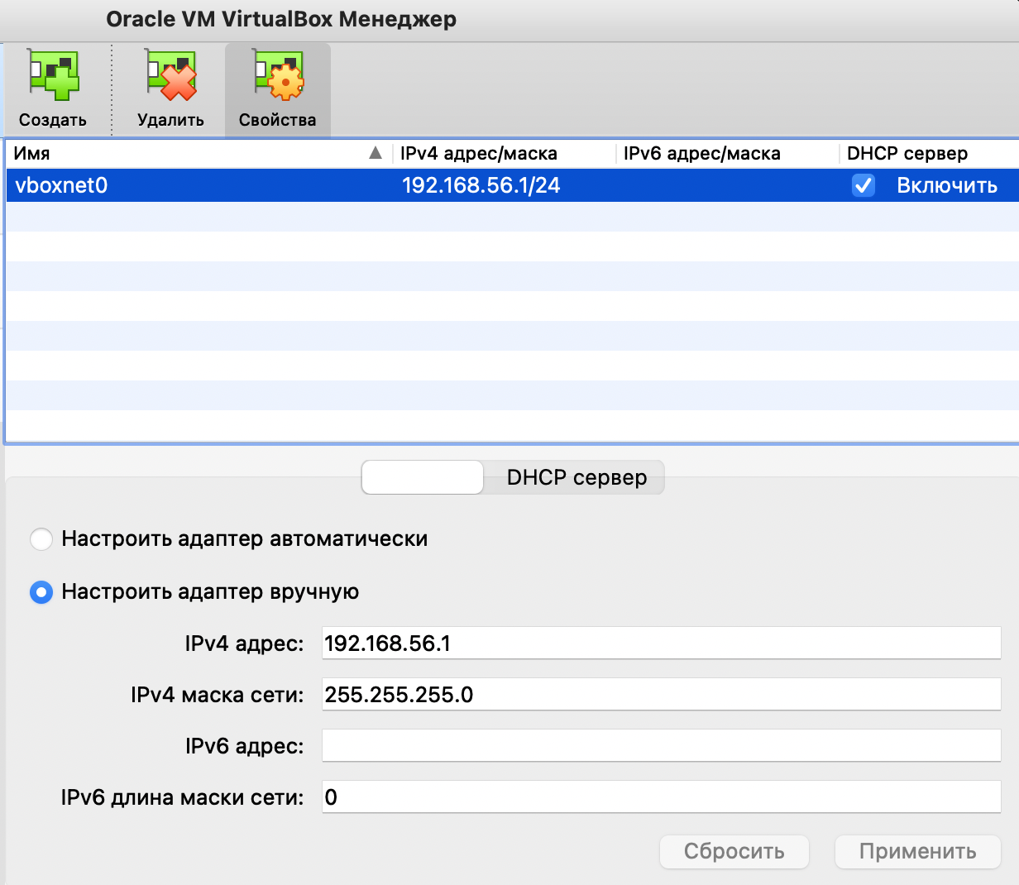

Рисунок 1 – Настройка сетевого адаптера

Далее в настройках виртуальной машины был добавлен новый сетевой адаптер типа «Виртуальный адаптер хоста» и был выбран сетевой адаптер, созданный на предыдущем шаге (рисунок 2)

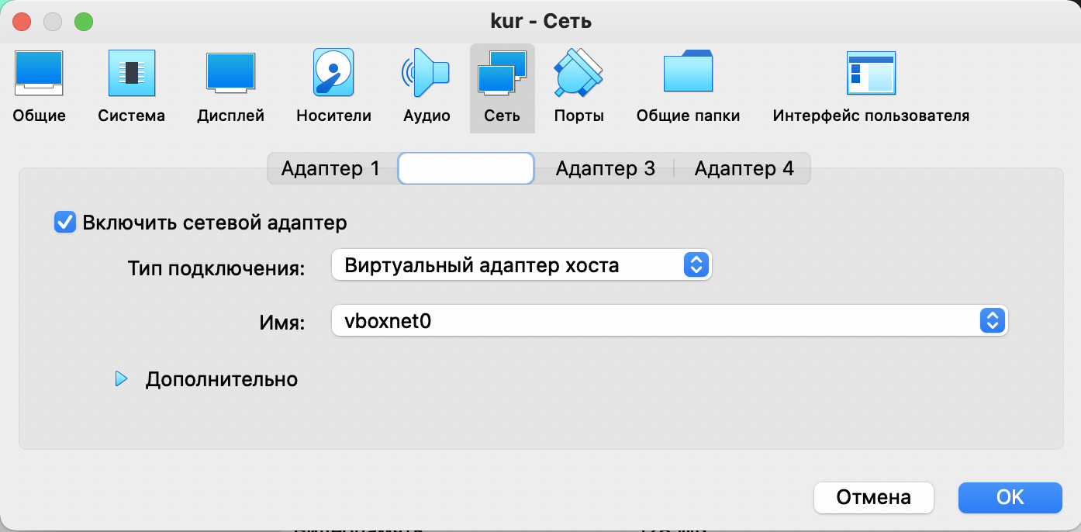

Рисунок 2 – Настройка сети виртуальной машины

В связи с тем, что интерфейс работы с виртуальными машинами имеет значительные ограничения (например, буфер обмена не является общим с хост-компьютером), то был установлен пакет для работы через SSH следующей командой:

sudo apt-get install openssh-server

После установки виртуальной машины и ее первоначальной настройки было выполнено клонирование с генерацией нового mac-адреса (рисунок 3)

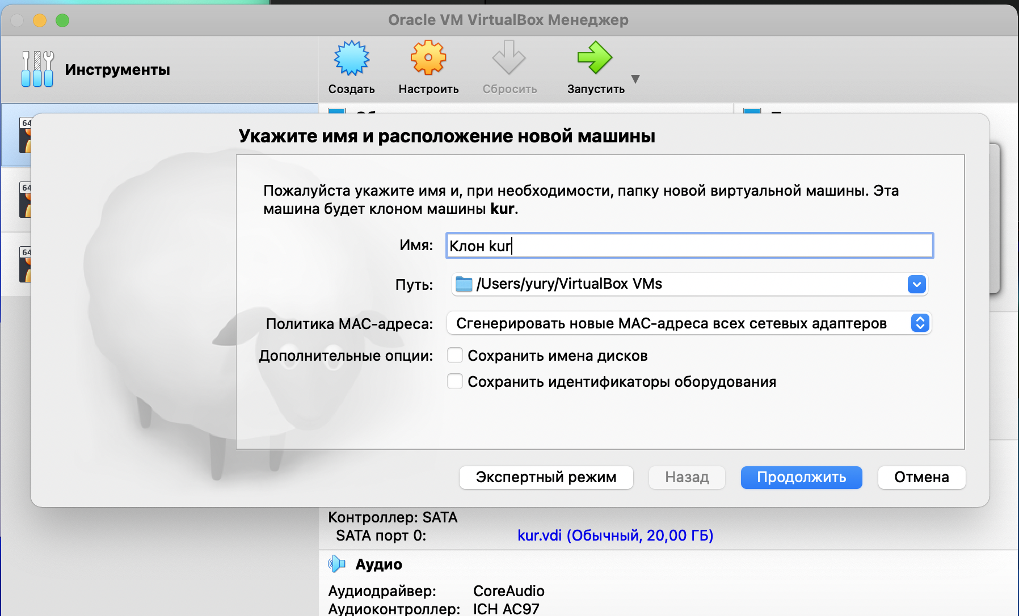

Рисунок 3 – Клонирование виртуальной машины

Дадим имена следующие имена виртуальным машинам: es-master, es-data1, es-data2.

## 2.2 Установка ElasticSearch

На всех виртуальных машинах выполним следующее:

1. Установим jdk, который необходим для работы ElasticSearch:

sudo apt-get install default-jdk=2:1.8-56ubuntu2

2. Установим python с необходимыми библиотеками:

sudo apt install python-pip=8.1.1-2ubuntu0.6

pip install Elasticsearch==7.1.0

3. Чтобы импортировать ключ GPG, введем команду:

wget -qO - https://artifacts.elastic.co/GPG-KEY-elasticsearch | sudo apt-key add -

4. Затем добавим список Elastic в каталог sources.list.d, где менеджер apt будет искать новые пакеты:

echo "deb https://artifacts.elastic.co/packages/7.x/apt stable main" | sudo tee -a /etc/apt/sources.list.d/elastic-7.x.list

5. Обновим индекс пакетов:

sudo apt update

6. Установим Elasticsearch:

sudo apt install elasticsearch=7.5.0

7. Запустим сервис Elasticsearch:

sudo systemctl start elasticsearch

8. Выполним следующую команду, чтобы Elasticsearch запускался при каждой загрузке сервера:

sudo systemctl enable elasticsearch

Дальнейшая настройка будет индивидуальной для каждой из нод. Модифицируем конфигурационный файл elasticsearch.yml, чтобы ноды начали работать в кластерном режиме следующей командой:

sudo vim /etc/elasticsearch/elasticsearch.yml

Добавим следующие строки на мастер ноду (es-master):

cluster.name: my-cluster

node.name: "es-master"

node.master: true

network.host: 192.168.56.101

http.port: 9200

cluster.initial\_master\_nodes: ["es-master"]

discovery.zen.ping.unicast.hosts: ["192.168.56.101","192.168.56.102","192.168.56.103"]

На первую ноду данных:

cluster.name: my-cluster

node.master: false

node.data: true

node.name: "es-data1"

network.host: 192.168.56.102

http.port: 9200

discovery.zen.ping.unicast.hosts: ["192.168.56.101","192.168.56.102","192.168.56.103"]

На вторую ноду данных:

cluster.name: my-cluster

node.master: false

node.data: true

node.name: "es-data2"

network.host: 192.168.56.103

http.port: 9200

discovery.zen.ping.unicast.hosts: ["192.168.56.101","192.168.56.102","192.168.56.103"]

Рассмотрим каждый параметр и его назначение.

Таблица 1 – Конфигурационные параметры ElasticSearch

|  |  |
| --- | --- |
| **Параметр** | **Описание** |
| cluster.name | Имя кластера, идентифицирует кластер для автоматического обнаружения. |
| node.master | Разрешить этому узлу быть мастер узлом (по умолчанию включено): |
| node.data | Разрешить этому узлу хранить данные (по умолчанию включено): |
| node.name | Имя ноды |
| network.host | Адрес, который другие узлы будут использовать для связи с этим узлом. |
| http.port | Порт, который другие узлы будут использовать для связи с этим узлом. |
| cluster.initial\_master\_nodes | Начальный массив мастер узлов |
| discovery.zen.ping.unicast.hosts | Массив всех узлов кластера |

Когда все параметры настроены, перезапустим сервис elasticsearch следующей командой на всех нодах:

sudo service elasticsearch restart

Проверим состояние кластера:

curl -XGET '192.168.56.101:9200/\_cluster/health?pretty'

Результат выполнения представлен на рисунке 4.

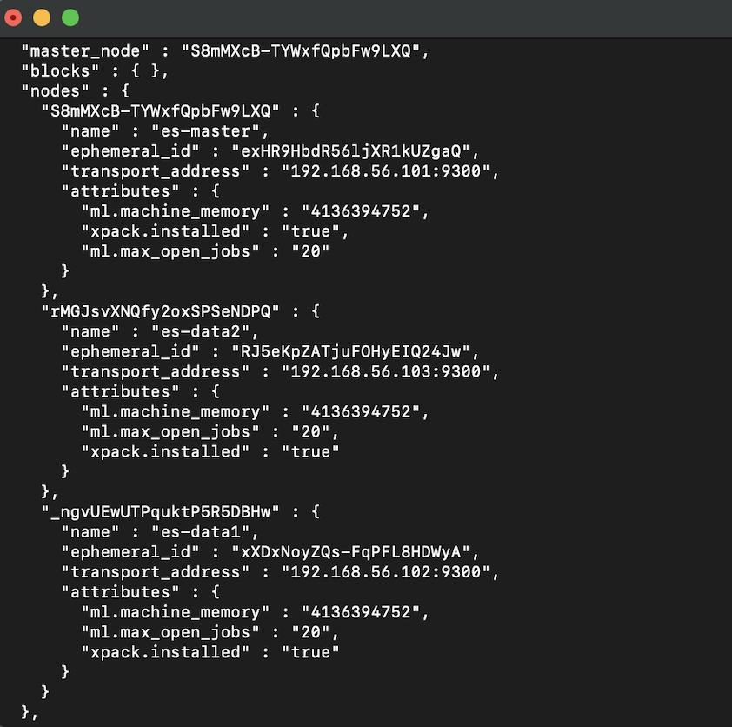

Рисунок 4 – Информация о нодах кластера

На хост компьютере так же доступен веб интерфейс, который позволяет получить информацию о состоянии нод:

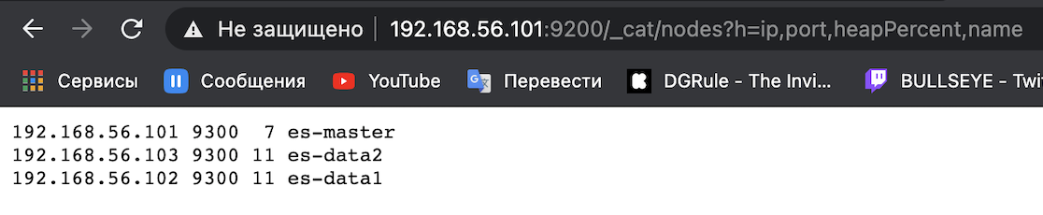

Рисунок 5 – Состояние нод кластера

## 2.3 Установка Neo4j

На всех виртуальных машинах выполним следующее:

1. Импортируем открытый ключ GPG для neo4j, добавим neo4j к менеджеру пакетов apt, добавим neo4j к менеджеру пакетов apt:

wget -O - https://debian.neo4j.com/neotechnology.gpg.key | sudo apt-key add -

echo 'deb https://debian.neo4j.com stable latest' | sudo tee /etc/apt/sources.list.d/neo4j.list

sudo apt-get update

2. Установим neo4j версии enterprise (только в этой версии присутствует поддержка кластерного режима) [4]

sudo apt-get install neo4j-enterprise

Добавим следующие строки на es-master:

dbms.default\_advertised\_address=192.168.56.101

dbms.mode=CORE

causal\_clustering.initial\_discovery\_members=192.168.56.101:5001,192.168.56.102:5001,192.168.56.103:5001

causal\_clustering.minimum\_core\_cluster\_size\_at\_formation=2

causal\_clustering.minimum\_core\_cluster\_size\_at\_runtime=2

causal\_clustering.discovery\_advertised\_address=192.168.56.101:5001

causal\_clustering.discovery\_listen\_address=0.0.0.0:5001

dbms.default\_listen\_address=0.0.0.0

На es-data1:

dbms.default\_advertised\_address=192.168.56.102

dbms.mode=CORE

causal\_clustering.initial\_discovery\_members=192.168.56.101:5001,192.168.102:5001,192.168.56.103:5001

causal\_clustering.minimum\_core\_cluster\_size\_at\_formation=2

causal\_clustering.minimum\_core\_cluster\_size\_at\_runtime=2

causal\_clustering.discovery\_listen\_address=0.0.0.0:5001

causal\_clustering.discovery\_advertised\_address=192.168.56.102:5001

dbms.default\_listen\_address=0.0.0.0

На es-data2:

dbms.default\_advertised\_address=192.168.56.103

dbms.mode=CORE

causal\_clustering.initial\_discovery\_members=192.168.56.101:5001,192.168.102:5001,192.168.56.103:5001

causal\_clustering.minimum\_core\_cluster\_size\_at\_formation=2

causal\_clustering.minimum\_core\_cluster\_size\_at\_runtime=2

causal\_clustering.discovery\_listen\_address=0.0.0.0:5001

causal\_clustering.discovery\_advertised\_address=192.168.56.103:5001

dbms.default\_listen\_address=0.0.0.0

Рассмотрим каждый параметр подробнее.

Таблица 2 – Конфигурационные параметры neo4j

|  |  |
| --- | --- |
| **Параметр** | **Описание** |
| dbms.default\_advertised\_address | Адрес, по которому другие ноды должны подключаться. Обычно устанавливается полное доменное имя или IP-адрес этого сервера. |
| dbms.mode | Режим работы ноды. Может быть два возможных режима: CORE или READ\_REPLICA. |
| dbms.default\_listen\_address | Адрес или сетевой интерфейс, который используется для прослушивания входящих сообщений. Установка этого значения в 0.0.0.0 делает Neo4j доступным для всех сетевых интерфейсов |
| causal\_clustering.initial\_  discovery\_members | Сетевые адреса начального набора элементов кластера Core, которые доступны для начальной загрузки этого экземпляра Core или Read Replica. По умолчанию начальные члены обнаружения представлены в виде разделенного запятыми списка пар адрес / порт, порт по умолчанию для службы обнаружения - :5000. Рекомендуется устанавливать для этого параметра одинаковое значение на всех основных серверах. |

Продолжение таблицы 2

|  |  |
| --- | --- |
| causal\_clustering.minimum\_core\_cluster\_size\_at\_formation | Минимальное количество Core машин в кластере при формировании. Кластер не будет сформирован без количества Core машин, определенного этим параметром. |
| causal\_clustering.minimum\_core\_cluster\_size\_at\_runtime | Минимальное количество экземпляров Core машин, которые будут существовать в группе. |
| causal\_clustering.discovery\_  listen\_address | Настройка адреса / порта, указывающая, к какому сетевому интерфейсу и порту будет привязан экземпляр Neo4j для протокола обнаружения кластера. |
| causal\_clustering.discovery\_  advertised\_address | Настройка адреса / порта, где экземпляр объявляет, что он будет прослушивать сообщения протокола обнаружения от других членов кластера. Если этот экземпляр включен в число initial\_discovery\_members других членов кластера, значение там должно точно соответствовать этому объявленному адресу. |

Запустим neo4j на всех нодах с помощью команды:

sudo neo4j start

Теперь на хост-машине можно получить доступ к удобному веб-интерфейсу для работы с сервером. После авторизации можно получить информацию о всех нодах кластера командой dbms.cluster.overview().

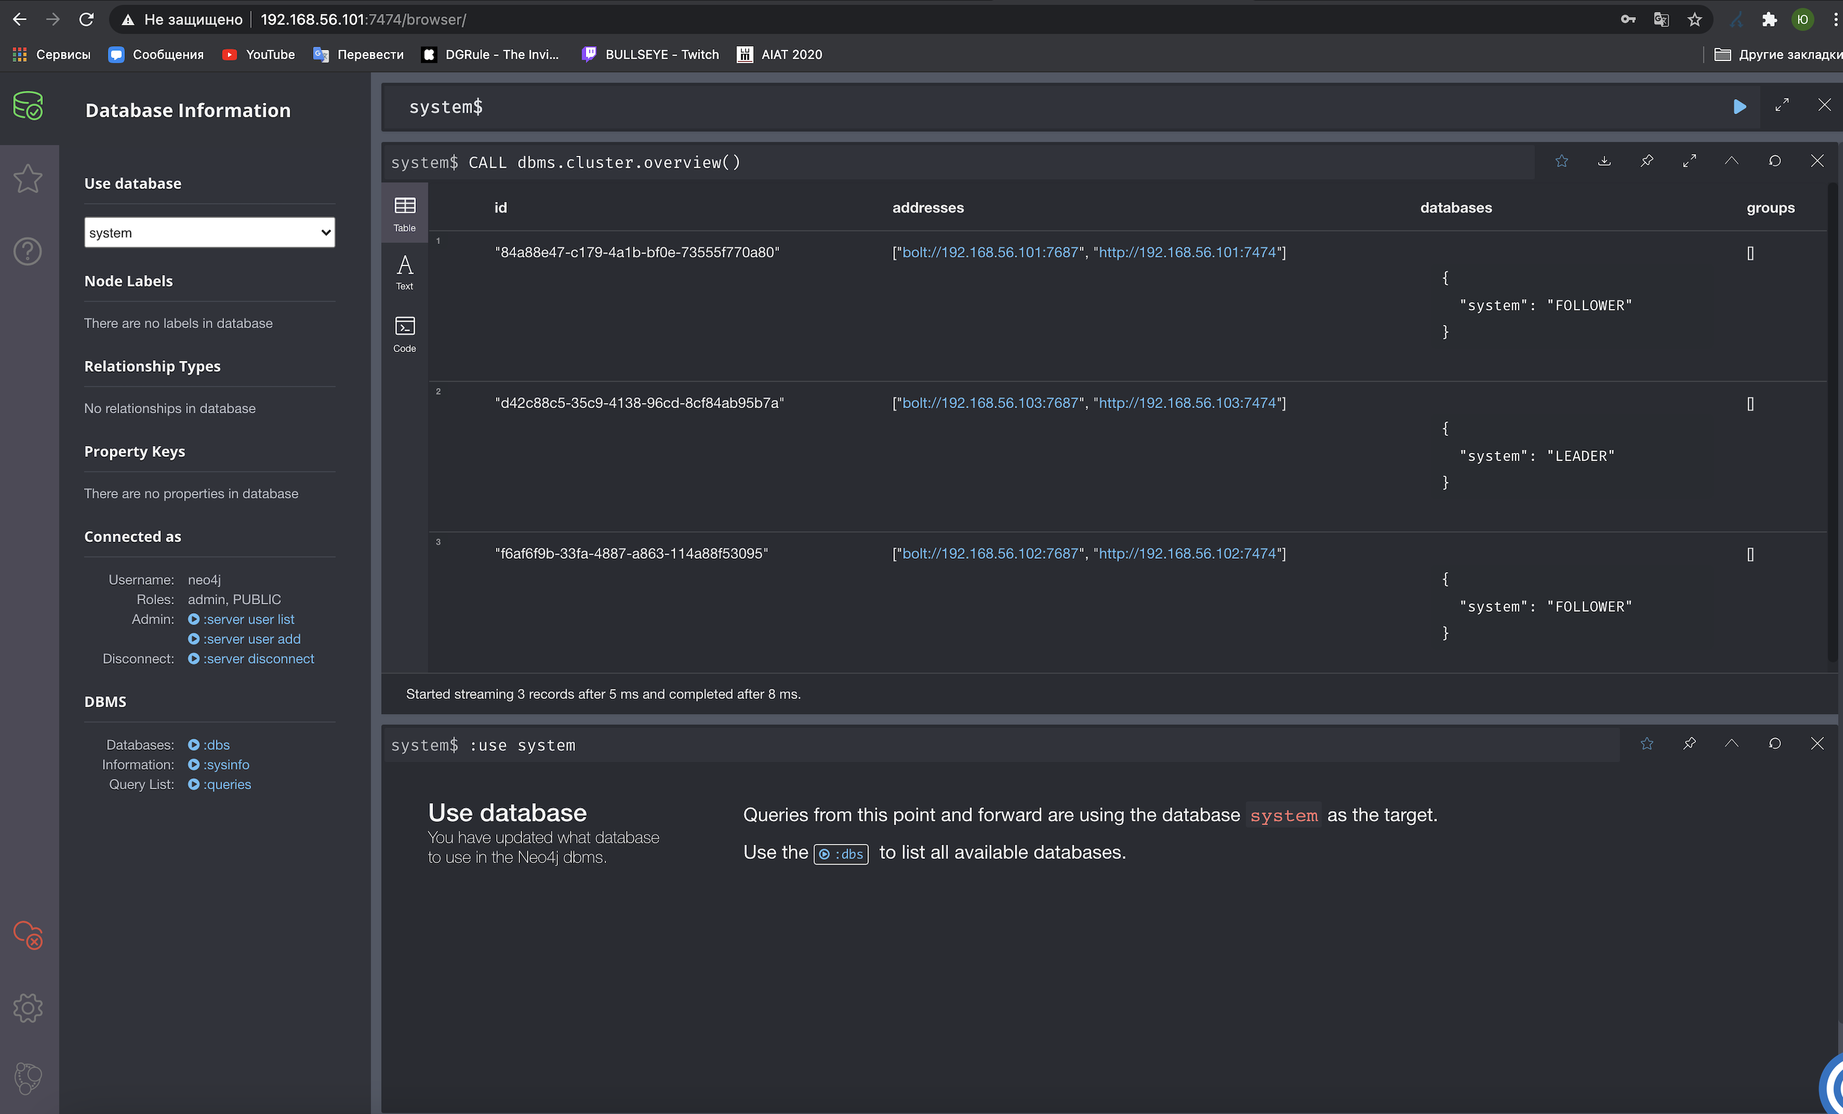

Рисунок 6 – Информация о нодах кластера neo4j

## 2.4 Установка Hadoop

На машине es-master выполним следующие действия

1. Создадим пользователя hduser в группе hadoop.

sudo addgroup hadoop

sudo adduser --ingroup hadoop hduser

2. Добавим новому пользователю права для выполнения команд от рута. В файл /etc/sudoers добавим строку hduser ALL=(ALL:ALL) ALL.

3. Сгенерируем SSH-ключи (под пользователем hduser)

sudo su hduser

ssh-keygen -t rsa -P ""

cat $HOME/.ssh/id\_rsa.pub >> $HOME/.ssh/authorized\_keys

4. Скачаем архив с Hadoop и разархивируем его.

wget http://apache-mirror.rbc.ru/pub/apache/hadoop/common/hadoop-3.3.0/hadoop-3.3.0.tar.gz

sudo tar -xzvf hadoop-3.3.0.tar.gz

sudo mv hadoop-3.3.0 /usr/local/hadoop/hadoop-3.3.0

5. Создадим рабочие каталоги для HDFS (NameNode и DataNode) и назначим владельца каталога hadoop (под пользователем hduser).

sudo mkdir -p /usr/local/hadoop/hadoop\_tmp/hdfs/namenode

sudo mkdir -p /usr/local/hadoop/hadoop\_tmp/hdfs/datanode

sudo chown hduser:hadoop -R /usr/local/hadoop/

6. Настроим переменные окружения.

cd

sudo gedit .bashrc

Добавим в файл строки:

export JAVA\_HOME=/usr/lib/jvm/java-1.8.0-openjdk-amd64

export HADOOP\_HOME=/usr/local/hadoop/hadoop-3.3.0

export PATH=$PATH:$HADOOP\_HOME/bin

export PATH=$PATH:$HADOOP\_HOME/sbin

export HADOOP\_MAPRED\_HOME=$HADOOP\_HOME

export HADOOP\_COMMON\_HOME=$HADOOP\_HOME

export HADOOP\_HDFS\_HOME=$HADOOP\_HOME

export YARN\_HOME=$HADOOP\_HOME

export HADOOP\_COMMON\_LIB\_NATIVE\_DIR=$HADOOP\_HOME/lib/native

export HADOOP\_OPTS="-Djava.library.path=$HADOOP\_HOME/lib/native"

7. В файл /usr/local/hadoop/hadoop-3.3.0/etc/hadoop/hadoop-env.sh добавим переменную

export JAVA\_HOME=/usr/lib/jvm/java-1.8.0-openjdk-amd64

8. В файл /usr/local/hadoop/hadoop-3.3.0/etc/hadoop/core-site.xml добавим

<configuration>

<property>

<name>fs.defaultFS</name>

<value>hdfs://192.168.56.101:9000</value>

</property>

<property>

<name>hadoop.temp.dir</name>

<value>/usr/local/hadoop/hadoop\_tmp</value>

</property>

</configuration>

9. В файл /usr/local/hadoop/hadoop-3.3.0/etc/hadoop/hdfs-site.xml добавим:

<configuration>

<property>

<name>dfs.replication</name>

<value>3</value>

</property>

<property>

<name>dfs.namenode.name.dir</name>

<value>file:///usr/local/hadoop/hadoop\_tmp/hdfs/namenode</value>

</property>

<property>

<name>dfs.datanode.data.dir</name>

<value>file:///usr/local/hadoop/hadoop\_tmp/hdfs/datanode</value>

</property>

</configuration>

10. В файл /usr/local/hadoop/hadoop-3.3.0/etc/hadoop/yarn-site.xml добавим:

<configuration>

<property>

<name>yarn.nodemanager.aux-services</name>

<value>mapreduce\_shuffle</value>

</property>

<property>

<name>yarn.nodemanager.aux-services.mapreduce.shuffle.class</name>

<value>org.apache.hadoop.mapred.ShuffleHandler</value>

</property>

<property>

<name>yarn.resourcemanager.resource-tracker.address</name>

<value>192.168.56.101:8025</value>

</property>

<property>

<name>yarn.resourcemanager.scheduler.address</name>

<value>192.168.56.101:8035</value>

</property>

<property>

<name>yarn.resourcemanager.address</name>

<value>192.168.56.101:8050</value>

</property>

</configuration>

11. В файл /usr/local/hadoop/hadoop-3.3.0/etc/hadoop/mapred-site.xml добавим

<configuration>

<property>

<name>mapreduce.job.tracker</name>

<value>192.168.56.101:5431</value>

</property>

<property>

<name>mapreduce.framework.name</name>

<value>yarn</value>

</property>

</configuration>

12. В файл /usr/local/hadoop/hadoop-3.3.0/etc/hadoop/masters добавим:

192.168.56.101

13. В файл /usr/local/hadoop/hadoop-3.3.0/etc/hadoop/slaves добавим

192.168.56.101

192.168.56.102

192.168.56.103

14. В файл /usr/local/hadoop/hadoop-3.3.0/etc/hadoop/workers добавим

192.168.56.101

192.168.56.102

192.168.56.103

15. Установим утилиту rsync для копирования Hadoop на подчиненные машины.

16. Скопируем данные на es-data1 и es-data2:

sudo rsync -avxP /usr/local/hadoop/ hduser@es-data1:/usr/local/hadoop/

sudo rsync -avxP /usr/local/hadoop/ hduser@es-data2:/usr/local/hadoop/

17. Запустим Hadoop на es-master командами.

start-dfs.sh

start-yarn.sh

18. Командой jps проверим, что на всех нодах запустились необходимые компоненты (NodeManager, ResourceManager, NameNode, DataNode и SecondNameNode на мастер ноде; NodeManager и DataNode на остальных) [5]

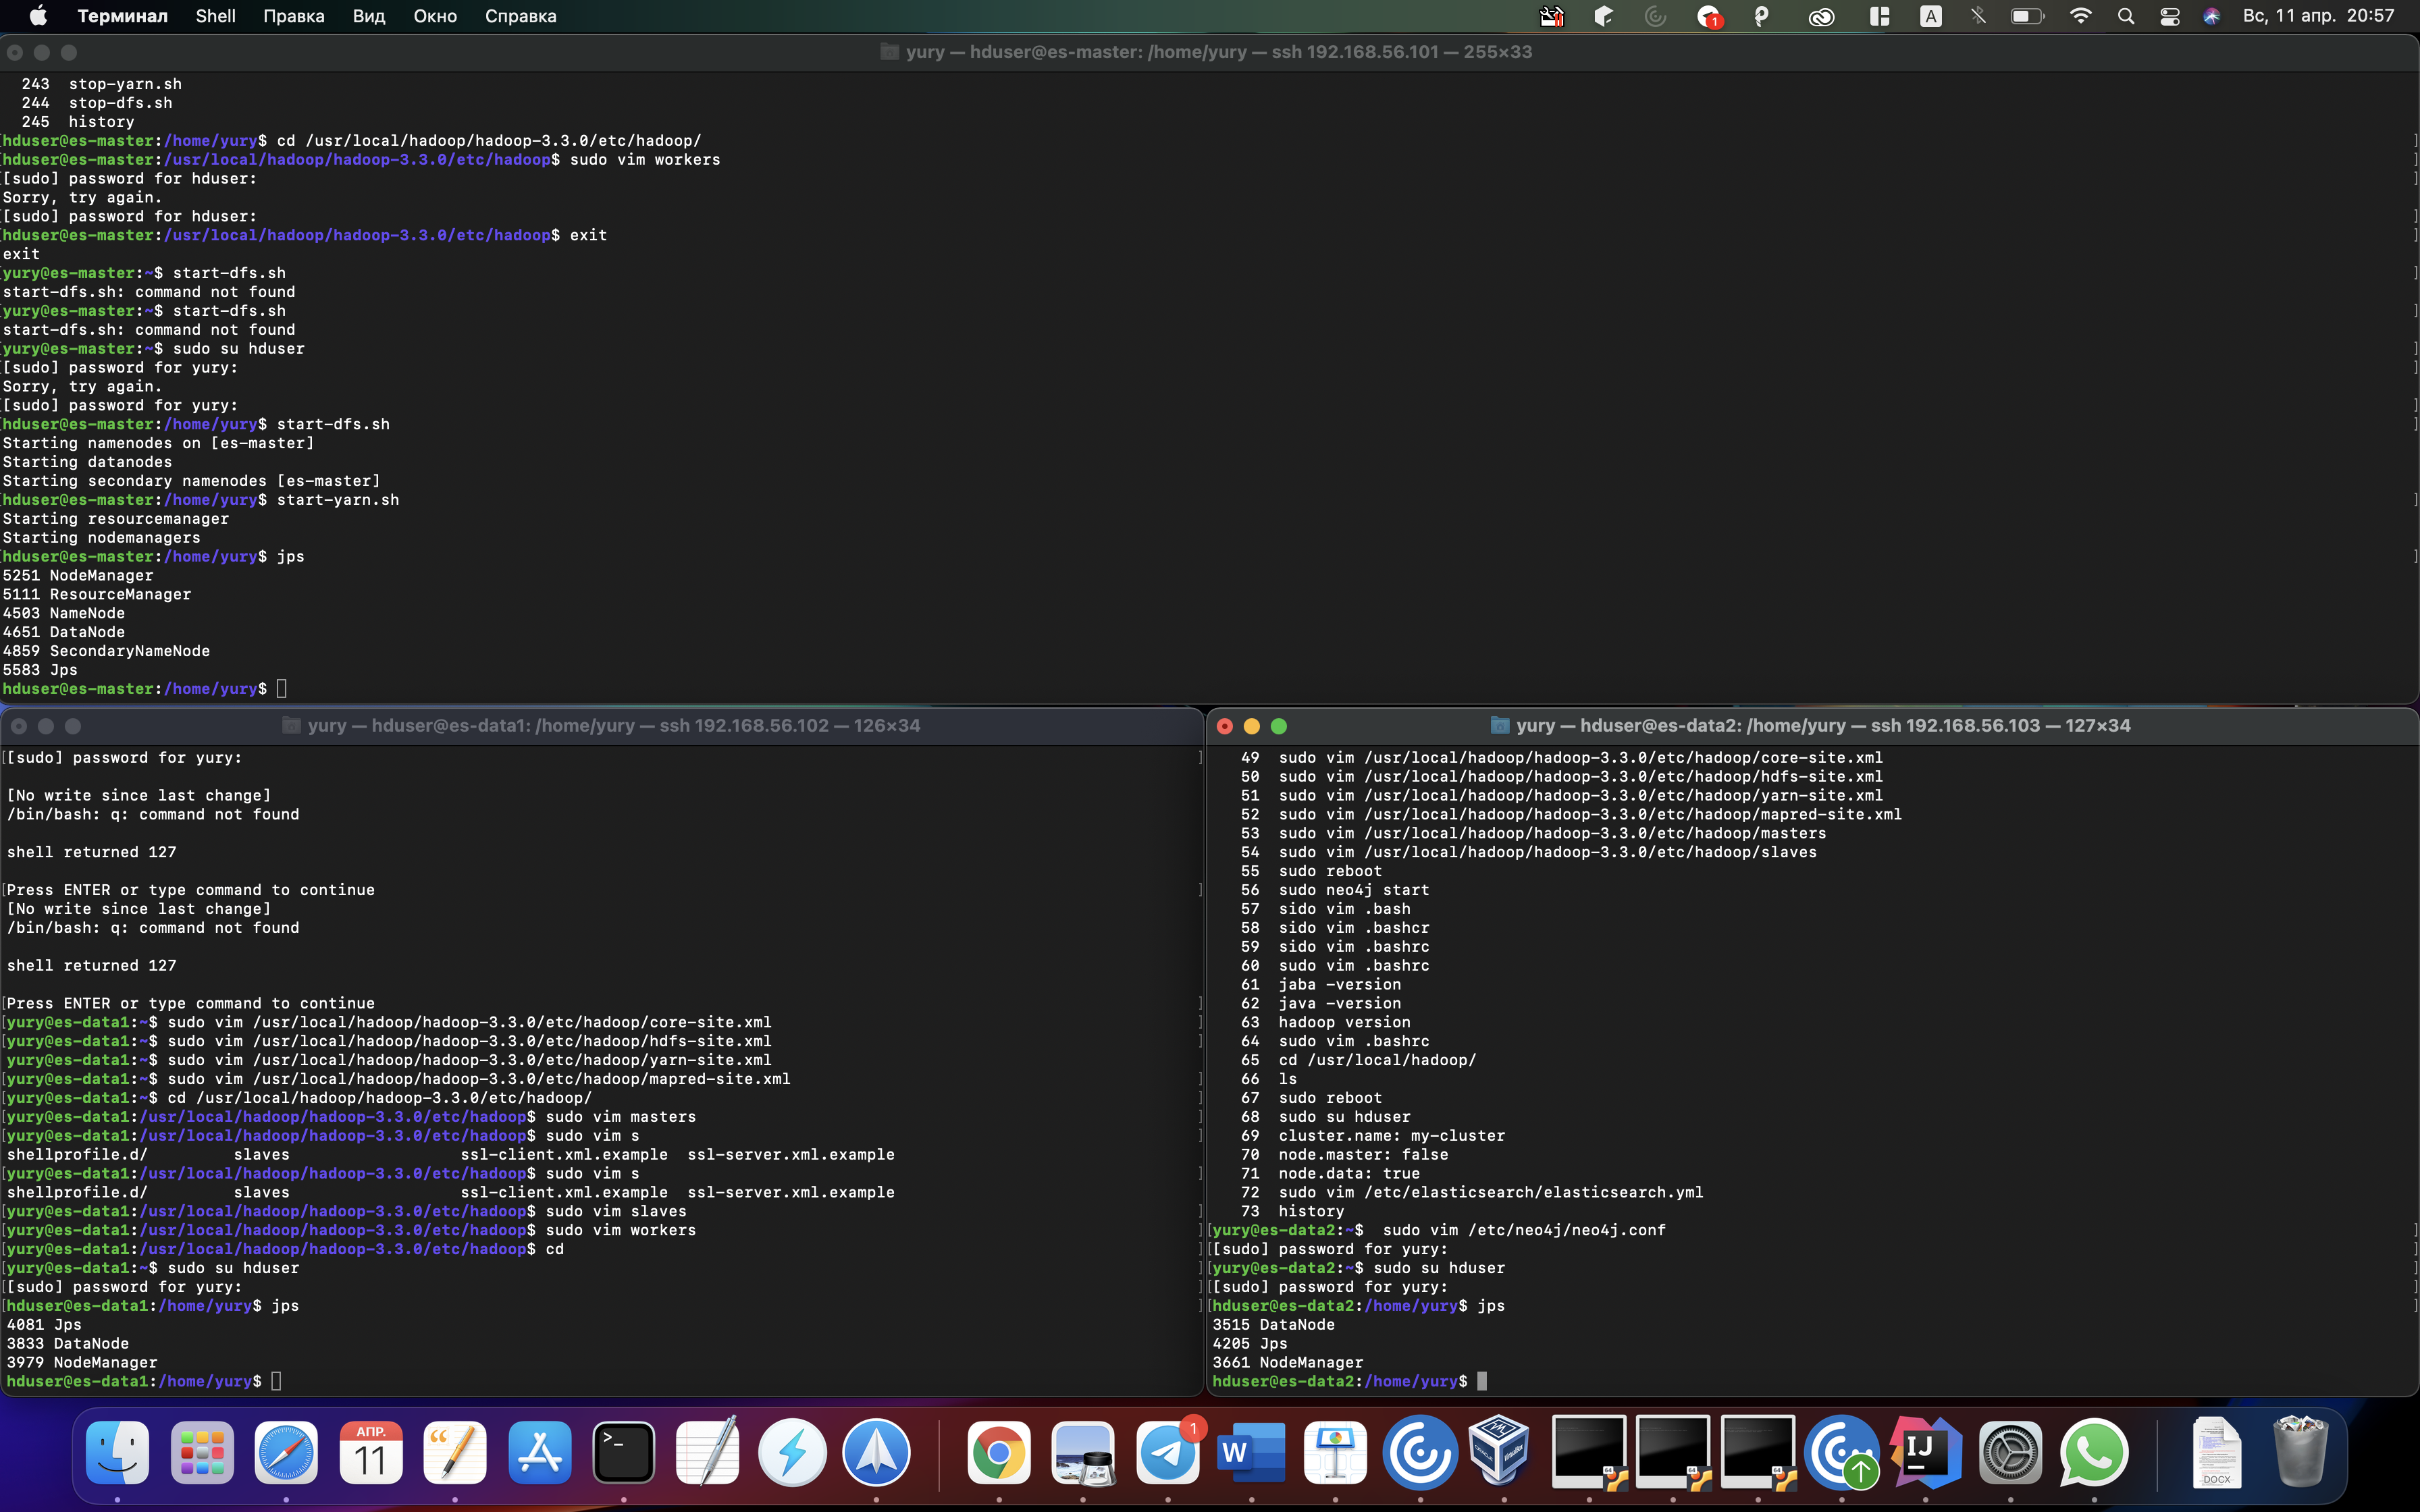

Рисунок 7 – Проверка запуска компонентов Hadoop

На хост компьютере по ссылке http://192.168.56.101:8088/cluster/nodes доступен веб-интерфейс, в котором можно получить информацию о состоянии нод кластера.

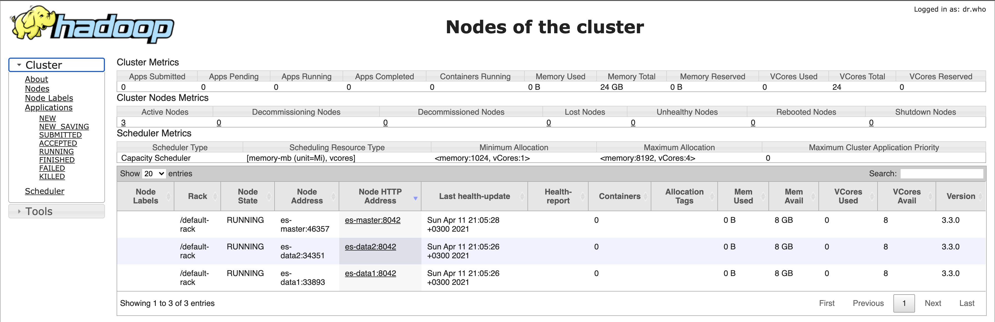

Рисунок 8 – Информация о нодах кластера Hadoop

## 2.5 Установка Spark

Выполним на es-master:

1. Скачаем и разархивируем дистрибутив spark

wget https://apache-mirror.rbc.ru/pub/apache/spark/spark-3.0.1/spark-3.0.1-bin-hadoop3.2.tgz

sudo tar -xzvf spark-3.0.1-bin-hadoop3.2.tgz

sudo mv spark-3.0.1-bin-hadoop3.2 /usr/local/spark/

1. Настроим переменные окружения.

sudo vim .bashrc

Добавим строки:

export SPARK\_HOME=/usr/local/spark-3.0.1

export PATH=$PATH:$SPARK\_HOME/bin

export PYSPARK\_PYTHON=/usr/bin/python3

export PYSPARK\_DRIVER\_PYTHON=python3

3. Перейдем в каталог с настройками и создадим файл spark-env.sh из шаблона

cd $SPARK\_HOME/conf

sudo cp spark-env.sh.template spark-env.sh

4. Добавим в этот файл строки:

SPARK\_MASTER\_HOST=192.168.56.101

export PYSPARK\_PYTHON=/usr/bin/python3

export PYSPARK\_DRIVER\_PYTHON=python3

5. Создадим файл slaves из шаблона

sudo cp slaves.template slaves

6. Добавим туда строки с IP-адресами всех виртуальных машин

192.168.56.101

192.168.56.102

192.168.56.103

7. Скопируем данные на все остальные машины

sudo rsync -avxP /usr/local/spark/ hduser@es-data1:/usr/local/spark/

sudo rsync -avxP /usr/local/spark/ hduser@es-data2:/usr/local/spark/

8. Запустим Spark

cd $SPARK\_HOME/sbin

./start-all.sh

9. Теперь по адресу http://192.168.56.101:8080/ на хост компьютере доступен веб-интерфейс spark из которого можно получить информацию обо всех рабочих машинах и работающих программах

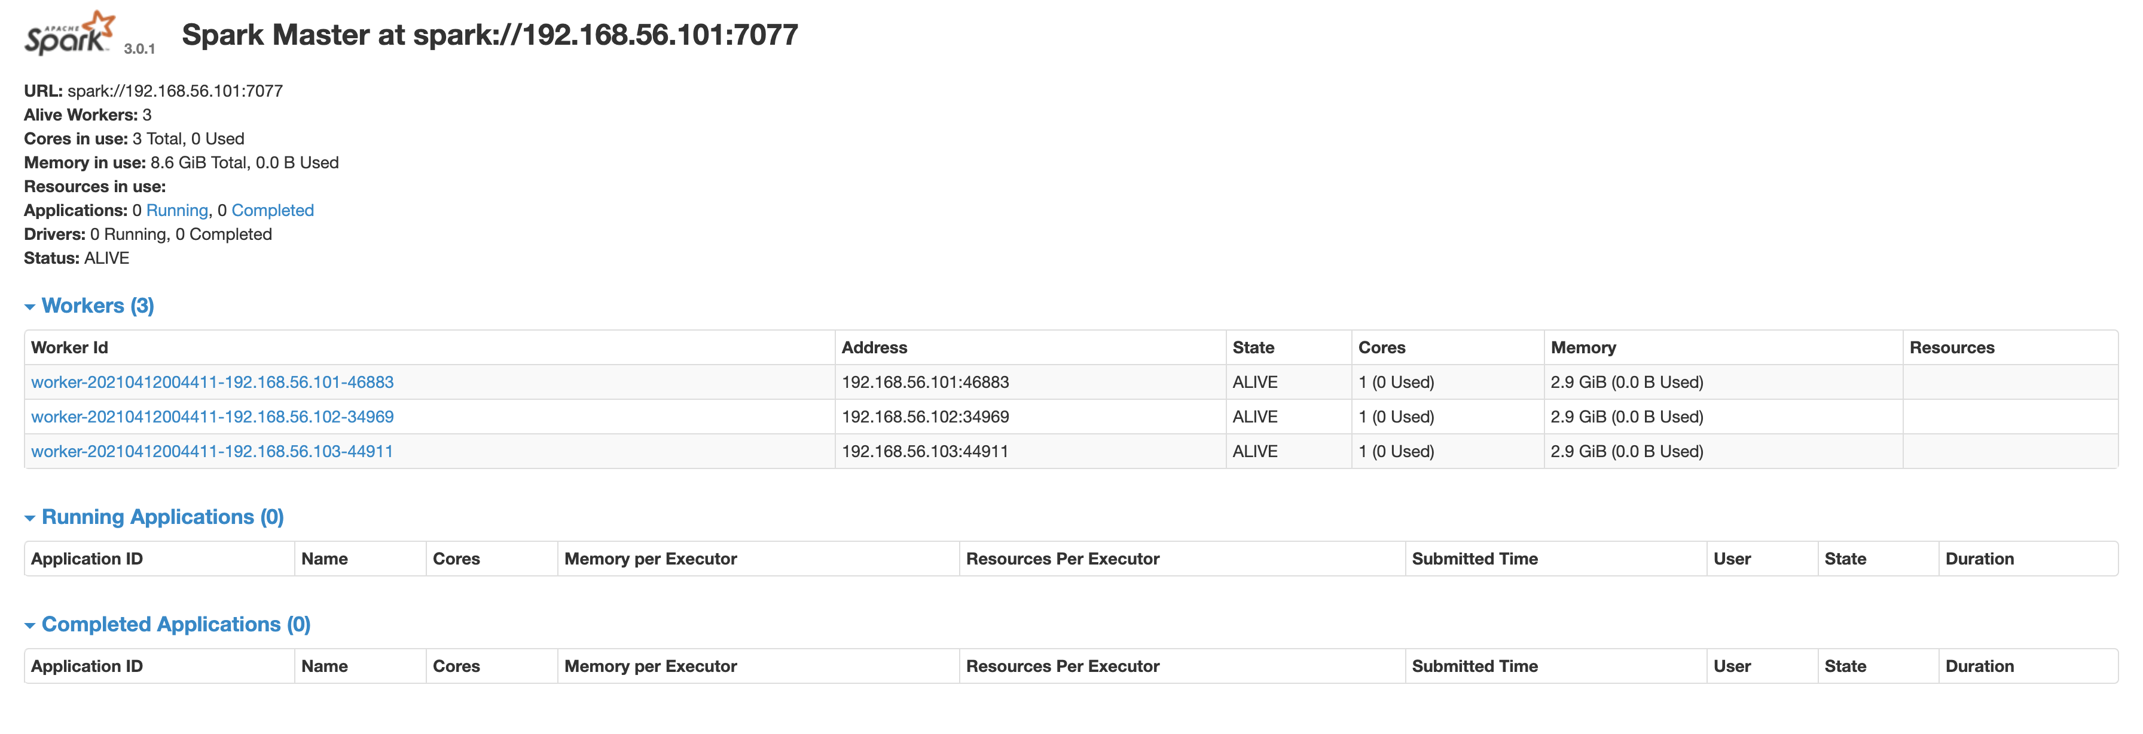

Рисунок 9 – Информация о нодах Spark

## 2.6 Генерация исходных данных

В связи с тем, что по заданию требовалось создать большой объем исходных данных, то на языке java была написана программа для их генерации. Исходный код программы приведен в приложении Б (программа генерации исходных данных).

Для преобразования данных в json использовалась библиотека Jackson [7], которая позволяет сериализировать и десериализовать объекты классов, парсить json без фиксированной структуры. Данная библиотека является самой широко используемой для работы с форматированными данными (json, xml и т. д.).

Для создания классов-оберток (которые в будущем будут использоваться для сериализации) могут быть сгенерированы автоматически с помощью различных интернет-ресурсов [8], что значительно упрощает написание кода. На ввод такого интернет-ресурса необходимо предоставить структуру jsonа. Важно обращать внимание на тип данных, так как от этого будет зависеть, какой тип данных будет в финальном java классе. Пример такого сгенерированного класса приведен в приложении Б (пример сгенерированного класса-обертки).

Сами исходные данные были сгенерированы случайным образом: для сток использовался случайный набор символов, для текстов – случайная часть из литературного произведения «Академия» Азимова.

# 3 Elasticsearch

## 3.1 Индексация документов

### 3.1.1 Анализатор

Каждый анализатор состоит из символьного фильтра, токенизатора и фильтра токенов [9]. Символьный фильтр работает с потоком отдельных символов, и может добавлять их, изменять или удалять. Токенизатор также работает с потоком символов, но не изменяет их, а только разделяет поток на отдельные токены, например, слова. Фильтр токенов получает на вход поток токенов, и может добавлять, изменять или удалять токены. В анализаторе, может быть, 0 или больше символьных фильтров, 1 токенизатор и 0 или больше фильтров токенов. На рисунке 6 представлена структура анализатора.



Рисунок 10 – Структура анализатора

В рамках данного курсового проекта необходимо было создать такой анализатор, который разделял бы строку на слова и убирал пунктуацию с помощью токенизатора standard (русский). Для достижения данной цели был написан фильтр russian\_stemmer типа stemmer, который приводит слово к его основе алгоритмическими методами [10], с паметром language : russian, что означает, что фильтр будет работать по русскоязычному алгоритму выделения корней. Кроме того, был добавлен стандартный фильтр lowercase, который приводит все токены к нижнему регистру.

Код анализатора приведен далее:

"settings": {  
 "analysis": {  
 "filter" : {  
 "russian\_stemmer": {  
 "type" : "stemmer",  
 "language" : "russian"  
 }  
 },  
 "analyzer": {  
 "my\_analyzer": {  
 "type": "custom",  
 "tokenizer": "standard",  
 "filter": [  
 "lowercase",  
 "russian\_stemmer"  
 ]  
 }  
 }  
 }  
}

После создания анализатора можно проверить его работу через REST API.

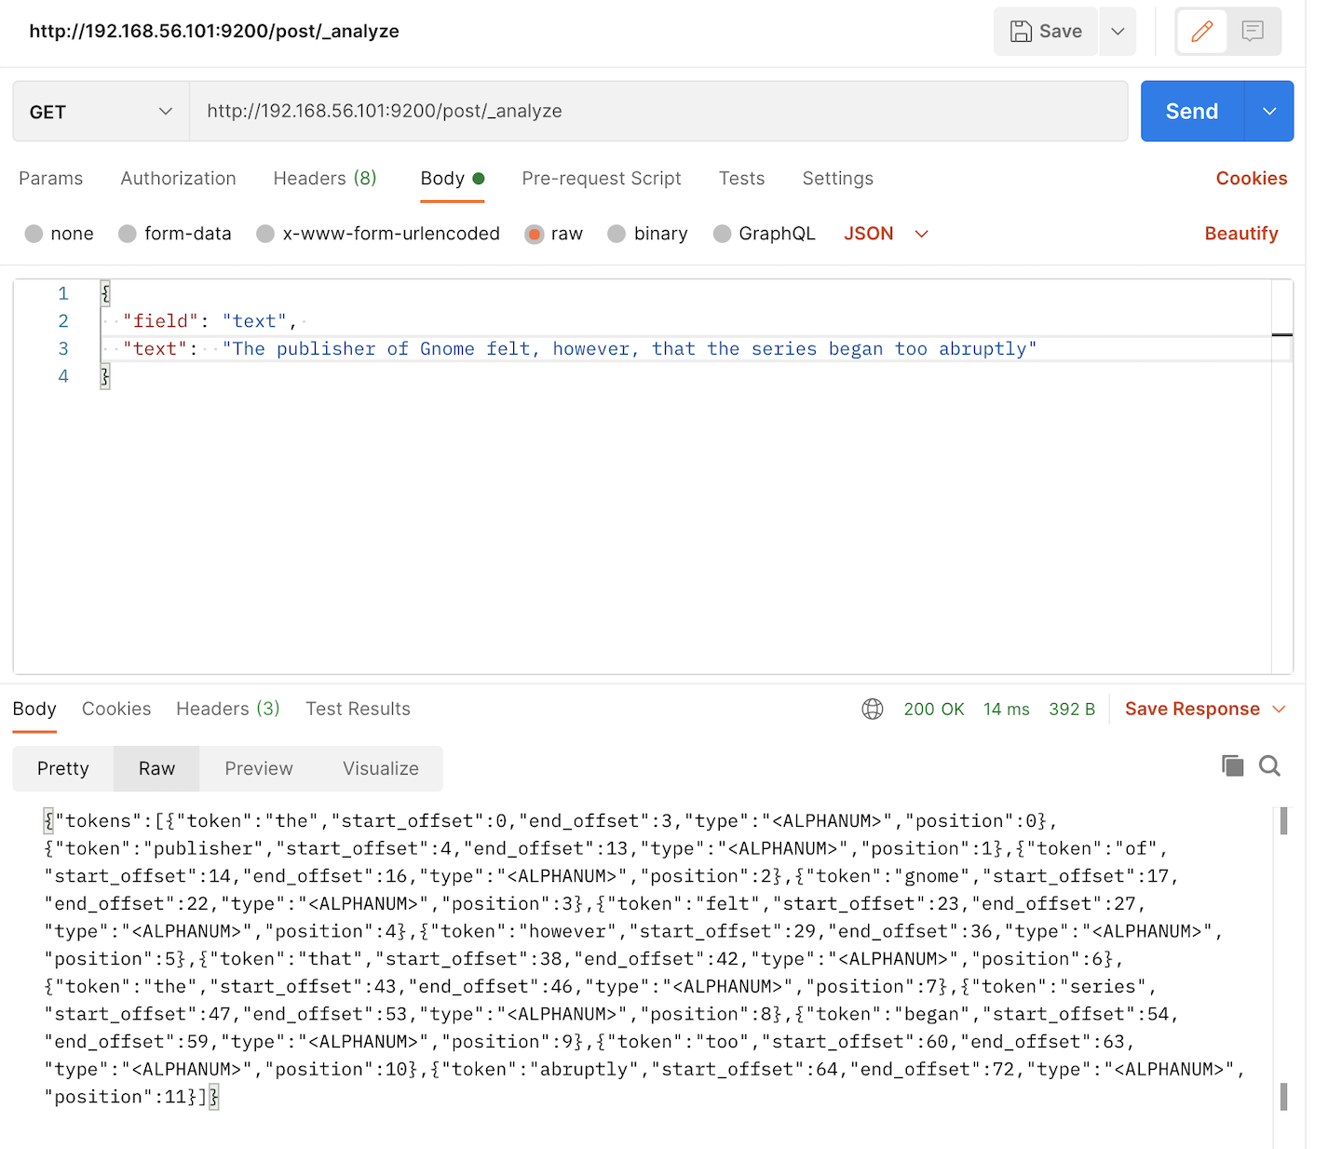

Рисунок 11 – Результат работы анализатора

### 3.1.2 Маппинг

Для описания того, как документы должны индексироваться, используется маппинг. Маппинг создается для всего индекса и используется при занесении документов в индекс. В маппинге указываются названия полей документов, типы данных полей, а также могут быть заданы анализаторы для текстовых полей. Далее представлен маппинг для постов:

"mappings": {  
 "properties": {  
 "date": {  
 "type": "date",  
 "format": "dd.MM.yyyy HH:mm"  
 },  
 "category": {  
 "type": "text",  
 "fielddata": true  
 },  
 "text": {  
 "type": "text",  
 "fielddata": true,  
 "analyzer":"my\_analyzer"  
 },  
 "video-href": {  
 "type": "text",  
 "fielddata": true  
 },  
 "image-href": {  
 "type": "text",  
 "fielddata": true  
 },  
 "view-num": {  
 "type": "long"  
 }  
 }  
}

Маппинг для подписчиков:

"mappings": {  
 "properties": {  
 "reg\_date": {  
 "type": "date",  
 "format": "dd.MM.yyyy HH:mm"  
 },  
 "name": {  
 "type": "text",  
 "fielddata": true  
 },  
 "image-href": {  
 "type": "text",  
 "fielddata": true  
 },  
 "birthday": {  
 "type": "date",  
 "format": "dd.MM.yyyy HH:mm"  
 },  
 "email": {  
 "type": "text",  
 "fielddata": true  
 },  
 "profession": {  
 "type": "text",  
 "fielddata": true  
 },  
 "education": {  
 "properties": {  
 "university": {  
 "type": "text",  
 "fielddata": true  
 },  
 "end-year": {  
 "type": "long"  
 },  
 "description": {  
 "type": "text",  
 "fielddata": true,  
 "analyzer": "my\_analyzer"  
 },  
 "speciality": {  
 "type": "text",  
 "fielddata": true  
 }  
 }  
 },  
 "comment": {  
 "type": "nested",  
 "properties": {  
 "date": {  
 "type": "date",  
 "format": "dd.MM.yyyy HH:mm"  
 },  
 "end-year": {  
 "type": "long"  
 },  
 "text": {  
 "type": "text",  
 "fielddata": true,  
 "analyzer": "my\_analyzer"  
 }  
 }  
 }  
 }  
}

Рассмотрим подробнее каждый из параметров:

* type – тип данных. Существует большое количество различных типов данных, которые могут использоваться в системе [11]. В рамках данной работы использовались стандартные типы: data, long, text для дат, цифр и строковых значений соответственно. Кроме того, использовался тип nested для комментариев, который позволяет хранить сложные типы данных с фиксированной структурой и поддерживает хранение массивов таких объектов.
* Fielddata – параметр, который позволяет получить доступ к токенам текстового поля для использования в агрегациях и сортировке.
* Analyzer – анализатор. Использовался анализатор из пункта 3.1.1.
* Format – формат даты для данного поля. Используется при индексировании документа для преобразования строки в дату.

Индексация документов производилась на языке Java. Далее представлена схема алгоритма работы программы. Исходный код программы представлен в приложении Б (индексирование ElasticSearch).

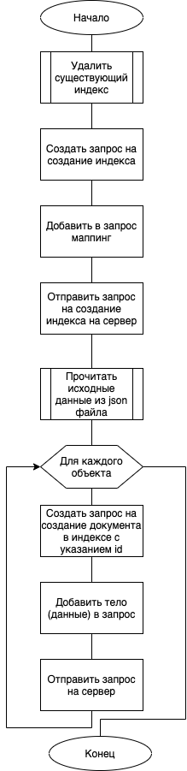

Рисунок 12 – Схема алгоритма индексирования документа

## 3.2 Запросы

В соответствии с задание курсового проекта необходимо реализовать 2 запроса. Реализуем двумя способами: через Java библиотеку (исходный код в приложении Б – запросы к ElasticSearch) и json запросом непосредственно к REST API ElasticSearch.

### 3.2.1 Запрос 1

Необходимо написать и выполнить запрос: разбить подписчиков по дате регистрации с интервалом 1 месяц, для каждой группы определить число комментариев по роду занятий.

Тело запроса:

{  
 "aggs": {  
 "group\_by\_month": {  
 "date\_histogram": {  
 "field": "reg\_date",  
 "interval": "month"  
 },  
 "aggs": {  
 "group\_by\_profession": {  
 "terms": {  
 "field": "profession"  
 },  
 "aggs": {  
 "comment\_count": {  
 "nested": {  
 "path": "comment"  
 }  
 }  
 }  
 }  
 }  
 }  
 }  
}

В запросе используется вложенная агрегация. Описание каждой из них находится внутри «aggs». Рассмотрим подробнее каждую из них:

* group\_by\_month – агрегация, которая стоится на основе временной гистограммы [12] («date\_histogram») по полю «reg\_date» («field») с интервалом в месяц («interval»).
* group\_by\_profession – агрегация, которая группирует значения по названию профессии внутри предыдущей агрегации [13].
* comment\_count – агрегация, которая считает количество сложных объектов (комментариев) внутри предыдущей агрегации [14].

Далее приведены результаты выполнения программы в среде Kibana:

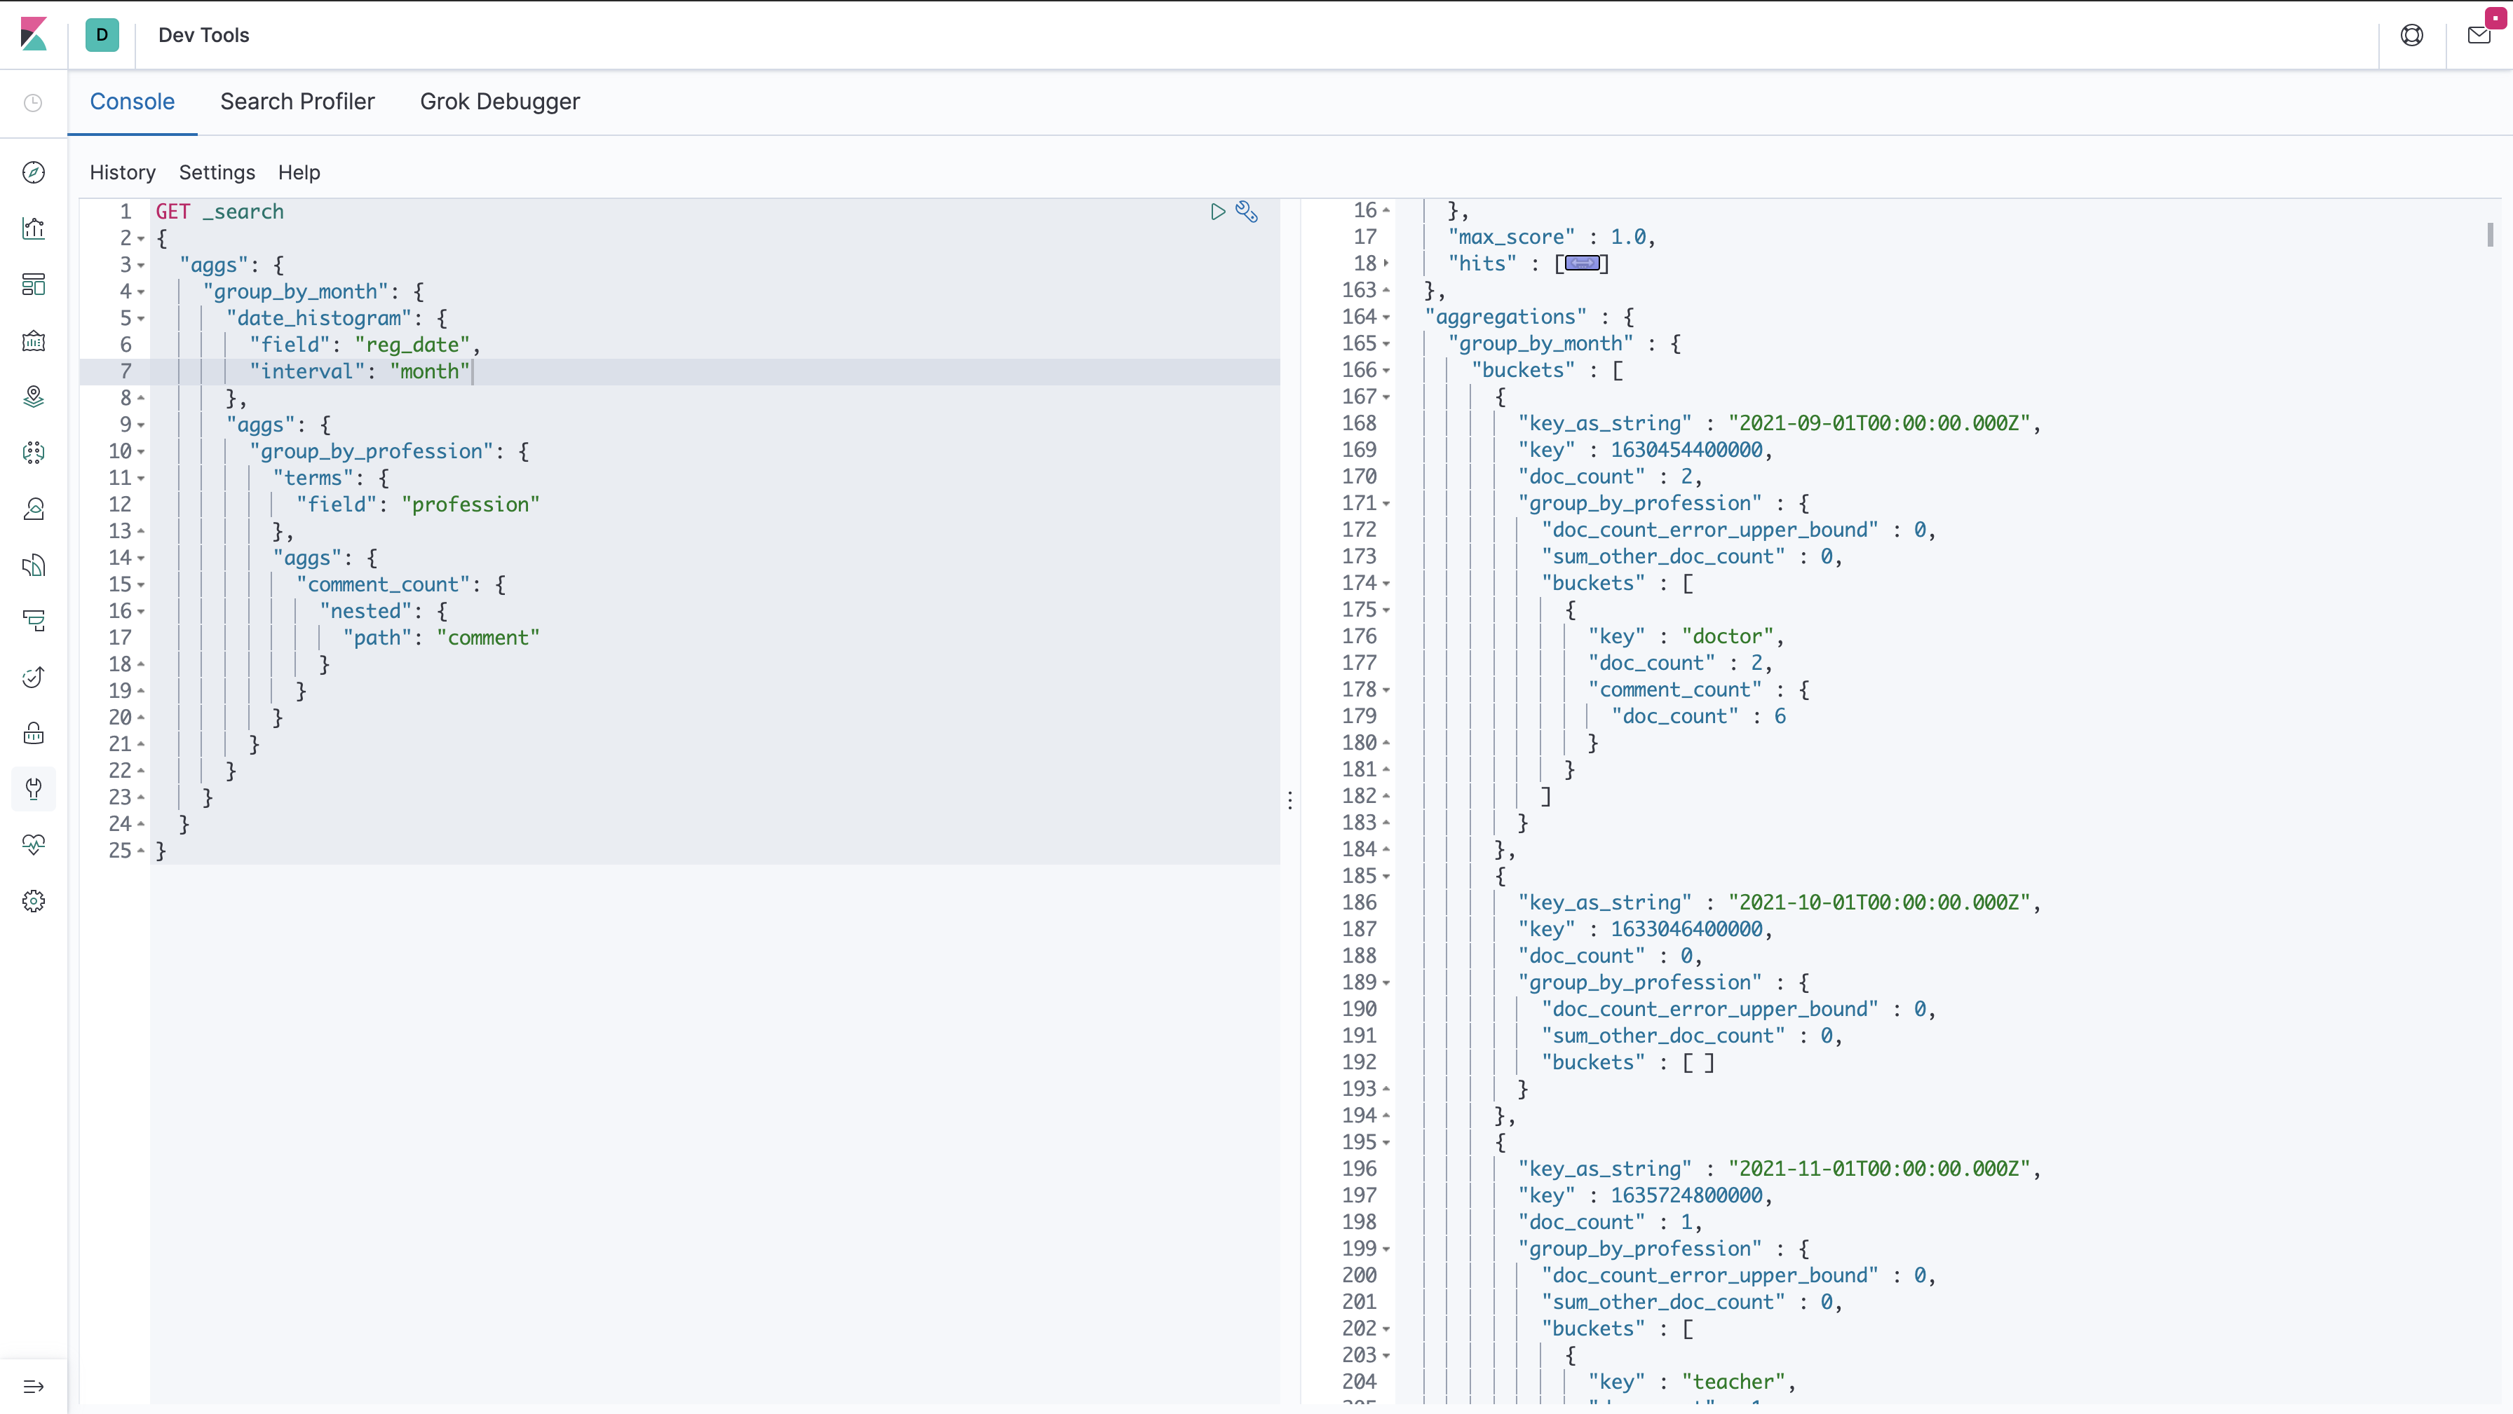

Рисунок 13 – Результат выполнения запроса 1 в среде Kibana

Кроме того, среда Kibana предоставляет профайлер, который позволяет увидеть, как выполняется запрос. На рисунке 14 представлен результат профайлера при выполнении запроса 1.

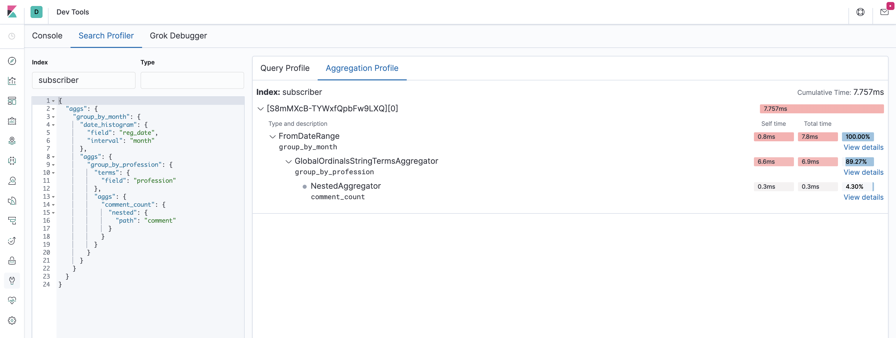

Рисунок 14 – Профайлер агрегации запроса 1

Рассмотрим подробнее одну из агрегаций для понимания того, из каких операций состоит агрегация.

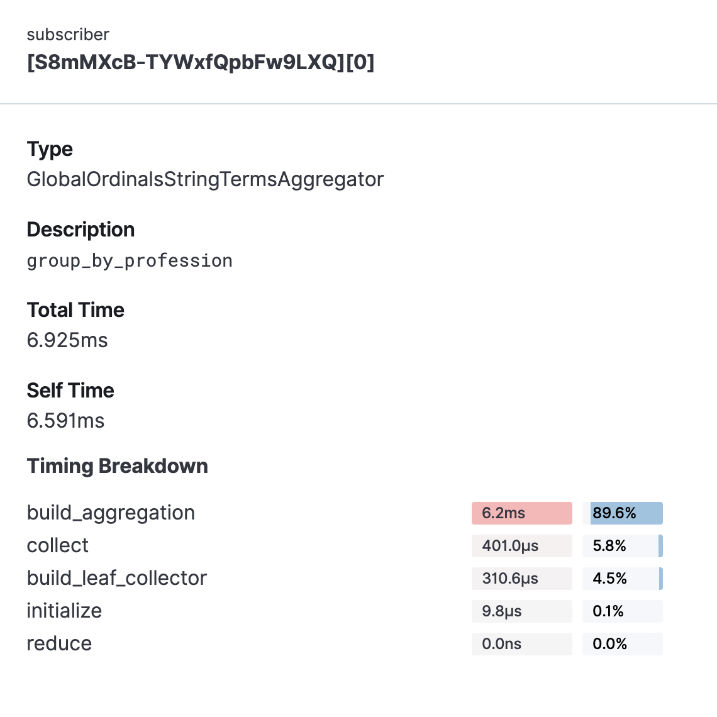

Рисунок 15 – Подробное описание агрегации group\_by\_profession

Рассмотрим каждый из параметров тайминга:

* build\_aggregation – это время, затраченное на создание результатов агрегирования на уровне сегментов, готовых для передачи обратно в reduce после завершения этапа сборки документов (collect).
* сollect – совокупное время, затраченное на фазу сбора агрегации. Здесь соответствующие документы передаются в агрегат, и состояние агрегатора обновляется на основе информации, содержащейся в документах.
* build\_leaf\_collector – время потраченное на метод getLeafCollector(), который собирает данные из памяти
* initialize – это время, необходимое для создания и инициализации агрегирования перед началом сбора документов.
* reduce – эта фаза в настоящее время не используется и всегда будет сообщать 0. В настоящее время при профилировании агрегирования учитываются только части выполнения агрегирования на уровне сегментов. Время фазы сокращения будет добавлено позже.

Аналогичные результаты были получены на языке Java. В консоль было выведено (показаны первые 10 строк):

01.09.2021 00:00 :

doctor : 6

01.10.2021 00:00 :

01.11.2021 00:00 :

teacher : 2

01.12.2021 00:00 :

01.01.2022 00:00 :

programmer : 1

01.02.2022 00:00 :

01.03.2022 00:00 :

01.04.2022 00:00 :

01.05.2022 00:00 :

doctor : 0

01.06.2022 00:00 :

…

### 3.2.2 Запрос 2

Необходимо написать и выполнить запрос: для каждой категории постов определить число просмотров.

{  
 "aggs": {  
 "by\_category": {  
 "terms": {  
 "field": "category"  
 },  
 "aggs": {  
 "do\_a\_sum\_on\_field\_view\_num": {  
 "sum": {  
 "field": "view-num"  
 }  
 }  
 }  
 }  
 }  
}

В запросе используется вложенная агрегация. Описание каждой из них находится внутри «aggs». Рассмотрим подробнее каждую из них:

* by\_category – агрегация, которая группирует значения по категории поста.
* do\_a\_sum\_on\_field\_view\_num – суммирование по полю "view-num".

Далее приведены результаты выполнения программы в среде Kibana:

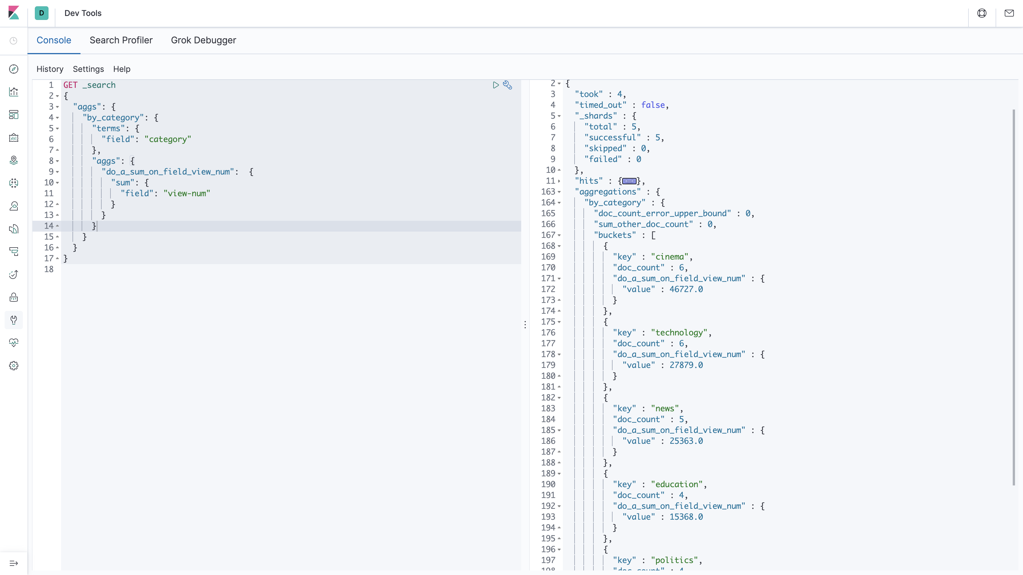

Рисунок 16 – Результат выполнения запроса 2 в среде Kibana

На рисунке 17 представлен результат профайлера при выполнении запроса 2.

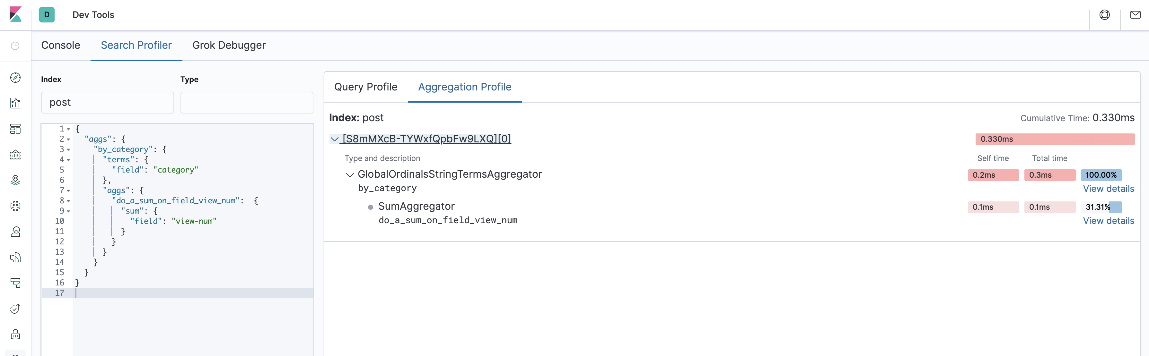

Рисунок 17 – Профайлер агрегации запроса 2

Аналогичные результаты были получены на языке Java. В консоль было выведено:

cinema : 46727.0

technology : 27879.0

news : 25363.0

education : 15368.0

politics : 17852.0

# 4 Neo4j

## 4.1 Создание и заполнение графовой БД

Заполнение БД Neo4j производится данными из кластера ES по схеме «Подписчик (дата\_регистрации, ФИО, дата\_рождения, род\_занятий, специальность) – Комментировал (число комментариев) – Пост (дата, категория, число просмотров)». Таким образом в базе данных будут ноды двух типов («Пост» и «Подписчик») и отношение «Комментировал» между нодами данных двух типов. Для заполнения базы была написана программа на языке Java (исходный код представлен в приложении Б, программа для работы с Neo4j). Далее представлена схема алгоритма заполнения графовой базы данных.

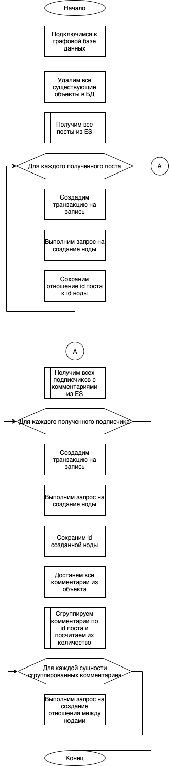

Рисунок 18 – Схема алгоритма заполнения графовой БД



Рисунок 19 – Схема алгоритма заполнения графовой БД (продолжение)

Проверка корректного создания всех объектов графовой базы данных может быть произведена при помощи графического интерфейса. Для этого выполним запрос «MATCH (n) RETURN n», который выведет все объекты БД.

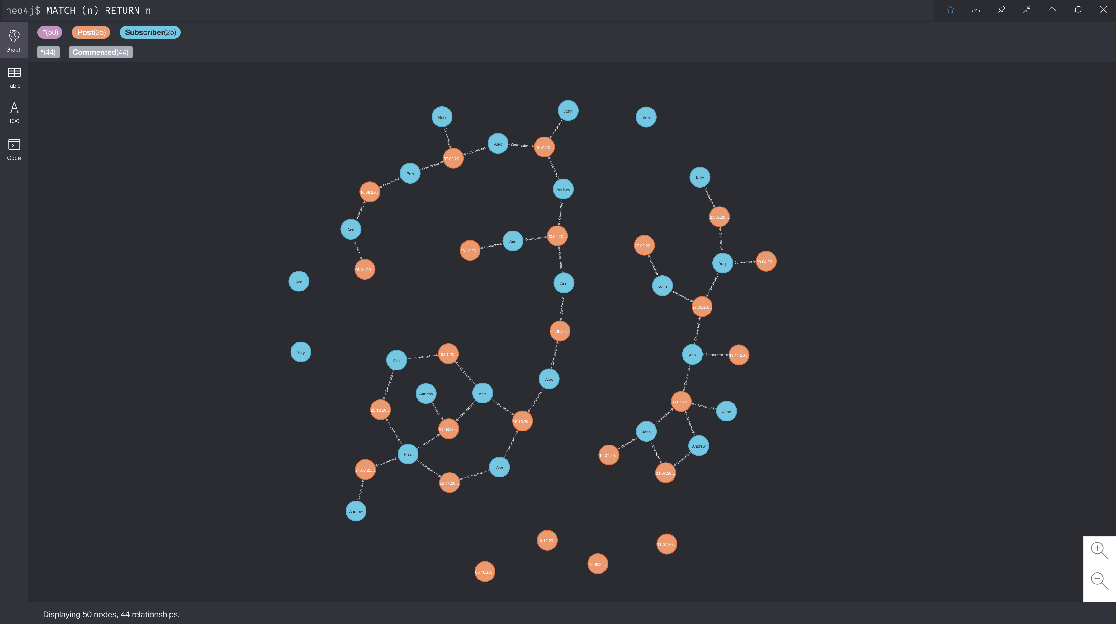

Рисунок 20 – Вывод всех объектов графовой БД

В табличном представлении данной диаграммы можно увидеть, что все свойства нод и отношений были сохранены корректно.

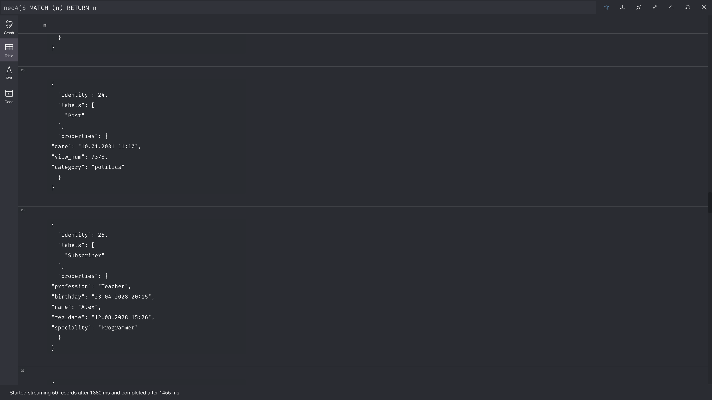

Рисунок 21 – табличное представление графовой БД

## 4.2 Запрос

По заданию курсового проекта необходимо написать следующий запрос: подписчики с каким родом занятий оставляют наибольшее число комментариев к постам.

Текст запроса на языке Cypher:

MATCH (s:Subscriber)-[r:Commented]->(c:Post)

RETURN s.profession AS profession, SUM(r.amount) AS sum  
ORDER BY sum DESC

Представленный запрос выбирает всех подписчиков, которые связаны с постами отношением комментирования, выводит профессии и сумму оставленных комментариев подписчиками данной профессии (группировка по профессии и агрегирующая функция суммирования). Результат выводится в порядке убывания суммы комментариев. Результат выполнения запроса представлен далее.

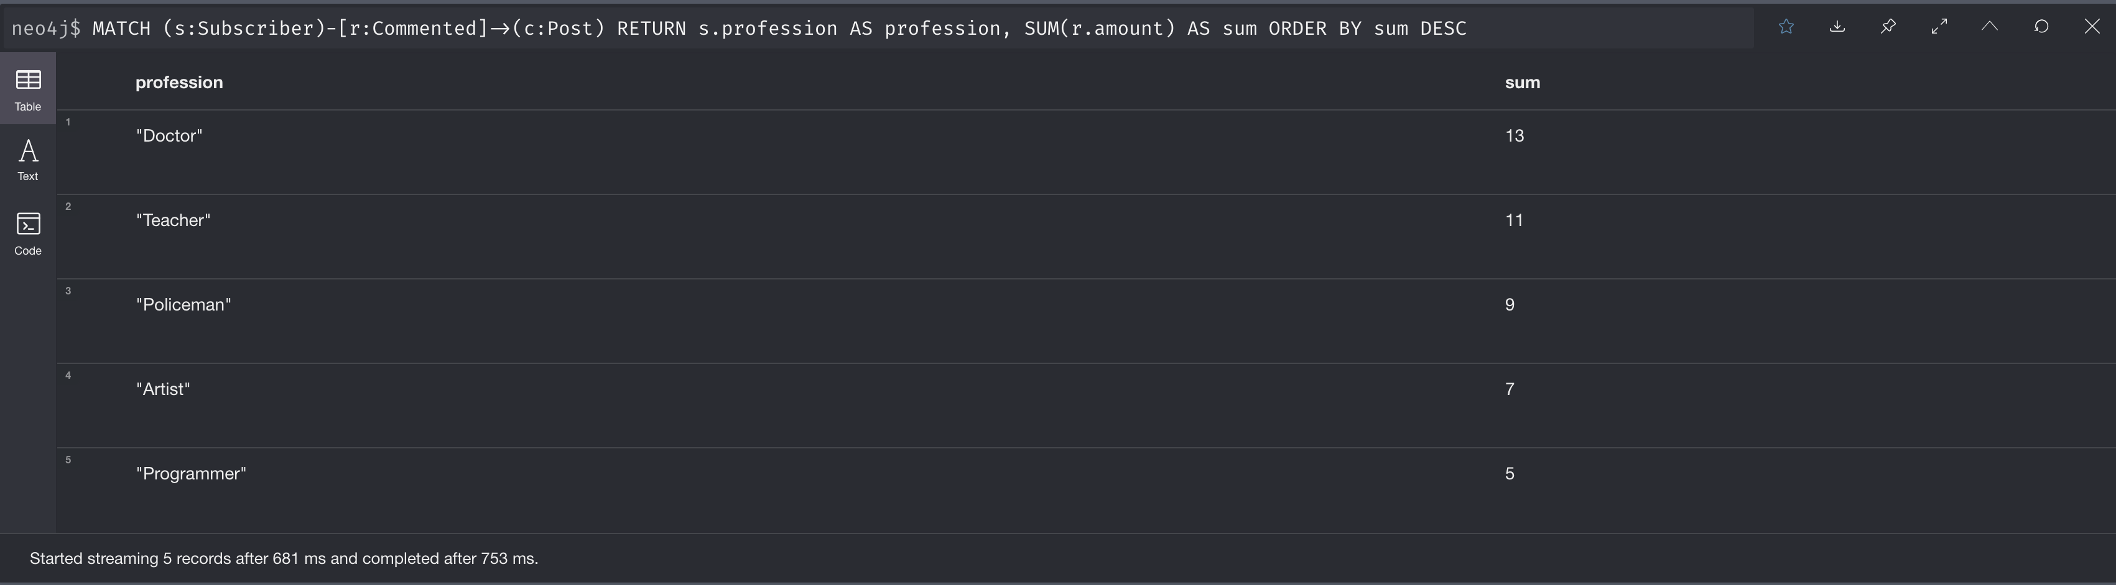

Рисунок 22 – Результат выполнения запроса

Данный запрос так же был выполнен из программы на языке Java. В результате выполнения программы в консоль был выведен следующий результат:

Profession : SUM

"Doctor" : 13

"Teacher" : 11

"Policeman" : 9

"Artist" : 7

"Programmer" : 5

# 5 Spark

## 5.1 Создание и заполнение таблиц

В соответствии с заданием курсового проекта необходимо сохранить посты, подписчиков и комментарии в csv файлы и загрузить их в файловую систему HDFS. Для создания csv файлов была написана программа на языке Java, алгоритм работы которой представлен на рисунке 23. Исходный код программы приведен в приложении Б (создание csv файлов).

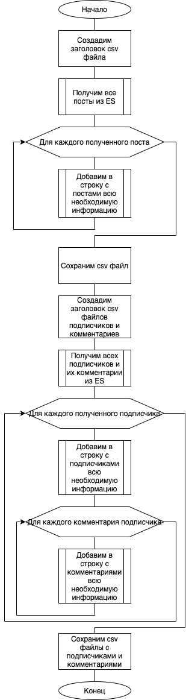

Рисунок 23 – Схема алгоритма создания csv файлов

В результате работы программы были созданы 3 csv файла, которые хранятся в корне проекта. Для переноса их на виртуальную машину воспользуемся командой scp.

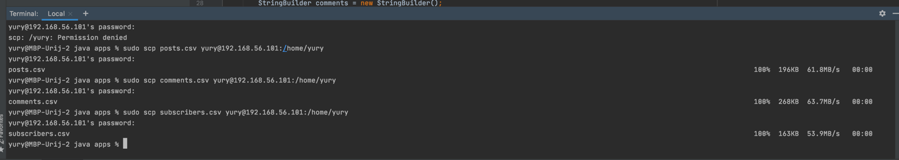

Рисунок 24 – Копирование csv файлов на виртуальную машину

Далее загрузим данные файлы в систему HDFS и проверим их наличие там.

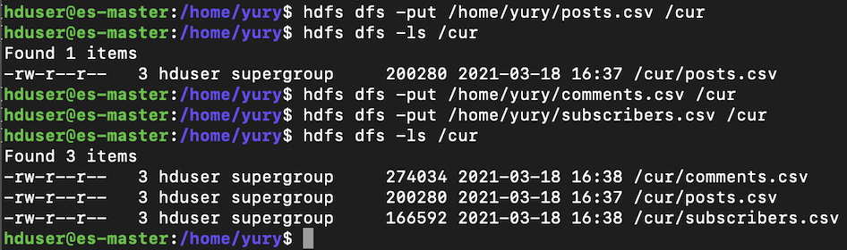

Рисунок 25 – Загрузка csv файлов в HDFS

## 5.2 Запрос

Требовалось реализовать следующий запрос: определить число комментариев к постам по датам их появления. Код запроса:

SELECT p.date AS postDate, COUNT(c.post\_id) AS cnt FROM posts p  
FULL JOIN comments c   
ON c.post\_id = p.id  
GROUP BY p.date  
ORDER BY cnt DESC

В запросе использован FULL JOIN для соединения таблиц, группировка по дате поста, агрегирующая функция COUNT по id поста из комментария для подсчета числа комментариев, сортировка по убыванию числа комментариев.

Для запуска данного запроса использовалась библиотека Spark для Java. Исходный код программы представлен в приложении Б (работа со Spark). После работы программы в интерфейсе master можно увидеть информацию о завершенных и выполненных программах. В информации о программе можно увидеть настройки ее запуска и какие ноды использовались для выполнения.

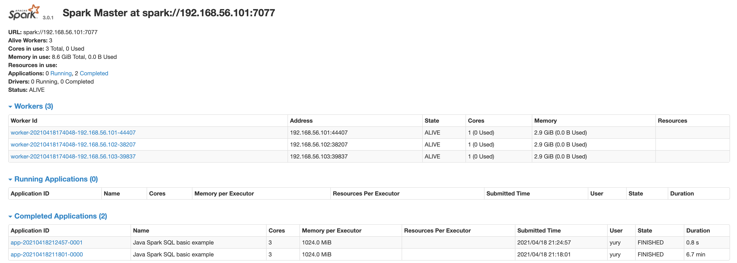

Рисунок 26 – Интерфейс Spark Master

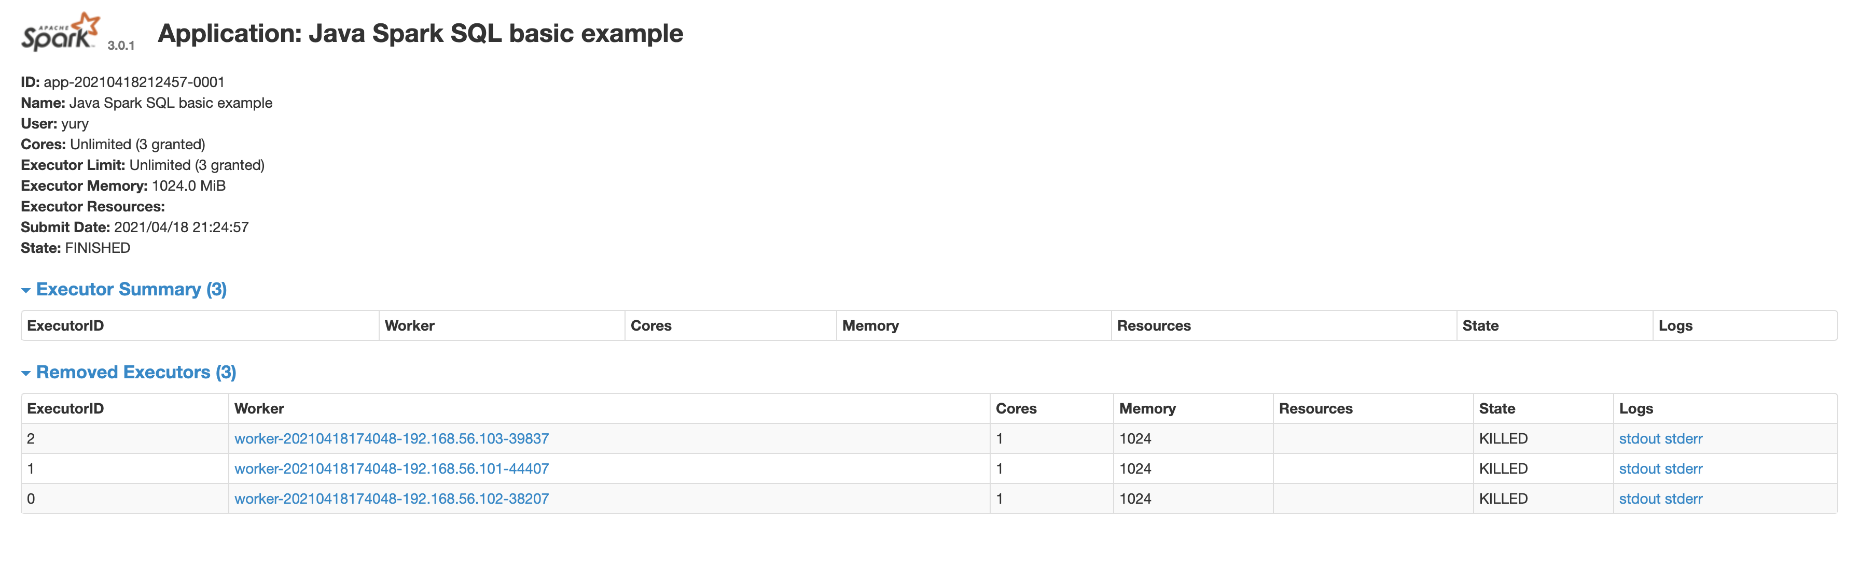

Рисунок 27 – Информация о выполненной программе

В результате выполнения программы был выведен полученный результат:

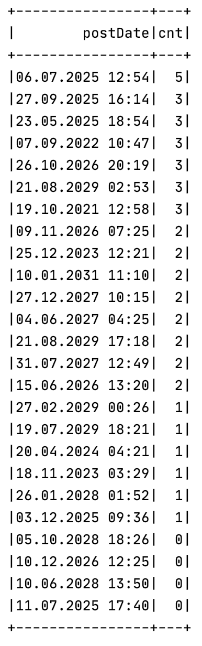

Рисунок 28 – Результат выполнения запроса

### 5.3 Монитор

Spark предоставляет графический интерфейс для мониторинга выполняемых задач. Он доступен в браузере по адресу http://192.168.56.101:4040. Монитор доступен только пока активна сессия Spark. В связи с тем, что библиотека для Java н позволяет запустить сессию так, чтобы данный монитор был активен, то воспользуемся командой для работы с языком scala непосредственно с виртуальной машины:

spark-shell --master spark://192.168.56.101:7077

К команде был добавлен параметр --master, чтобы spark запустился не в локальном режиме. Выполним код и не будем закрывать сессию, чтобы получить доступ к монитору.

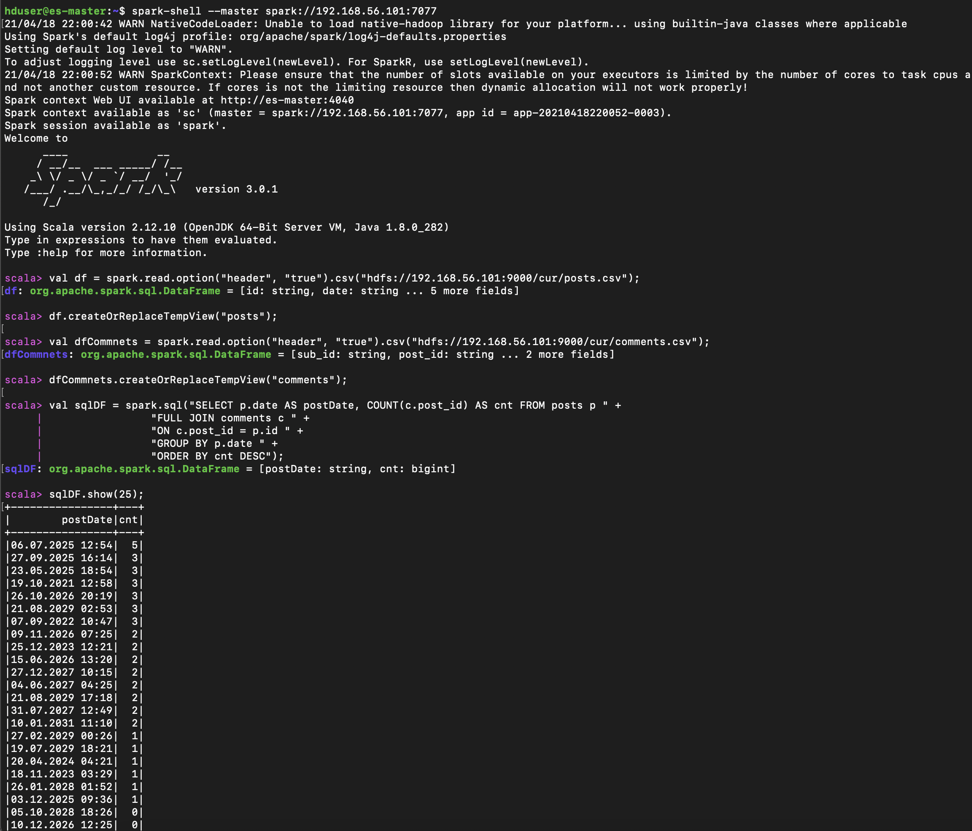

Рисунок 29 – Результат выполнения программы на языке scala

Во вкладке «Jobs» (рисунок 30) можно увидеть, какие процессы выполнялись сервером в какие промежутки времени. Как видно из графика, самым первым был запущен «Executor driver», который отвечает за запуск всех нод кластера для процесса. Далее были запущены все ноды. Оставшиеся 3 задания – непосредственно работа скрипта.

Во вкладке «Stages» (рисунок 31) можно получить информацию обо всех этапах, которые были выполнены в данной сессии, успешности задач данных этапов и объеме информации прочитанной и записанной в рамках выполнения операции.

В «Storage» сохраненные RDD (Resilient Distributed Datasets) и фреймы данных, сохраненные в памяти, если таковые имеются, в приложении. На сводной странице показаны уровни хранения, размеры и разделы всех RDD. В нашей программе RDD не использовались и фреймы данных в памяти не сохранялись, поэтому данная страница пуста. [15]

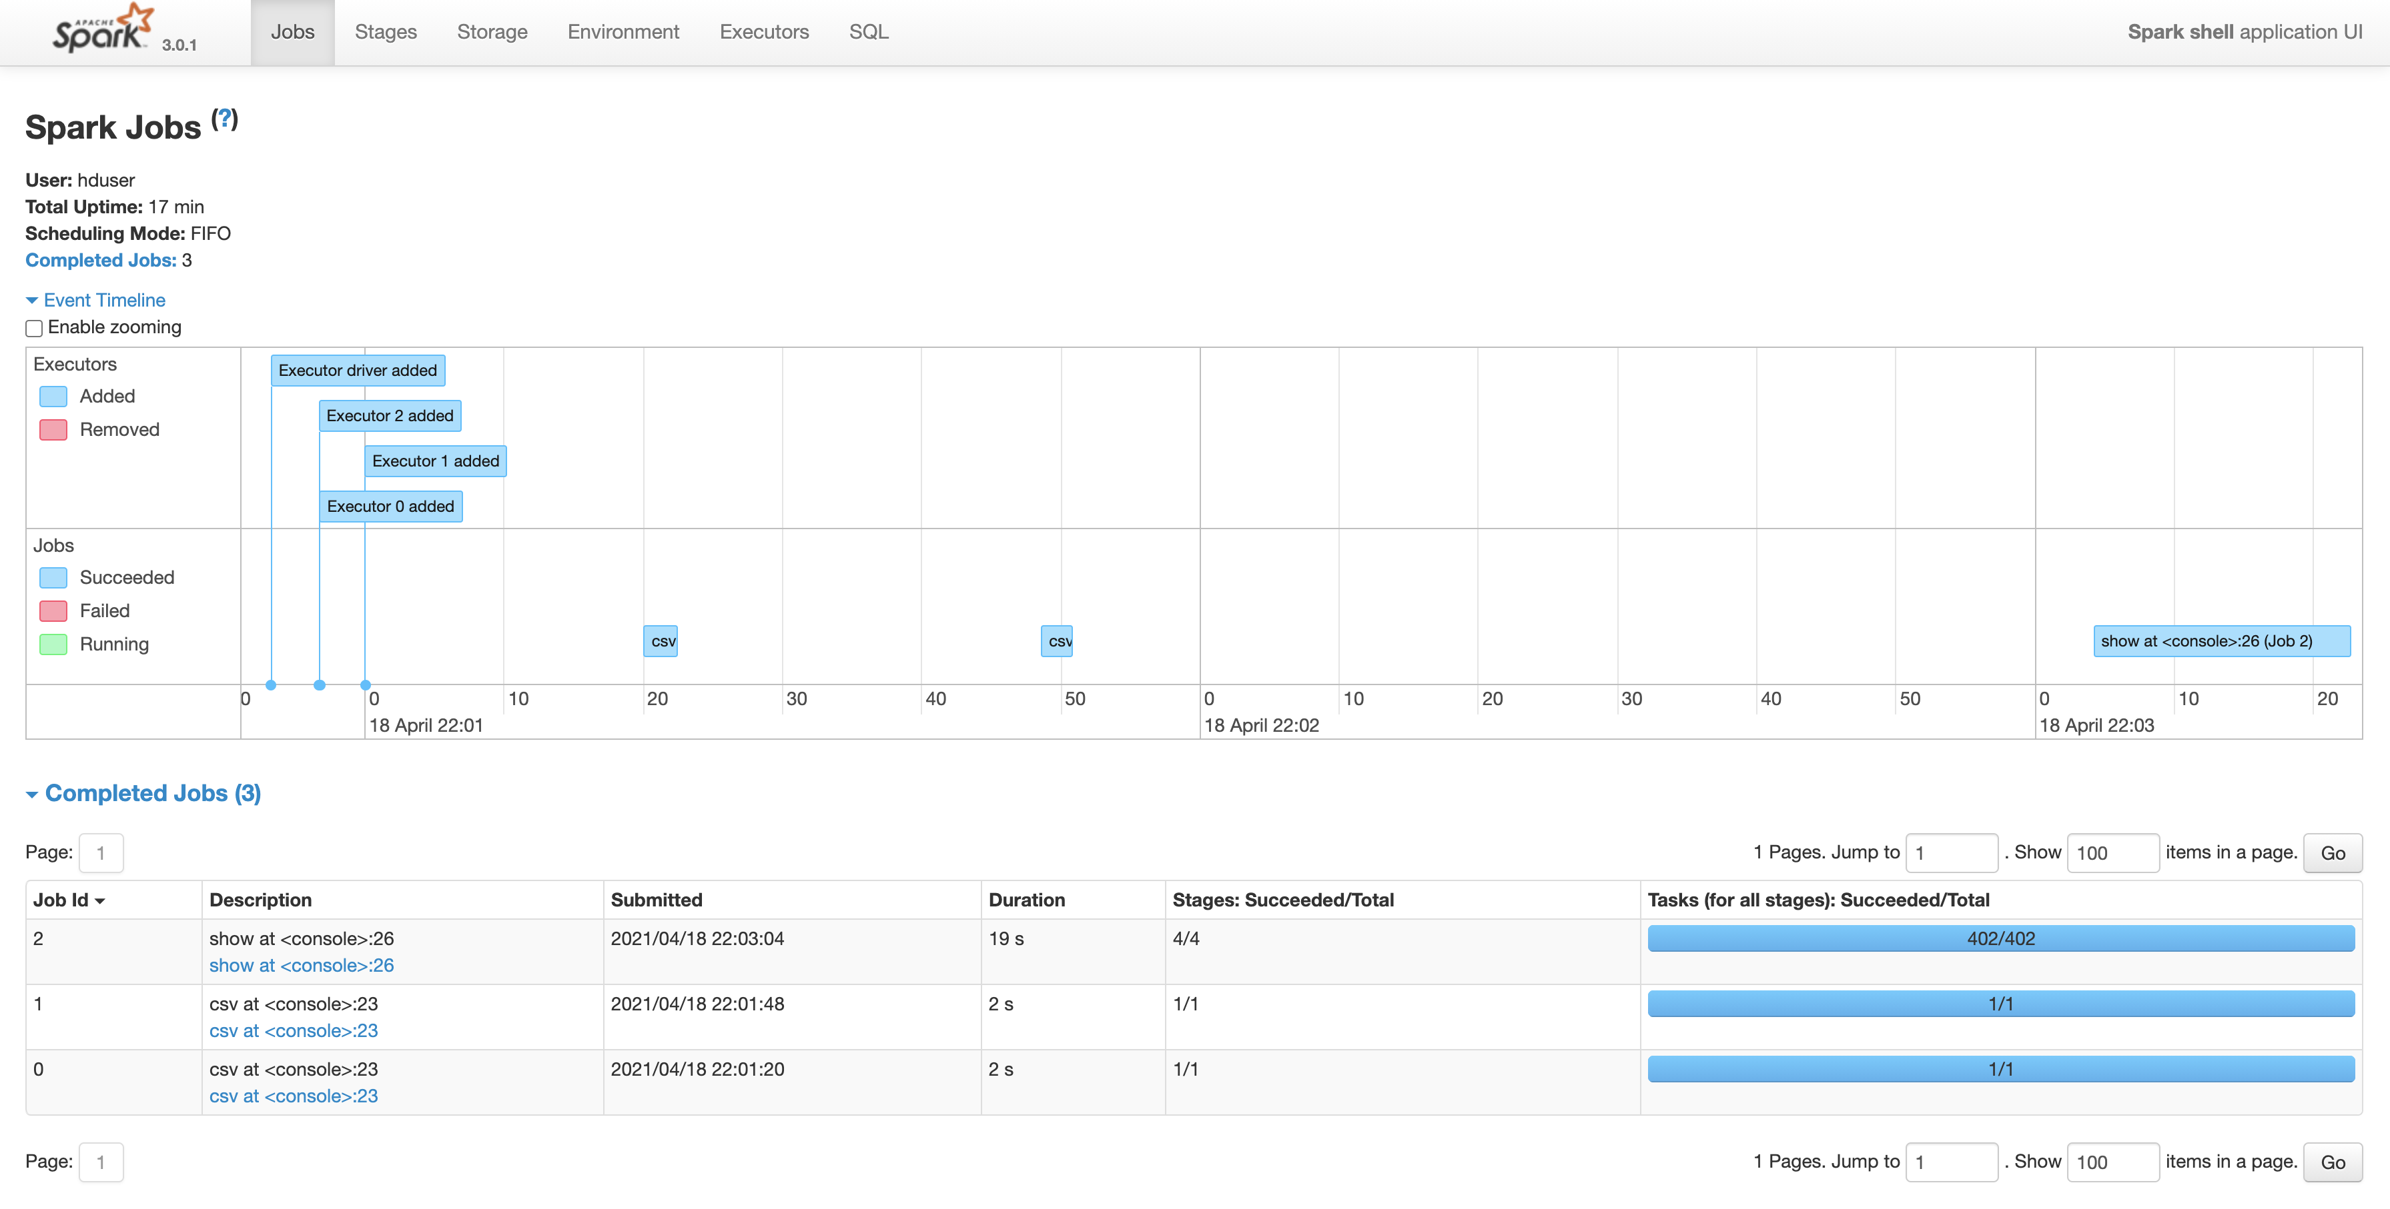

Рисунок 30 – Монитор Spark, Задания

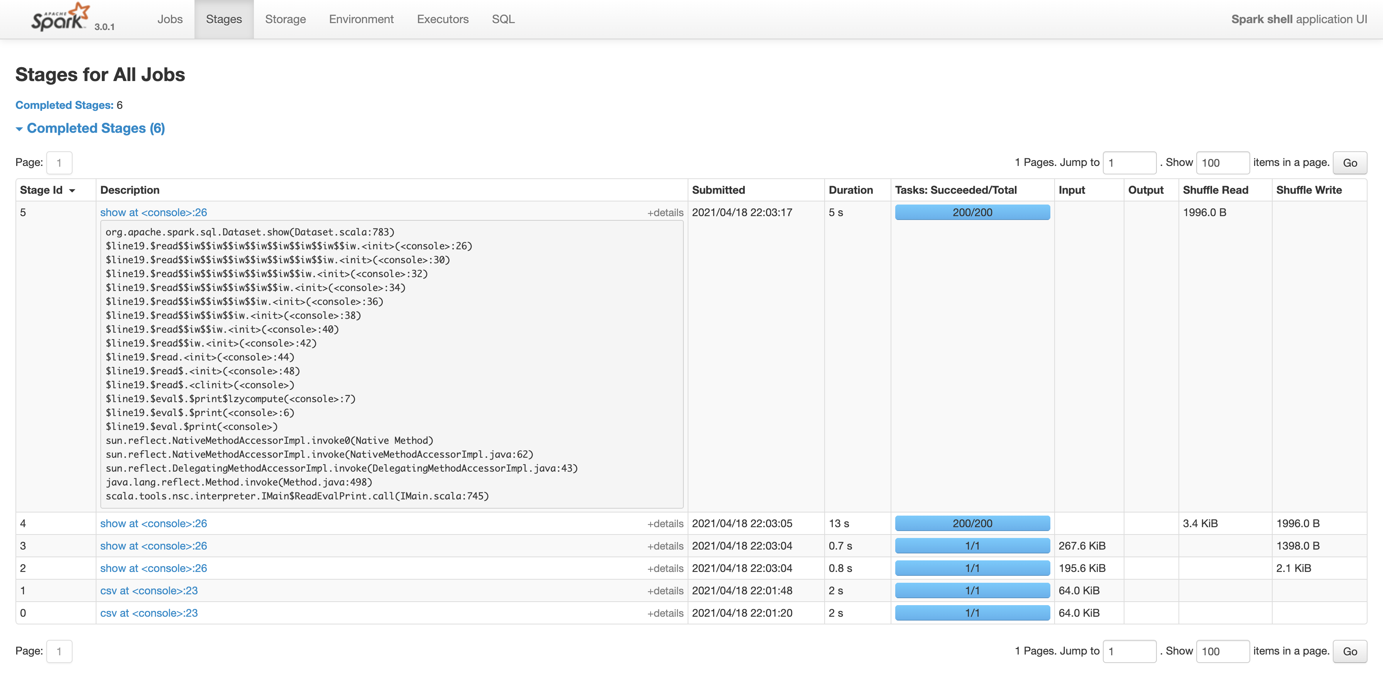

Рисунок 31 – Монитор Spark, Этапы

Во вкладке «Environment» содержится информация о параметрах запуска Spark, Hadoop и системы в целом.

Во вкладке «Executors» (рисунок 32) представлена информация об исполнителях для данной сессии. Здесь можно получить информацию о статусе исполнителя, используемой памяти, операциях чтения и записи, количестве задач.

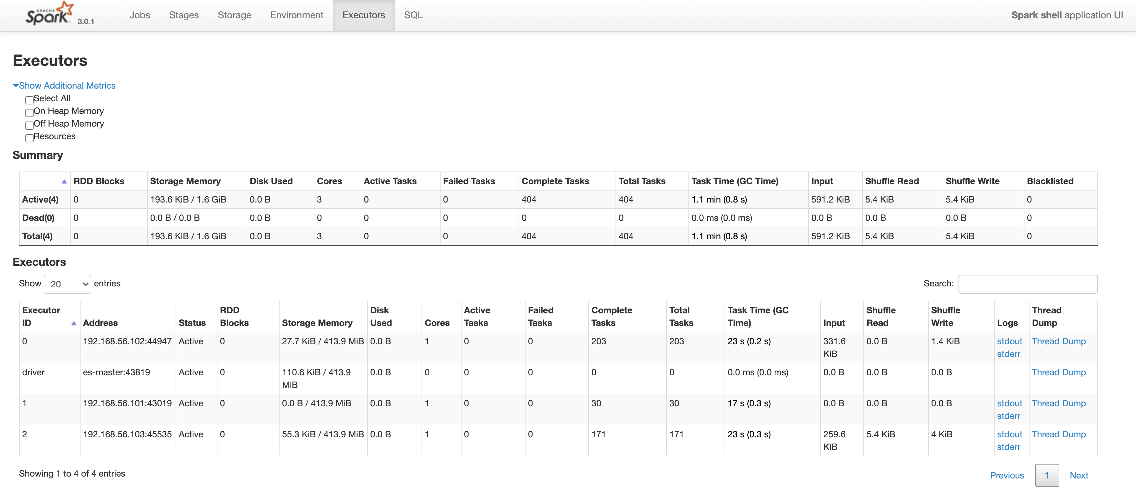

Рисунок 32 – Монитор Spark, Исполнители

Если приложение выполняет запросы Spark SQL, на вкладке «SQL» отображается такая информация, как продолжительность, задания, а также физические и логические планы для запросов.

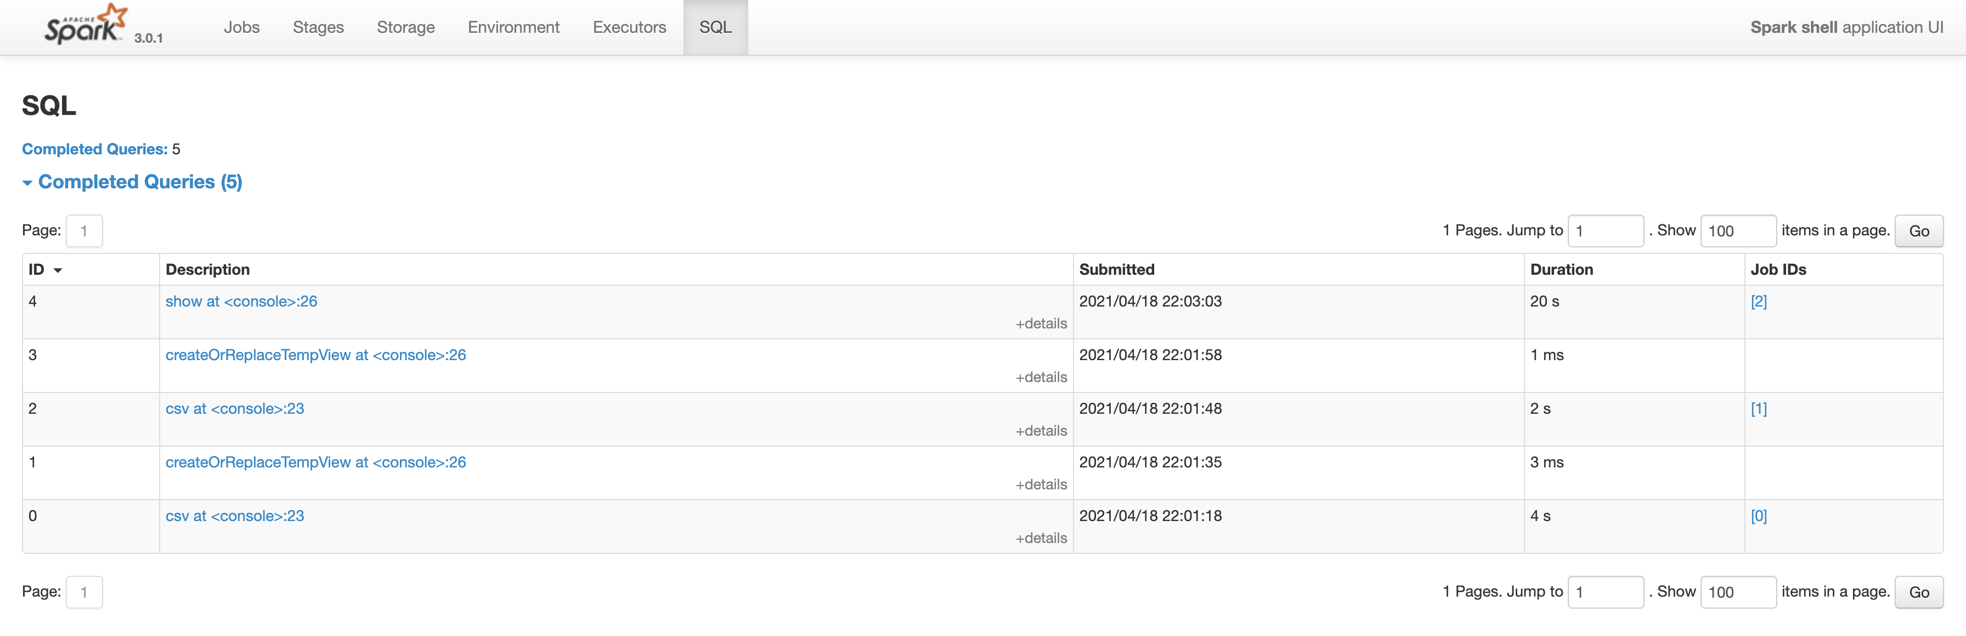

Рисунок 33 – Монитор Spark, SQL

Рассмотрим подробнее, план запроса, который был написан в предыдущем пункте. Для этого можно рассмотреть планы запроса и DAG (Directed Acyclic Graph). DAG, конечный граф без направленных циклов. С помощью DAG Spark оптимизирует план выполнения и минимизирует перемешивание.

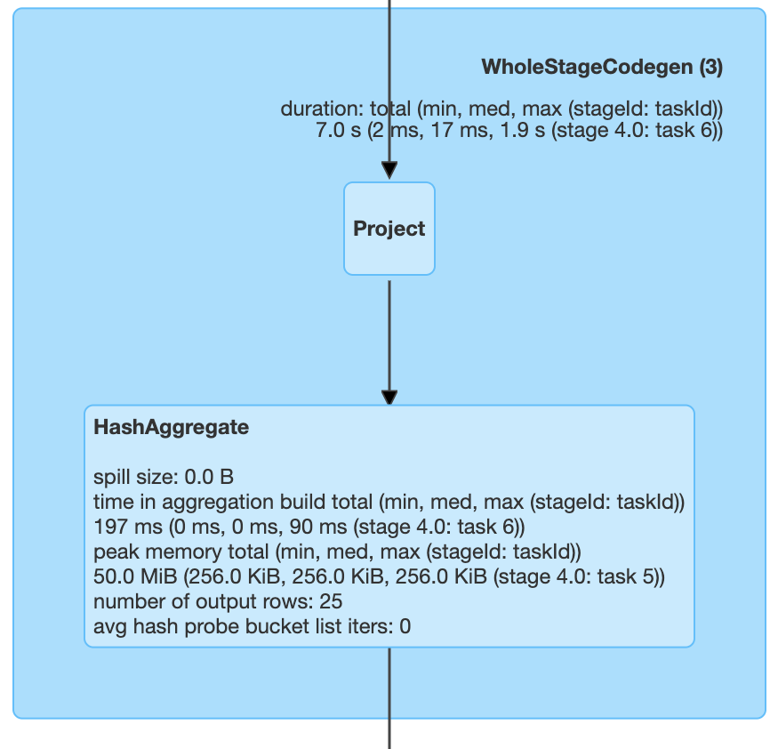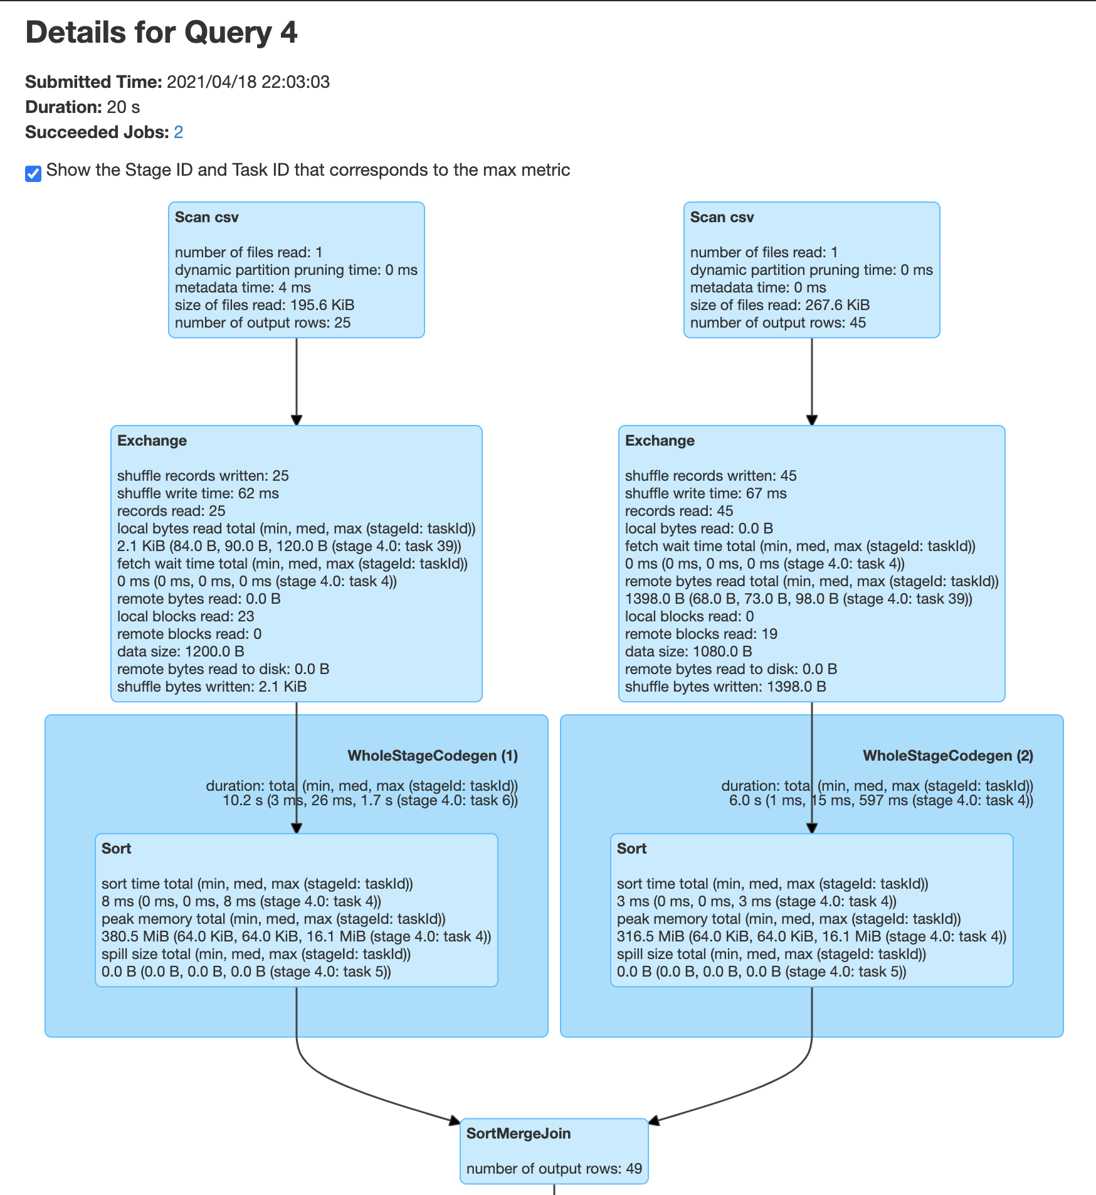

Рисунок 34 – DAG выполнения запроса

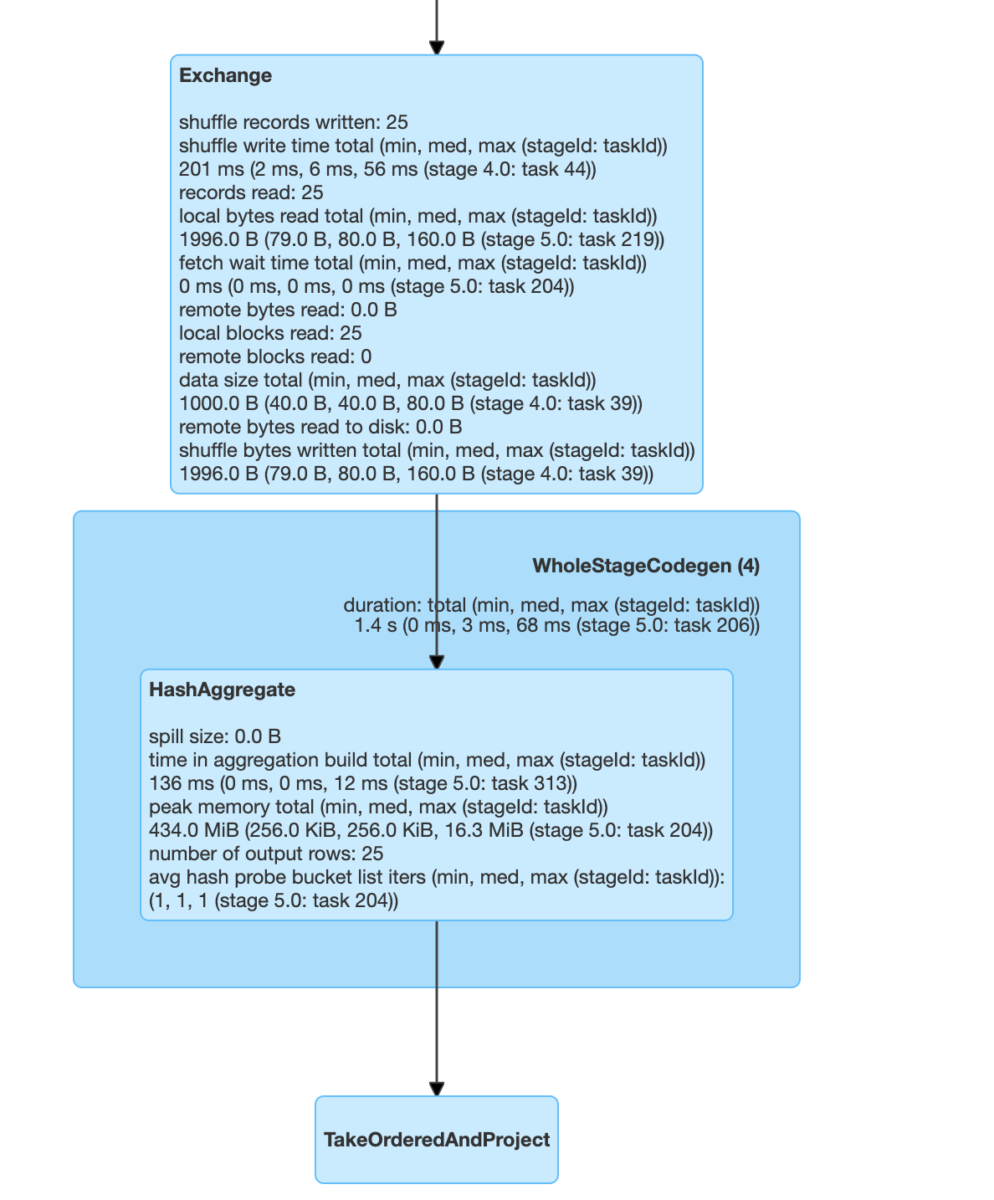

Рисунок 35 – DAG выполнения запроса (продолжение)

По данной диаграмме можно получить подробную информацию о каждом этапе выполнения запроса. Первый блок «Scan csv» отвечает за чтение данных из csv файла и показывает информацию и числе прочитанных файлов, времени, затраченном на эту операцию, времени, затраченном на чтение метаданных.

Второй блок «Exchange» показывает показатели обмена между процессами в случайном порядке, включая количество записанных записей, общий размер данных.

Блок «WholeStageCodegen» компилирует несколько операторов вместе в одну функцию Java для повышения производительности, такие показатели, как количество строк и размер блока, перечислены в информации о блоке.

Если открыть детали запроса, то можно увидеть различные этапы логического и физический этапы выполнения запроса.

«Sort» выполняет сортировку по определенному атрибуту. В нашем случае это происходит по полю ID поста, по которому будет происходить join.

Затем выполняется «SortMergeJoin», который соединяет два подзапроса в одну таблицу по ID поста.

Далее выполняется «HashAggregate». Эта операция вычисляет значение функции агрегации, в данном случае partial\_count, для разрозненных частей данных, который посчитает число строк в каждой из партиций. На следующем этапе уже будет применен обычный count, который объединит в себе значения каждой из партиций.

Последний этап, «TakeOrderedAndProject», выполняет сортировку данных по указанному атрибуту и проекцию на определенные атрибуты.

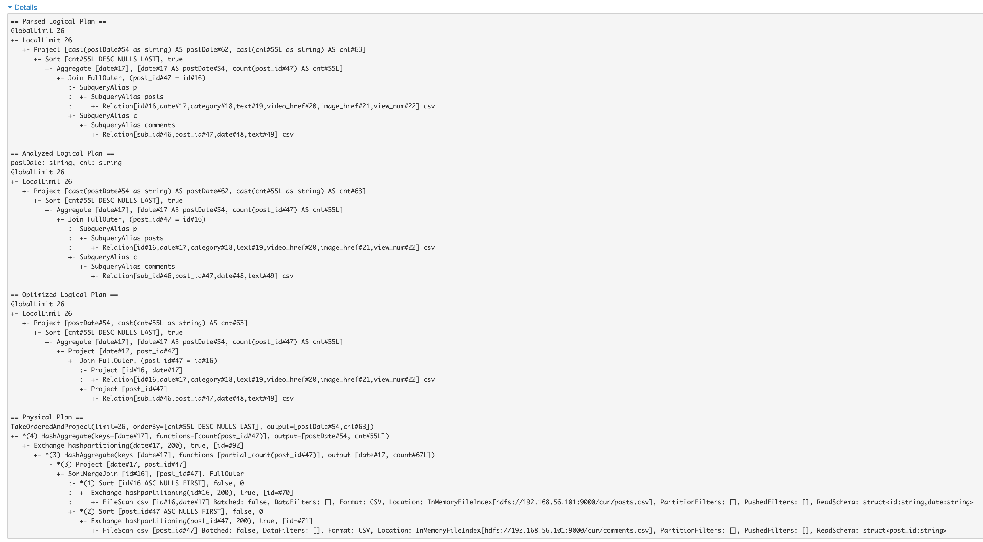

Рисунок 36 – Планы выполнения запросов

Метрики операторов SQL отображаются в блоке физических операторов. Метрики SQL могут быть полезны, когда мы хотим углубиться в детали выполнения каждого оператора. Например, «количество строк вывода» может отвечать, сколько строк выводится после оператора фильтра, «общее количество записанных байтов в случайном порядке» в операторе Exchange показывает количество байтов, записанных путем перемешивания. Далее представлена полная таблица таких метрик.

Таблица 3 – SQL метрики

|  |  |  |
| --- | --- | --- |
| SQL метрики | Значение | Операторы |
| number of output rows | количество строк вывода оператора | Aggregate operators, Join operators, Sample, Range, Scan operators, Filter, etc. |
| data size | размер транслируемых / перетасованных / собранных данных оператора | BroadcastExchange, ShuffleExchange, Subquery |
| time to collect | время, потраченное на сбор данных | BroadcastExchange, Subquery |
| scan time | время, потраченное на сканирование данных | ColumnarBatchScan, FileSourceScan |
| metadata time | время, потраченное на получение метаданных, таких как количество разделов, количество файлов | FileSourceScan |
| shuffle bytes written | количество записанных байтов | CollectLimit, TakeOrderedAndProject, ShuffleExchange |
| shuffle records written | количество записанных записей | CollectLimit, TakeOrderedAndProject, ShuffleExchange |
| shuffle write time | время, потраченное на перемешивание записи | CollectLimit, TakeOrderedAndProject, ShuffleExchange |
| remote blocks read | количество блоков, прочитанных удаленно | CollectLimit, TakeOrderedAndProject, ShuffleExchange |
| sort time | время, потраченное на сортировку | Sort |

Таблица 3 – SQL местрики (продолжение)

|  |  |  |
| --- | --- | --- |
| remote bytes read | количество байтов, прочитанных удаленно | CollectLimit, TakeOrderedAndProject, ShuffleExchange |
| remote bytes read to disk | количество байтов, прочитанных с удаленного на локальный диск | CollectLimit, TakeOrderedAndProject, ShuffleExchange |
| local blocks read | количество блоков, читаемых локально | CollectLimit, TakeOrderedAndProject, ShuffleExchange |
| local bytes read | количество байтов, прочитанных локально | CollectLimit, TakeOrderedAndProject, ShuffleExchange |
| fetch wait time | время, затраченное на получение данных (локальное и удаленное) | CollectLimit, TakeOrderedAndProject, ShuffleExchange |
| records read | количество прочитанных записей | CollectLimit, TakeOrderedAndProject, ShuffleExchange |
| peak memory | пиковое использование памяти в операторе | Sort, HashAggregate |
| spill size | количество байтов, сброшенных на диск из памяти в операторе | Sort, HashAggregate |
| time in aggregation build | время, затраченное на агрегацию | HashAggregate, ObjectHashAggregate |
| avg hash probe bucket list iters | среднее количество итераций по списку ведер на поиск во время агрегации | HashAggregate |
| data size of build side | размер построенной хеш-карты | ShuffledHashJoin |
| time to build hash map | время, потраченное на построение хеш-карты | ShuffledHashJoin |

# Заключение

В представленном курсовом проекте разработан макет аналитической системы предметной области «Блог» с использованием NoSQL баз данных Elasticsearch и Neo4j, а также связки систем Hadoop и Spark.

Необходимые программные компоненты установлены на виртуальные машину под управлением ОС Ubuntu с поддержкой кластерного режима. Было создано 3 аналогичных друг другу виртуальных машины, которые были объединены в кластер.

Данные для заполнения кластера ElasticSearch сгенерированы автоматически скриптом на языке Java. Для индексов документов в кластере ES разработаны маппинги и анализатор текстовых полей. Разработаны и реализованы запросы к данным с использованием вложенной агрегации. Результаты выполнения запросов представлены в среде Kibana.

Заполнение графовой БД Neo4j осуществлено данными из кластера ES. Созданы узлы типов «Подписчик» и «Пост» со связями «Комментировал» с соответствующими свойствами. Реализован запрос к графовой БД на языке Cypher. Результаты представлены в графическом интерфейсе Neo4j.

Данные из ES записаны в файловую систему HDFS в 3 CSV-файла. С помощью скриптов на языках Java и Scala реализован SQL-запрос. Разобраны этапы выполнения запроса и проведен анализ его выполнения с помощью монитора Spark.

# Список использованных источников

1. Neo4j – URL: https://ru.wikipedia.org/wiki/Neo4j (дата обращения 18.04.2021).

2. Hadoop – URL: https://ru.wikipedia.org/wiki/Hadoop (дата обращения 18.04.2021).

3. Apache Spark – URL: https://ru.wikipedia.org/wiki/Apache\_Spark (дата обращения 18.04.2021).

4. Neo4j Debian Packages – URL: https://debian.neo4j.com/?\_ga=2.67281361.1543671577.1613409219-341326928.1613409219 (дата обращения 18.04.2021).

5. Настройка кластера HADOOP – URL: https://xn---57-qdd4aqo.xn--p1ai/pages/aadress.php?page=482 (дата обращения 18.04.2021).

6. Apache Spark установка, настройка, запуск скриптов – URL: https://xn---57-qdd4aqo.xn--p1ai/pages/aadress.php?page=497#razdel2 (дата обращения 18.04.2021).

7. FasterXML/jackson-docs – URL: https://github.com/FasterXML/jackson-docs (дата обращения 18.04.2021).

8. Convert JSON to POJO Objects in Java Online – URL: https://json2csharp.com/json-to-pojo (дата обращения 18.04.2021).

9. Anatomy of an analyzer – URL: https://www.elastic.co/guide/en/elasticsearch/reference/current/analyzer-anatomy.html (дата обращения 18.04.2021).

10. Algorithmic stemmers – URL: https://www.elastic.co/guide/en/elasticsearch/reference/current/stemming.html#algorithmic-stemmers (дата обращения 18.04.2021).

11. – URL: https://www.elastic.co/guide/en/elasticsearch/reference/current/mapping-types.html (дата обращения 18.04.2021).

12. Field data types – URL: https://www.elastic.co/guide/en/elasticsearch/reference/current/search-aggregations-bucket-datehistogram-aggregation.html (дата обращения 18.04.2021).

13. Terms aggregation – URL: https://www.elastic.co/guide/en/elasticsearch/reference/current/search-aggregations-bucket-terms-aggregation.html (дата обращения 18.04.2021).

14. Nested aggregation – URL: https://www.elastic.co/guide/en/elasticsearch/reference/current/search-aggregations-bucket-nested-aggregation.html (дата обращения 18.04.2021).

15. Web UI – URL: https://spark.apache.org/docs/3.0.0-preview/web-ui.html (дата обращения 18.04.2021).

# Приложение А

Примеры исходных данных

Посты (4 шт.):

[ {  
 "index" : "post",  
 "doc\_type" : "post",  
 "id" : 0,  
 "body" : {  
 "date" : "05.10.2028 18:26",  
 "category" : "news",  
 "text" : " up free association, beginning with whatever I first saw. The book I had with me was a collection of the Gilbert and Sullivan plays. I happened to open it to the picture of the Fairy Queen of lolanthe throwing herself at the feet of Private Willis. I thought of soldiers, of military empires, of the Roman Empire - of a Galactic Empire - aha!\r \r Why shouldn't I write of the fall of the Galactic Empire and of the return of feudalism, written from the viewpoint of someone in the secure days of the Second Galactic Empire? After all, I had read Gibbon's Decline and Fall of the Roman Empire not once, but twice.\r \r I was bubbling over by the time I got to Campbell's, and my enthusiasm must have been catching for Campbell blazed up as I had never seen him do. In the course of an hour we built up the notion of a vast series of connected stories that were to deal in intricate detail with the thousand-year period between the First and Second Galactic Empires. This was to be illuminated by the science of psychohistory, which Campbell and I thrashed out between us.\r \r On August 11, 1941, therefore, I began the story of that interregnum and called it \"Foundation.\" In it, I described how the psychohistorian, Hari Seldon, established a pair of Foundations at opposite ends of the Universe under such circumstances as to make sure that the forces of history would bring about the second Empire after one thousand years instead of the thirty thousand that would be required otherwise.\r \r The story was submitted on September 8 and, to make sure that Campbell really meant what he said about a series, I ended \"Foundation\" on a cliff-hanger. Thus, it seemed to me, he would be forced to buy a second story.\r \r However, when I started the second story (on October 24), I found that I had outsmarted myself. I quickly wrote myself into an impasse, and the Foundation series would have died an ignominious death had I not had a conversation with Fred Pohl on November 2 (on the Brooklyn Bridge, as it happened). I don't remember what Fred actually said, but, whatever it was, it pulled me out of the hole.\r \r \"Foundation\" appeared in the May 1942 issue of Astounding and the succeeding story, \"Bridle and Saddle,\" in the June 1942 issue.\r \r After that there was only the routine trouble of writing the stories. Through the remainder of the decade, John Campbell kept my nose to the grindstone and made sure he got additional Foundation stories.\r \r \"The Big and the Little\" was in the August 1944 Astounding, \"The Wedge\" in the October 1944 issue, and \"Dead Hand\" in the April 1945 issue. (These stories were written while I was working at the Navy Yard in Philadelphia.)\r \r On January 26, 1945, I began \"The Mule,\" my personal favorite among the Foundation stories, and the longest yet, for it was 50,000 words. It was printed as a two-part serial (the very first serial I was ever responsible for) in the November and December 1945 issues. By the time the second part appeared I was in the army.\r \r After I got out of the army, I wrote \"Now You See It-\" which appeared in the January 1948 issue. By this time, though, I had grown tired of the Foundation stories so I tried to end them by setting up, and solving, the mystery of the location of the Second Foundation. Campbell would have none of that, however. He forced me to change the ending, and made me promise I would do one more Foundation story.\r \r Well, Campbell was the kind of editor who could not be denied, so I wrote one more Foundation story, vowing to myself that it would be the last. I called it \"-And Now You Don't,\" and it appeared as a three-part serial in the November 1949, December 1949, and January 1950 issues of Astounding.\r \r By then, I was on the biochemistry faculty of Boston University School of Medicine, my first book had just been published, and I was determined to move on to new things. I had spent eight years on the Foundation, written nine stories with a total of about 220,000 words. My total earnings for the series came to $3,641 and that seemed enough. The Foundation was over and done with, as far as I was concerned.\r \r In 1950, however, hardcover science fiction was just coming into existence. I had no objection to earning a little more money by having the Foundation series reprinted in book form. I offered the series to Doubleday (which had already published a science-fiction novel by me, and which had contracted for another) and to Little-Brown, but both rejected it. In that year, though, a small publishing firm, Gnome Press, was beginning to be active, and it was prepared to do the Foundation series as three books.\r \r The publisher of Gnome felt, however, that the series began too abruptly. He persuaded me to write a small Foundation story, one that would serve as an introductory section to the first book (so that the first part of the Foundation series was the last written).\r \r In 1951, the Gnome Press edition of Foundation was published, containing the introduction and the first four stories of the series. In 1952, Foundation and Empire appeared, with the fifth and sixth stories; and in 1953, Second Foundation appeared, with the seventh and eighth stories. The three books together came to be called The Foundation Trilogy.\r \r The mere fact of the existence of the Trilogy pleased me, but Gnome Press did not have the financial clout or the publishing knowhow to get the books distributed properly, so that few copies were sold and fewer still paid me royalties. (Nowadays, copies of first editions of those Gnome Press books sell at $50 a copy and up-but I still get no royalties from them.)\r \r Ace Books did put out paperback editions of Foundation and of Foundation and Empire, but they changed the titles, and used cut versions. Any money that was involved was paid to Gnome Press and I didn't see much of that. In the first decade of the existence of The Foundation Trilogy it may have earned something like $1500 total.\r \r And yet there was some foreign interest. In early 1961, Timothy Seldes, who was then my editor at Doubleday, told me that Doubleday had received a request for the Portuguese rights for the Foundation series and, since they weren't Doubleday books, he was passing them on to me. I sighed and said, \"The heck with it, Tim. I don't get royalties on those books.\"\r \r Seldes was horrified, and instantly set about getting the books away from Gnome Press so that Doubleday could publish them instead. He paid no attention to my loudly expressed fears that Doubleday \"would lose its shirt on them.\" In August 1961 an",  
 "video-href" : "https://rTgoNEeUtrGiJQtQgebRlUyVCLgpkzOCJHZTURZzTCaIdKQemx.ru",  
 "image-href" : "https://nAiGJcQAXxPjuhLOoZpIeIjrLBrEoaxGKTvndIVyPsdOxlHLWl.ru",  
 "view-num" : 2588  
 }  
}, {  
 "index" : "post",  
 "doc\_type" : "post",  
 "id" : 1,  
 "body" : {  
 "date" : "10.06.2028 13:50",  
 "category" : "education",  
 "text" : "xistence. I had no objection to earning a little more money by having the Foundation series reprinted in book form. I offered the series to Doubleday (which had already published a science-fiction novel by me, and which had contracted for another) and to Little-Brown, but both rejected it. In that year, though, a small publishing firm, Gnome Press, was beginning to be active, and it was prepared to do the Foundation series as three books.\r \r The publisher of Gnome felt, however, that the series began too abruptly. He persuaded me to write a small Foundation story, one that would serve as an introductory section to the first book (so that the first part of the Foundation series was the last written).\r \r In 1951, the Gnome Press edition of Foundation was published, containing the introduction and the first four stories of the series. In 1952, Foundation and Empire appeared, with the fifth and sixth stories; and in 1953, Second Foundation appeared, with the seventh and eighth stories. The three books together came to be called The Foundation Trilogy.\r \r The mere fact of the existence of the Trilogy pleased me, but Gnome Press did not have the financial clout or the publishing knowhow to get the books distributed properly, so that few copies were sold and fewer still paid me royalties. (Nowadays, copies of first editions of those Gnome Press books sell at $50 a copy and up-but I still get no royalties from them.)\r \r Ace Books did put out paperback editions of Foundation and of Foundation and Empire, but they changed the titles, and used cut versions. Any money that was involved was paid to Gnome Press and I didn't see much of that. In the first decade of the existence of The Foundation Trilogy it may have earned something like $1500 total.\r \r And yet there was some foreign interest. In early 1961, Timothy Seldes, who was then my editor at Doubleday, told me that Doubleday had received a request for the Portuguese rights for the Foundation series and, since they weren't Doubleday books, he was passing them on to me. I sighed and said, \"The heck with it, Tim. I don't get royalties on those books.\"\r \r Seldes was horrified, and instantly set about getting the books away from Gnome Press so that Doubleday could publish them instead. He paid no attention to my loudly expressed fears that Doubleday \"would lose its shirt on them.\" In August 1961 an agreement was reached and the Foundation books became Doubleday property. What's more, Avon Books, which had published a paperback version of Second Foundation, set about obtaining the rights to all three from Doubleday, and put out nice editions.\r \r From that moment on, the Foundation books took off and began to earn increasing royalties. They have sold well and steadily, both in hardcover and softcover, for two decades so far. Increasingly, the letters I received from the readers spoke of them in high praise. They received more attention than all my other books put together.\r \r Doubleday also published an omnibus volume, The Foundation Trilogy, for its Science Fiction Book Club. That omnibus volume has been continuously featured by the Book Club for over twenty years.\r \r Matters reached a climax in 1966. The fans organizing the World Science Fiction Convention for that year (to be held in Cleveland) decided to award a Hugo for the best all-time series, where the series, to qualify, had to consist of at least three connected novels. It was the first time such a category had been set up, nor has it been repeated since. The Foundation series was nominated, and I felt that was going to have to be glory enough for me, since I was sure that Tolkien's \"Lord of the Rings\" would win.\r \r It didn't. The Foundation series won, and the Hugo I received for it has been sitting on my bookcase in the livingroom ever since.\r \r In among all this litany of success, both in money and in fame, there was one annoying side-effect. Readers couldn't help but notice that the books of the Foundation series covered only three hundred-plus years of the thousand-year hiatus between Empires. That meant the Foundation series \"wasn't finished.\" I got innumerable letters from readers who asked me to finish it, from others who demanded I finish it, and still others who threatened dire vengeance if I didn't finish it. Worse yet, various editors at Doubleday over the years have pointed out that it might be wise to finish it.\r \r It was flattering, of course, but irritating as well. Years had passed, then decades. Back in the 1940s, I had been in a Foundation-writing mood. Now I wasn't. Starting in the late 1950s, I had been in a more and more nonfiction-writing mood.\r \r That didn't mean I was writing no fiction at all. In the 1960s and 1970s, in fact, I wrote two science-fiction novels and a mystery novel, to say nothing of well over a hundred short stories - but about eighty percent of what I wrote was nonfiction.\r \r One of the most indefatigable nags in the matter of finishing the Foundation series was my good friend, the great science-fiction writer, Lester del Rey. He was constantly telling me I ought to finish the series and was just as constantly suggesting plot devices. He even told Larry Ashmead, then my editor at Doubleday, that if I refused to write more Foundation stories, he, Lester, would be willing to take on the task.\r \r When Ashmead mentioned this to me in 1973, I began another Foundation novel out of sheer desperation. I called it \"Lightning Rod\" and managed to write fourteen pages before other tasks called me away. The fourteen pages were put away and additional years passed.\r \r In January 1977, Cathleen Jordan, then my editor at Doubleday, suggested I do \"an important book - a Foundation novel, perhaps.\" I said, \"I'd rather do an autobiography,\" and I did - 640,000 words of it.\r \r In January 1981, Doubleday apparently lost its temper. At least, Hugh O'Neill, then my editor there, said, \"Betty Prashker wants to see you,\" and marched me into her office. She was then one of the senior editors, and a sweet and gentle person.\r \r She wasted no time. \"Isaac,\" she said, \"you are going to write a novel for us and you are going to sign a contract to that effect.\"\r \r \"Betty,\" I said, \"I am already working on a big science book for Doubleday and I have to revise the Biographical Encyclopedia for Doubleday and -\"\r \r \"It can all wait,\" she said. \"You are going to sign a contract to do a novel. What's more, we're going to give you a $50,000 advance.\"\r \r That was a stunner. I don't like large advances. They put me under too great an obligation. My average advance is something like $3,000. Why not? It's all out of royalties.\r \r I said, \"That's way too much money, Betty.\"\r \r \"No, it isn't,\" she said.\r \r \"Doubleday will lose its shirt,\" I said.\r \r \"You keep telling us that all the time. It won't.\"\r \r I said, desperately, \"All right. Have the contract read that I don't get any money until I notify you in writing that I have begun the novel.\"\r \r \"Are you crazy?\" she said. \"You'll never start if that clause is in the contract. You get $25,000 on signing the contract, and $25,000 on delivering a completed manuscript.\"\r \r \"But suppose the novel is no good.\"\r \r \"Now you're being silly,\" she said, and she ended the conversation.\r \r That night, Pat LoBrutto, the science-fiction editor at Doubleday called to express his pleasure. \"And remember,\" he said, \"that when we say 'novel' we mean 'science-fiction novel,' not anything else. And when we say 'science-fiction novel,' we mean 'Foundation novel' and not anything else.\"\r \r On February 5, 1981, I signed the contract, and within the week, the Doubleday accounting system cranked out the check for $25,000.\r \r I moaned that I was not my own master anymore and Hugh O'Neill sa",  
 "video-href" : "https://TkztmJtHqiIOghyzhXWClpeHhspYejNYdnpDAgcnMrJnienhoH.ru",  
 "image-href" : "https://enkYoNtrTbyTNPzCVdmfeojZDmrBXGANpXyXRuwOayVbHwlrmw.ru",  
 "view-num" : 1193  
 }  
}, {  
 "index" : "post",  
 "doc\_type" : "post",  
 "id" : 2,  
 "body" : {  
 "date" : "10.12.2026 12:25",  
 "category" : "technology",  
 "text" : "ory was submitted on September 8 and, to make sure that Campbell really meant what he said about a series, I ended \"Foundation\" on a cliff-hanger. Thus, it seemed to me, he would be forced to buy a second story.\r \r However, when I started the second story (on October 24), I found that I had outsmarted myself. I quickly wrote myself into an impasse, and the Foundation series would have died an ignominious death had I not had a conversation with Fred Pohl on November 2 (on the Brooklyn Bridge, as it happened). I don't remember what Fred actually said, but, whatever it was, it pulled me out of the hole.\r \r \"Foundation\" appeared in the May 1942 issue of Astounding and the succeeding story, \"Bridle and Saddle,\" in the June 1942 issue.\r \r After that there was only the routine trouble of writing the stories. Through the remainder of the decade, John Campbell kept my nose to the grindstone and made sure he got additional Foundation stories.\r \r \"The Big and the Little\" was in the August 1944 Astounding, \"The Wedge\" in the October 1944 issue, and \"Dead Hand\" in the April 1945 issue. (These stories were written while I was working at the Navy Yard in Philadelphia.)\r \r On January 26, 1945, I began \"The Mule,\" my personal favorite among the Foundation stories, and the longest yet, for it was 50,000 words. It was printed as a two-part serial (the very first serial I was ever responsible for) in the November and December 1945 issues. By the time the second part appeared I was in the army.\r \r After I got out of the army, I wrote \"Now You See It-\" which appeared in the January 1948 issue. By this time, though, I had grown tired of the Foundation stories so I tried to end them by setting up, and solving, the mystery of the location of the Second Foundation. Campbell would have none of that, however. He forced me to change the ending, and made me promise I would do one more Foundation story.\r \r Well, Campbell was the kind of editor who could not be denied, so I wrote one more Foundation story, vowing to myself that it would be the last. I called it \"-And Now You Don't,\" and it appeared as a three-part serial in the November 1949, December 1949, and January 1950 issues of Astounding.\r \r By then, I was on the biochemistry faculty of Boston University School of Medicine, my first book had just been published, and I was determined to move on to new things. I had spent eight years on the Foundation, written nine stories with a total of about 220,000 words. My total earnings for the series came to $3,641 and that seemed enough. The Foundation was over and done with, as far as I was concerned.\r \r In 1950, however, hardcover science fiction was just coming into existence. I had no objection to earning a little more money by having the Foundation series reprinted in book form. I offered the series to Doubleday (which had already published a science-fiction novel by me, and which had contracted for another) and to Little-Brown, but both rejected it. In that year, though, a small publishing firm, Gnome Press, was beginning to be active, and it was prepared to do the Foundation series as three books.\r \r The publisher of Gnome felt, however, that the series began too abruptly. He persuaded me to write a small Foundation story, one that would serve as an introductory section to the first book (so that the first part of the Foundation series was the last written).\r \r In 1951, the Gnome Press edition of Foundation was published, containing the introduction and the first four stories of the series. In 1952, Foundation and Empire appeared, with the fifth and sixth stories; and in 1953, Second Foundation appeared, with the seventh and eighth stories. The three books together came to be called The Foundation Trilogy.\r \r The mere fact of the existence of the Trilogy pleased me, but Gnome Press did not have the financial clout or the publishing knowhow to get the books distributed properly, so that few copies were sold and fewer still paid me royalties. (Nowadays, copies of first editions of those Gnome Press books sell at $50 a copy and up-but I still get no royalties from them.)\r \r Ace Books did put out paperback editions of Foundation and of Foundation and Empire, but they changed the titles, and used cut versions. Any money that was involved was paid to Gnome Press and I didn't see much of that. In the first decade of the existence of The Foundation Trilogy it may have earned something like $1500 total.\r \r And yet there was some foreign interest. In early 1961, Timothy Seldes, who was then my editor at Doubleday, told me that Doubleday had received a request for the Portuguese rights for the Foundation series and, since they weren't Doubleday books, he was passing them on to me. I sighed and said, \"The heck with it, Tim. I don't get royalties on those books.\"\r \r Seldes was horrified, and instantly set about getting the books away from Gnome Press so that Doubleday could publish them instead. He paid no attention to my loudly expressed fears that Doubleday \"would lose its shirt on them.\" In August 1961 an agreement was reached and the Foundation books became Doubleday property. What's more, Avon Books, which had published a paperback version of Second Foundation, set about obtaining the rights to all three from Doubleday, and put out nice editions.\r \r From that moment on, the Foundation books took off and began to earn increasing royalties. They have sold well and steadily, both in hardcover and softcover, for two decades so far. Increasingly, the letters I received from the readers spoke of them in high praise. They received more attention than all my other books put together.\r \r Doubleday also published an omnibus volume, The Foundation Trilogy, for its Science Fiction Book Club. That omnibus volume has been continuously featured by the Book Club for over twenty years.\r \r Matters reached a climax in 1966. The fans organizing the World Science Fiction Convention for that year (to be held in Cleveland) decided to award a Hugo for the best all-time series, where the series, to qualify, had to consist of at least three connected novels. It was the first time such a category had been set up, nor has it been repeated since. The Foundation series was nominated, and I felt that was going to have to be glory enough for me, since I was sure that Tolkien's \"Lord of the Rings\" would win.\r \r It didn't. The Foundation series won, and the Hugo I received for it has been sitting on my bookcase in the livingroom ever since.\r \r In among all this litany of success, both in money and in fame, there was one annoying side-effect. Readers couldn't help but notice that the books of the Foundation series covered only three hundred-plus years of the thousand-year hiatus between Empires. That meant the Foundation series \"wasn't finished.\" I got innumerable letters from readers who asked me to finish it, from others who demanded I finish it, and still others who threatened dire vengeance if I didn't finish it. Worse yet, various editors at Doubleday over the years have pointed out that it might be wise to finish it.\r \r It was flattering, of course, but irritating as well. Years had passed, then decades. Back in the 1940s, I had been in a Foundation-writing mood. Now I wasn't. Starting in the late 1950s, I had been in a more and more nonfiction-writing mood.\r \r That didn't mean I was writing no fiction at all. In the 1960s and 1970s, in fact, I wrote two science-fiction novels and a mystery novel, to say nothing of well over a hundred short stories - but about eighty percent of what I wrote was nonfiction.\r \r One of the most indefatigable nags in the matter of finishing the Foundation series was my good friend, the great science-fiction writer, Lester del Rey. He was constantly telling me I ought to finish the series and was just as constantly suggesting plot devices. He even told Larry Ashmead, then my editor at Doubleday, that if I refused to write more Foundation stories, he, Lester, would be willing to take on the task.\r \r When Ashmead mentioned this to me in 1973, I began another Foundation novel out of sheer desperation. I called it \"Lightning Rod\" and managed to write fourteen pages before other tasks called me away. The fourteen pages were put away and additional years passed.\r \r In January 1977, Cathleen Jordan, then my editor at Doubleday, suggested I do \"an important book - a Foundation novel, perhaps.\" I said, \"I'd rather do an autobiography,\" and I did - 640,000 words of it.\r \r In January 1981, Doubleday apparently lost its temper. At least, Hugh O'Neill, then my editor there, said, \"Betty Prashker wants to see you,\" and marched me into her office. She was then one of the senior editors, and a sweet and gentle person.\r \r She wasted no time. \"Isaac,\" she said, \"you are going to write a novel for us and you are going to sign a contract to that effect.\"\r \r \"Betty,\" I said, \"I am already working on a big science book for Doubleday and I have to revise the Biographical Encyclopedia for Doubleday and -\"\r \r \"It can all wait,\" she said. \"You are going to sign a contract to do a novel. What's more, we're going to give you a $50,000 advance.\"\r \r That was a stunner. I don't like large advances. They put me under too great an obligation. My average advance is something like $3,000. Why not? It's all out of royalties.\r \r I said, \"That's way too much money, Betty.\"\r \r \"No, it isn't,\" she said.\r \r \"Doubleday will lose its shirt,\" I said.\r \r \"You keep telling us that all the time. It won't.\"\r \r I said, desperately, \"All right. Have the contract read that I don't get any money until I notify you in writing that I have begun the novel.\"\r \r \"Are you crazy?\" she said. \"You'll never start if that clause is in the contract. You get $25,000 on signing the contract, and $25,000 on delivering a completed manuscript.\"\r \r \"But suppose the novel is no good.\"\r \r \"Now you're being silly,\" she said, and she ended the conversation.\r \r That night, Pat LoBrutto, the science-fiction editor at Doubleday called to express his pleasure. \"And remember,\" he said, \"that when we say 'novel' we mean 'science-fiction novel,' not anything else. And when we say 'science-fiction novel,' we mean 'Foundation novel' and not anything else.\"\r \r On February 5, 1981, I signed the contract, and within the week, the Doubleday accounting system cranked out the check for $25,000.\r \r I moaned that I was not my own master anymore and Hugh O'Neill said, cheerfully, \"That's right, and from now on, we're going to call every other week and say, 'Where's the manuscript?�\" (But they didn't. They left me strictly alone, and never even asked for a progress report.)\r \r Nearly four months passed while I took care of a vast number of things I had to do, but about the end of May, I pic",  
 "video-href" : "https://DrTcWMKPAoiZblkWfEcoNkKfPGKSyYmTlgUrxqPVEvUGwBSLVh.ru",  
 "image-href" : "https://fjbZtTHyLkIHlsnGUBDNSistsiirTKHKIjhrSIejeyDbSYQvGj.ru",  
 "view-num" : 3593  
 }  
}, {  
 "index" : "post",  
 "doc\_type" : "post",  
 "id" : 3,  
 "body" : {  
 "date" : "26.10.2026 20:19",  
 "category" : "technology",  
 "text" : "oundation and Empire, but they changed the titles, and used cut versions. Any money that was involved was paid to Gnome Press and I didn't see much of that. In the first decade of the existence of The Foundation Trilogy it may have earned something like $1500 total.\r \r And yet there was some foreign interest. In early 1961, Timothy Seldes, who was then my editor at Doubleday, told me that Doubleday had received a request for the Portuguese rights for the Foundation series and, since they weren't Doubleday books, he was passing them on to me. I sighed and said, \"The heck with it, Tim. I don't get royalties on those books.\"\r \r Seldes was horrified, and instantly set about getting the books away from Gnome Press so that Doubleday could publish them instead. He paid no attention to my loudly expressed fears that Doubleday \"would lose its shirt on them.\" In August 1961 an agreement was reached and the Foundation books became Doubleday property. What's more, Avon Books, which had published a paperback version of Second Foundation, set about obtaining the rights to all three from Doubleday, and put out nice editions.\r \r From that moment on, the Foundation books took off and began to earn increasing royalties. They have sold well and steadily, both in hardcover and softcover, for two decades so far. Increasingly, the letters I received from the readers spoke of them in high praise. They received more attention than all my other books put together.\r \r Doubleday also published an omnibus volume, The Foundation Trilogy, for its Science Fiction Book Club. That omnibus volume has been continuously featured by the Book Club for over twenty years.\r \r Matters reached a climax in 1966. The fans organizing the World Science Fiction Convention for that year (to be held in Cleveland) decided to award a Hugo for the best all-time series, where the series, to qualify, had to consist of at least three connected novels. It was the first time such a category had been set up, nor has it been repeated since. The Foundation series was nominated, and I felt that was going to have to be glory enough for me, since I was sure that Tolkien's \"Lord of the Rings\" would win.\r \r It didn't. The Foundation series won, and the Hugo I received for it has been sitting on my bookcase in the livingroom ever since.\r \r In among all this litany of success, both in money and in fame, there was one annoying side-effect. Readers couldn't help but notice that the books of the Foundation series covered only three hundred-plus years of the thousand-year hiatus between Empires. That meant the Foundation series \"wasn't finished.\" I got innumerable letters from readers who asked me to finish it, from others who demanded I finish it, and still others who threatened dire vengeance if I didn't finish it. Worse yet, various editors at Doubleday over the years have pointed out that it might be wise to finish it.\r \r It was flattering, of course, but irritating as well. Years had passed, then decades. Back in the 1940s, I had been in a Foundation-writing mood. Now I wasn't. Starting in the late 1950s, I had been in a more and more nonfiction-writing mood.\r \r That ",  
 "video-href" : "https://XIkyLVzUHRyJwipXUYLVTwGgCMGYrCPhKSAUqwQqjkeLGgWJPh.ru",  
 "image-href" : "https://DPiViRIDzlwyRqQlOKEcoPXkdyeeDCwuhWeHCBAdVjkVfdKSGc.ru",  
 "view-num" : 1517  
 }  
},

…

]

Подписчики (4 шт.):

[ {  
 "index" : "subscriber",  
 "doc\_type" : "subscriber",  
 "id" : 0,  
 "body" : {  
 "reg\_date" : "12.08.2028 15:26",  
 "name" : "Alex",  
 "image-href" : "https://xAjmUqITWPpQlWJkCqicNzaumLHPagUGxIsDfVVnxhbNyiWGQQ.ru",  
 "birthday" : "23.04.2028 20:15",  
 "email" : "GzODTHTjedrpRLoDfWaw@WkfORxd.ru",  
 "profession" : "Teacher",  
 "education" : {  
 "university" : "MSU",  
 "end-year" : 2008,  
 "description" : "the remainder of the decade, John Campbell kept my nose to the grindstone and made sure he got additional Foundation stories.\r \r \"The Big and the Little\" was in the August 1944 Astounding, \"The Wedge\" in the October 1944 issue, and \"Dead Hand\" in the April 1945 issue. (These stories were written while I was working at the Navy Yard in Philadelphia.)\r \r On January 26, 1945, I began \"The Mule,\" my personal favorite among the Foundation stories, and the longest yet, for it was 50,000 words. It was printed as a two-part serial (the very first serial I was ever responsible for) in the November and December 1945 issues. By the time the second part appeared I was in the army.\r \r After I got out of the army, I wrote \"Now You See It-\" which appeared in the January 1948 issue. By this time, though, I had grown tired of the Foundation stories so I tried to end them by setting up, and solving, the mystery of the location of the Second Foundation. Campbell would have none of that, however. He forced me to change the ending, and made me promise I would do one more Foundation story.\r \r Well, Campbell was the kind of editor who could not be denied, so I wrote one more Foundation story, vowing to myself that it would be the last. I called it \"-And Now You Don't,\" and it appeared as a three-part serial in the November 1949, December 1949, and January 1950 issues of Astounding.\r \r By then, I was on the biochemistry faculty of Boston University School of Medicine, my first book had just been published, and I was determined to move on to new things. I had spent eight years on the Foundation, written nine stories with a total of about 220,000 words. My total earnings for the series came to $3,641 and that seemed enough. The Foundation was over and done with, as far as I was concerned.\r \r In 1950, however, hardcover science fiction was just coming into existence. I had no objection to earning a little more money by having the Foundation series reprinted in book form. I offered the series to Doubleday (which had already published a science-fiction novel by me, and which had contracted for another) and to Little-Brown, but both rejected it. In that year, though, a small publishing firm, Gnome Press, was beginning to be active, and it was prepared to do the Foundation series as three books.\r \r The publisher of Gnome felt, however, that the series began too abruptly. He persuaded me to write a small Foundation story, one that would serve as an introductory section to the fi",  
 "speciality" : "Programmer"  
 },  
 "comment" : [ {  
 "date" : "20.12.2026 07:37",  
 "post\_id" : 11,  
 "text" : "f the Foundation series was the last written).\r \r In 1951, the Gnome Press edition of Foundation was published, containing the introduction and the first four stories of the series. In 1952, Foundation and Empire appeared, with the fifth and sixth stories; and in 1953, Second Foundation appeared, with the seventh and eighth stories. The three books together came to be called The Foundation Trilogy.\r \r The mere fact of the existence of the Trilogy pleased me, but Gnome Press did not have the financial clout or the publishing knowhow to get the books distributed properly, so that few copies were sold and fewer still paid me royalties. (Nowadays, copies of first editions of those Gnome Press books sell at $50 a copy and up-but I still get no royalties from them.)\r \r Ace Books did put out paperback editions of Foundation and of Foundation and Empire, but they changed the titles, and used cut versions. Any money that was involved was paid to Gnome Press and I didn't see much of that. In the first decade of the existence of The Foundation Trilogy it may have earned something like $1500 total.\r \r And yet there was some foreign interest. In early 1961, Timothy Seldes, who was then my editor at Doubleday, told me that Doubleday had received a request for the Portuguese rights for the Foundation series and, since they weren't Doubleday books, he was passing them on to me. I sighed and said, \"The heck with it, Tim. I don't get royalties on those books.\"\r \r Seldes was horrified, and instantly set about getting the books away from Gnome Press so that Doubleday could publish them instead. He paid no attention to my loudly expressed fears that Doubleday \"would lose its shirt on them.\" In August 1961 an agreement was reached and the Foundation books became Doubleday property. What's more, Avon Books, which had published a paperback version of Second Foundation, set about obtaining the rights to all three from Doubleday, and put out nice editions.\r \r From that moment on, the Foundation books took off and began to earn increasing royalties. They have sold well and steadily, both in hardcover and softcover, for two decades so far. Increasingly, the letters I received from the readers spoke of them in high praise. They received more attention than all my other books put together.\r \r Doubleday also published an omnibus volume, The Foundation Trilogy, for its Science Fiction Book Club. That omnibus volume has been continuously featured by the Book Club for over twenty years.\r \r Matters reached a climax in 1966. The fans organizing the World Science Fiction Convention for that year (to be held in Cleveland) decided to award a Hugo for the best all-time series, where the series, to qualify, had to consist of at least three connected novels. It was the first time such a category had been set up, nor has it been repeated since. The Foundation series was nominated, and I felt that was going to have to be glory enough for me, since I was sure that Tolkien's \"Lord of the Rings\" would win.\r \r It didn't. The Foundation series won, and the Hugo I received for it has been sitting on my bookcase in the livingroom ever since.\r \r In among all this litany of success, both in money and in fame, there was one annoying side"  
 }, {  
 "date" : "23.04.2028 04:17",  
 "post\_id" : 19,  
 "text" : " the succeeding story, \"Bridle and Saddle,\" in the June 1942 issue.\r \r After that there was only the routine trouble of writing the stories. Through the remainder of the decade, John Campbell kept my nose to the grindstone and made sure he got additional Foundation stories.\r \r \"The Big and the Little\" was in the August 1944 Astounding, \"The Wedge\" in the October 1944 issue, and \"Dead Hand\" in the April 1945 issue. (These stories were written while I was working at the Navy Yard in Philadelphia.)\r \r On January 26, 1945, I began \"The Mule,\" my personal favorite among the Foundation stories, and the longest yet, for it was 50,000 words. It was printed as a two-part serial (the very first serial I was ever responsible for) in the November and December 1945 issues. By the time the second part appeared I was in the army.\r \r After I got out of the army, I wrote \"Now You See It-\" which appeared in the January 1948 issue. By this time, though, I had grown tired of the Foundation stories so I tried to end them by setting up, and solving, the mystery of the location of the Second Foundation. Campbell would have none of that, however. He forced me to change the ending, and made me promise I would do one more Foundation story.\r \r Well, Campbell was the kind of editor who could not be denied, so I wrote one more Foundation story, vowing to myself that it would be the last. I called it \"-And Now You Don't,\" and it appeared as a three-part serial in the November 1949, December 1949, and January 1950 issues of Astounding.\r \r By then, I was on the biochemistry faculty of Boston University School of Medicine, my first book had just been published, and I was determined to move on to new things. I had spent eight years on the Foundation, written nine stories with a total of about 220,000 words. My total earnings for the series came to $3,641 and that seemed enough. The Foundation was over and done with, as far as I was concerned.\r \r In 1950, however, hardcover science fiction was just coming into existence. I had no objection to earning a little more money by having the Foundation series reprinted in book form. I offered the series to Doubleday (which had already published a science-fiction novel by me, and which had contracted for another) and to Little-Brown, but both rejected it. In that year, though, a small publishing firm, Gnome Press, was beginning to be active, and it was prepared to do the Foundation series as three books.\r \r The publisher of Gnome felt, however, that the series began too abruptly. He persuaded me to write a small Foundation story, one that would serve as an introductory section to the first book (so that the first part of the Foundation series was the last written).\r \r In 1951, the Gnome Press edition of Foundation was published, containing the introduction and the first four stories of the series. In 1952, Foundation and Empire appeared, with the fifth and sixth stories; and in 1953, Second Foundation appeared, with the seventh and eighth stories. The three books together came to be called The Foundation Trilogy.\r \r The mere fact of the existence of the Trilogy pleased me, but Gnome Press did not have the financial clout or the publishing knowhow to get the books distributed properly, so that few copies were sold and fewer still paid me royalties. (Nowadays, copies of first editions of those Gnome Press books sell at $50 a copy and up-but I still get no royalties from them.)\r \r Ace Books did put out paperback editions of Foundation and of Foundation and Empire, but they changed the titles, and used cut versions. Any money that was involved was paid to Gnome Press and I didn't see much of that. In the first decade of the existence of The Foundation Trilogy it may have earned something like $1500 total.\r \r And yet there was some foreign interest. In early 1961, Timothy Seldes, who was then my editor at Doubleday, told me that Doubleday had received a request for the Portuguese rights for the Foundation series and, since they weren't Doubleday books, he was passing them on to me. I sighed and said, \"The heck with it, Tim. I don't get royalties on those books.\"\r \r Seldes was horrified, and instantly set about getting the books away from Gnome Press so that Doubleday could publish them instead. He paid no attention to my loudly expressed fears that Doubleday \"would lose its shirt on them.\" In August 1961 an agreement was reached and the Foundation books became Doubleday property. What's more, Avon Books, which had published a paperback version of Second Foundation, set about obtaining the rights to all three from Doubleday, and put out nice editions.\r \r From that moment on, the Foundation books took off and began to earn increasing royalties. They have sold well and steadily, both in hardcover and softcover, for two decades so far. Increasingly, the letters I received from the readers spoke of them in high praise. They received more attention than all my other books put together.\r \r Doubleday also published an omnibus volume, The Foundation Trilogy, for its Science Fiction Book Club. That omnibus volume has been continuously featured by the Book Club for over twenty years.\r \r Matters reached a climax in 1966. The fans organizing the World Science Fiction Convention for that year (to be held in Cleveland) decided to award a Hugo for the best all-time series, where the series, to qualify, had to consist of at least three connected novels. It was the first time such a category had been set up, nor has it been repeated since. The Foundation series was nominated, and I felt that was going to have to be glory enough for me, since I was sure that Tolkien's \"Lord of the Rings\" would win.\r \r It didn't. The Foundation series won, and the Hugo I received for it has been sitting on my bookcase in the livingroom ever since.\r \r In among all this litany of success, both in money and in fame, there was one annoying side-effect. Readers couldn't help but notice that the books of the Foundation series covered only three hundred-plus years of the thousand-year hiatus between Empires. That meant the Foundation series \"wasn't finished.\" I got innumerable letters from readers who asked me to finish it, from others who demanded I finish it, and still others who threatened dire vengeance if I didn't finish it. Worse yet, various editors at Doubleday over the years have pointed out that it might be wise to finish it.\r \r It was flattering, of course, but irritating as well. Years had passed, then decades. Back in the 1940s, I had been in a Foundation-writing mood. Now I wasn't. Starting in the late 1950s, I had been in a more and more nonfiction-writing mood.\r \r That didn't mean I was writing no fiction at all. In the 1960s and 1970s, in fact, I wrote two science-fiction novels and a mystery novel, to say nothing of well over a hundred short stories - but about eighty percent of what I wrote was nonfiction.\r \r One of the most indefatigable nags in the matter of finishing the Foundation series was my good friend, the great science-fiction writer, Lester del Rey. He was constantly telling me I ought to finish the series and was just as constantly suggesting plot devices. He even told Larry Ashmead, then my editor at Doubleday, that if I refused to write more Foundation stories, he, Lester, would be willing to take on the task"  
 } ]  
 }  
}, {  
 "index" : "subscriber",  
 "doc\_type" : "subscriber",  
 "id" : 1,  
 "body" : {  
 "reg\_date" : "03.05.2025 10:49",  
 "name" : "Yury",  
 "image-href" : "https://CIAqAYyxDgBpDMtHktQzwIfISzpMtAnVswpwwjcrXcPEDRQBvY.ru",  
 "birthday" : "09.12.2023 21:00",  
 "email" : "AOklPutKKvJbXLhzAKAC@HMTjtEG.ru",  
 "profession" : "Doctor",  
 "education" : {  
 "university" : "MSU",  
 "end-year" : 2014,  
 "description" : "d it. In that year, though, a small publishing firm, Gnome Press, was beginning to be active, and it was prepared to do the Foundation series as three books.\r \r The publisher of Gnome felt, however, that the series began too abruptly. He persuaded me to write a small Foundation story, one that would serve as an introductory section to the first book (so that the first part of the Foundation series was the last written).\r \r In 1951, the Gnome Press edition of Foundation was published, containing the introduction and the first four stories of the series. In 1952, Foundation and Empire appeared, with the fifth and sixth stories; and in 1953, Second Foundation appeared, with the seventh and eighth stories. The three books together came to be called The Foundation Trilogy.\r \r The mere fact of the existence of the Trilogy pleased me, but Gnome Press did not have the financial clout or the publishing knowhow to get the books distributed properly, so that few copies were sold and fewer still paid me royalties. (Nowadays, copies of first editions of those Gnome Press books sell at $50 a copy and up-but I still get no royalties from them.)\r \r Ace Books did put out paperback editions of Foundation and of Foundation and Empire, but they changed the titles, and used cut versions. Any money that was involved was paid to Gnome Press and I didn't see much of that. In the first decade of the existence of The Foundation Trilogy it may have earned something like $1500 total.\r \r And yet there was some foreign interest. In early 1961, Timothy Seldes, who was then my editor at Doubleday, told me that Doubleday had received a request for the Portuguese rights for the Foundation series and, since they weren't Doubleday books, he was passing them on to me. I sighed and said, \"The heck with it, Tim. I don't get royalties on those books.\"\r \r Seldes was horrified, and instantly set about getting the books away from Gnome Press so that Doubleday could publish them instead. He paid no attention to my loudly expressed fears that Doubleday \"would lose its shirt on them.\" In August 1961 an agreement was reached and the Foundation books became Doubleday property. What's more, Avon Books, which had published a paperback version of Second Foundation, set about obtaining the rights to all three from Doubleday, and put out nice editions.\r \r From that moment on, the Foundation books took off and began to earn increasing royalties. They have sold well and steadily, both in hardcover and softcover, for two decades so far. Increasingly, the letters I received from the readers spoke of them in high praise. They received more attention than all my other books put together.\r \r Doubleday also published an omnibus volume, The Foundation Trilogy, for its Science Fiction Book Club. That omnibus volume has been continuously featured by the Book Club for over twenty years.\r \r Matters reached a climax in 1966. The fans organizing the World Science Fiction Convention for that year (to be held in Cleveland) decided to award a Hugo for the best all-time series, where the series, to qualify, had to consist of at least three connected novels. It was the first time such a category had been set up, nor has it been repeated since. The Foundation series was nominated, and I felt that was going to have to be glory enough for me, since I was sure that Tolkien's \"Lord of the Rings\" would win.\r \r It didn't. The Foundation series won, and the Hugo I received for it has been sitting on my bookcase in the livingroom ever since.\r \r In among all this litany of success, both in money and in fame, there was one annoying side-effect. Readers couldn't help but notice that the books of the Foundation series covered only three hundred-plus years of the thousand-year hiatus between Empires. That meant the Foundation series \"wasn't finished.\" I got innumerable letters from readers who asked me to finish it, from others who demanded I finish it, and still others who threatened dire vengeance if I didn't finish it. Worse yet, various editors at Doubleday over the years have pointed out that it might be wise to finish it.\r \r It was flattering, of course, but irritating as well. Years had passed, then decades. Back in the 1940s, I had been in a Foundation-writing mood. Now I wasn't. Starting in the late 1950s, I had been in a more and more nonfiction-writing mood.\r \r That didn't mean I was writing no fiction at all. In the 1960s and 1970s, in fact, I wrote two science-fiction novels and a mystery novel, to say nothing of well over a hundred short stories - but about eighty percent of what I wrote was nonfiction.\r \r One of the most indefatigable nags in the matter of finishing the Foundation series was my good friend, the great science-fiction writer, Lester del Rey. He was constantly telling me I ought to finish the series and was just as constantly suggesting plot devices. He even told Larry Ashmead, then my editor at Doubleday, that if I refused to write more Foundation stories, he, Lester, would be willing to take on the task.\r \r When Ashmead mentioned this to me in 1973, I began another Foundation novel out of sheer desperation. I called it \"Lightning Rod\" and managed to write fourteen pages before other tasks called me away. The fourteen pages were put away and additional years passed.\r \r In January 1977, Cathleen Jordan, then my editor at Doubleday, suggested I do \"an important book - a Foundation novel, perhaps.\" I said, \"I'd rather do an autobiography,\" and I did - 640,000 words of it.\r \r In January 1981, Doubleday apparently lost its temper. At least, Hugh O'Neill, then my editor there, said, \"Betty Prashker wants to see you,\" and marched me into her office. She was then one of the senior editors, and a sweet and gentle person.\r \r She wasted no time. \"Isaac,\" she said, \"you are going to write a novel for us and you are going to sign a contract to that effect.\"\r \r \"Betty,\" I said, \"I am already working on a big science book for Doubleday and I have to revise the Biographical Encyclopedia for Doubleday and -\"\r \r \"It can all wait,\" she said. \"You are going to sign a contract to do a novel. What's more, we're going to give you a $50,000 advance.\"\r \r That was a stunner. I don't like large advances. They put me under too great an obligation. My average advance is something like $3,000. Why not? It's all out of royalties.\r \r I said, \"That's way too much money, Betty.\"\r \r \"No, it isn't,\" she said.\r \r \"Doubleday will lose its shirt,\" I said.\r \r \"You keep telling us that all the time. It won't.\"\r \r I said, desperately, \"All right. Have the contract read that I don't get any money until I notify you in writing that I have begun the novel.\"\r \r \"Are you crazy?\" she said. \"You'll never start if that clause is in the contract. You get $25,000 on signing the contract, and $25,000 on delivering a completed manuscript.\"\r \r \"But suppose the novel is no good.\"\r \r \"Now you're being silly,\" she said, and she ended the conversation.\r \r That night, Pat LoBrutto, the science-fiction editor at Doubleday called to express his pleasure. \"And remember,\" he said, \"that when we say 'novel' we mean 'science-fiction novel,' not anything else. And when we say 'science-fiction novel,' we mean 'Foundation novel' and not anything else.\"\r \r On February 5, 1981, I signed the contract, and within the week, the Doubleday accounting system cranked out the check for $25,000.\r \r I moaned that I was not my own master anymore and Hugh O'Neill said, cheerfully, \"That's right, and from now on, we're going to call every other week and say, 'Where's the manuscript?�\" (But they didn't. They left me strictly alone, and never even asked for a progress report.)\r \r Nearly four months passed while I took care of a vast number of things I had to do, but about the end of May, I picked up my own copy of The Foundation Trilogy and began reading.\r \r I had to. For one thing, I hadn't read the Trilogy in thirty years and while I remembered the general plot, I did not remember the details. Besides, before beginning a new Foundation novel I had to immerse myself in the style and atmosphere of the series.\r \r I read it with mounting uneasiness. I kept waiting for something to happen, and nothing ever did. All three volumes, all the nearly quarter of a million words, consisted of thoughts and of conversations. No action. No physical suspense.\r \r What was all the fuss about, then? Why did everyone want more of that stuff? - To be sure, I couldn't help but notice that I was turning the pages eagerly, and that I was upset when I finished the book, and that I wanted more, but I was the author, for goodness' sake. You couldn't go by me.\r \r I was on the edge of deciding it was all a terrible mistake and of insisting on giving back the money, when (quite by accident, I swear) I came across some sentences by science-fiction writer and critic, James Gunn, who, in connection with the Foundation series, said, \"Action and romance have little to do with the success of the Trilogy - virtually all the action takes place offstage, and the romance is almost invisible - but the stories provide a detective-story fascination with the permutations and reversals of ideas.\"\r \r Oh, well, if what was needed were \"permutations and reversals of ideas,\" then that I could supply. Panic receded, and on June 10, 1981, I dug out the fourteen pages I had written more than eight years before and reread them. They sounded good to me. I didn't remember where I had been headed back then, but I had worked out what seemed to me to be a good ending now, and, starting page 15 on that day, I proceeded to work toward the new ending.\r \r I found, to my infinite relief, that I had no trouble getting back into a \"Foundation-mood,\" and, fresh from my rereading, I had Foundation history at my finger-tips.\r \r There were differences, to be sure:\r \r 1) The original stories were written for a science-fiction magazine and were from 7,000 to 50,000 words long, and no more. Consequently, each book in the trilogy had at least two stories and lacked unity. I intended to make the new book a single story.\r \r 2) I had a particularly good",  
 "speciality" : "Teacher"  
 },  
 "comment" : [ {  
 "date" : "25.03.2025 04:36",  
 "post\_id" : 20,  
 "text" : "ies on those books.\"\r \r Seldes was horrified, and instantly set about getting the books away from Gnome Press so that Doubleday could publish them instead. He paid no attention to my loudly expressed fears that Doubleday \"would lose its shirt on them.\" In August 1961 an agreement was reached and the Foundation books became Doubleday property. What's more, Avon Books, which had published a paperback version of Second Foundation, set about obtaining the rights to all three from Doubleday, and put out nice editions.\r \r From that moment on, the Foundation books took off and began to earn increasing royalties. They have sold well and steadily, both in hardcover and softcover, for two decades so far. Increasingly, the letters I received from the readers spoke of them in high praise. They received more attention than all my other books put together.\r \r Doubleday also published an omnibus volume, The Foundation Trilogy, for its Science Fiction Book Club. That omnibus volume has been continuously featured by the Book Club for over twenty years.\r \r Matters reached a climax in 1966. The fans organizing the World Science Fiction Convention for that year (to be held in Cleveland) decided to award a Hugo for the best all-time series, where the series, to qualify, had to consist of at least three connected novels. It was the first time such a category had been set up, nor has it been repeated since. The Foundation series was nominated, and I felt that was going to have to be glory enough for me, since I was sure that Tolkien's \"Lord of the Rings\" would win.\r \r It didn't. The Foundation series won, and the Hugo I received for it has been sitting on my bookcase in the livingroom ever since.\r \r In among all this litany of success, both in money and in fame, there was one annoying side-effect. Readers couldn't help but notice that the books of the Foundation series covered only three hundred-plus years of the thousand-year hiatus between Empires. That meant the Foundation series \"wasn't finished.\" I got innumerable letters from readers who asked me to finish it, from others who demanded I finish it, and still others who threatened dire vengeance if I didn't finish it. Worse yet, various editors at Doubleday over the years have pointed out that it might be wise to finish it.\r \r It was flattering, of course, but irritating as well. Years had passed, then decades. Back in the 1940s, I had been in a Foundation-writing mood. Now I wasn't. Starting in the late 1950s, I had been in a more and more nonfiction-writing mood.\r \r That didn't mean I was writing no fiction at all. In the 1960s and 1970s, in fact, I wrote two science-fiction novels and a mystery novel, to say nothing of well over a hundred short stories - but about eighty percent of what I wrote was nonfiction.\r \r One of the most indefatigable nags in the matter of finishing the Foundation series was my good friend, the great science-fiction writer, Lester del Rey. He was constantly telling me I ought to finish the series and was just as constantly suggesting plot devices. He even told Larry Ashmead, then my editor at Doubleday, that if I refused to write more Foundation stories, he, Lester, would be willing to take on the task.\r \r When Ashmead mentioned this to me in 1973, I began another Foundation novel out of sheer desperation. I called it \"Lightning Rod\" and managed to write fourteen pages before other tasks called me away. The fourteen pages were put away and additional years passed.\r \r In January 1977, Cathleen Jordan, then my editor at Doubleday, suggested I do \"an important book - a Foundation novel, perhaps.\" I said, \"I'd rather do an autobiography,\" and I did - 640,000 words of it.\r \r In January 1981, Doubleday apparently lost its temper. At least, Hugh O'Neill, then my editor there, said, \"Betty Prashker wants to see you,\" and marched me into her office. She was then one of the senior editors, and a sweet and gentle person.\r \r She wasted no time. \"Isaac,\" she said, \"you are going to write a novel for us and you are going to sign a contract to that effect.\"\r \r \"Betty,\" I said, \"I am already working on a big science book for Doubleday and I have to revise the Biographical Encyclopedia for Doubleday and -\"\r \r \"It can all wait,\" she said. \"You are going to sign a contract to do a novel. What's more, we're going to give you a $50,000 advance.\"\r \r That was a stunner. I don't like large advances. They put me under too great an obligation. My average advance is something like $3,000. Why not? It's all out of royalties.\r \r I said, \"That's way too much money, Betty.\"\r \r \"No, it isn't,\" she said.\r \r \"Doubleday will lose its shirt,\" I said.\r \r \"You keep telling us that all the time. I"  
 }, {  
 "date" : "27.01.2030 08:52",  
 "post\_id" : 4,  
 "text" : "he said about a series, I ended \"Foundation\" on a cliff-hanger. Thus, it seemed to me, he would be forced to buy a second story.\r \r However, when I started the second story (on October 24), I found that I had outsmarted myself. I quickly wrote myself into an impasse, and the Foundation series would have died an ignominious death had I not had a conversation with Fred Pohl on November 2 (on the Brooklyn Bridge, as it happened). I don't remember what Fred actually said, but, whatever it was, it pulled me out of the hole.\r \r \"Foundation\" appeared in the May 1942 issue of Astounding and the succeeding story, \"Bridle and Saddle,\" in the June 1942 issue.\r \r After that there was only the routine trouble of writing the stories. Through the remainder of the decade, John Campbell kept my nose to the grindstone and made sure he got additional Foundation stories.\r \r \"The Big and the Little\" was in the August 1944 Astounding, \"The Wedge\" in the October 1944 issue, and \"Dead Hand\" in the April 1945 issue. (These stories were written while I was working at the Navy Yard in Philadelphia.)\r \r On January 26, 1945, I began \"The Mule,\" my personal favorite among the Foundation stories, and the longest yet, for it was 50,000 words. It was printed as a two-part serial (the very first serial I was ever responsible for) in the November and December 1945 issues. By the time the second part appeared I was in the army.\r \r After I got out of the army, I wrote \"Now You See It-\" which appeared in the January 1948 issue. By this time, though, I had grown tired of the Foundation stories so I tried to end them by setting up, and solving, the mystery of the location of the Second Foundation. Campbell would have none of that, however. He forced me to change the ending, and made me promise I would do one more Foundation story.\r \r Well, Campbell was the kind of editor who could not be denied, so I wrote one more Foundation story, vowing to myself that it would be the last. I called it \"-And Now You Don't,\" and it appeared as a three-part serial in the November 1949, December 1949, and January 1950 issues of Astounding.\r \r By then, I was on the biochemistry faculty of Boston University School of Medicine, my first book had just been published, and I was determined to move on to new things. I had spent eight years on the Foundation, written nine stories with a total of about 220,000 words. My total earnings for the series came to $3,641 and that seemed enough. The Foundation was over and done with, as far as I was concerned.\r \r In 1950, however, hardcover science fiction was just coming into existence. I had no objection to earning a little more money by having the Foundation series reprinted in book form. I offered the series to Doubleday (which had already published a science-fiction novel by me, and which had contracted for another) and to Little-Brown, but both rejected it. In that year, though, a small publishing firm, Gnome Press, was beginning to be active, and it was prepared to do the Foundation series as three books.\r \r The publisher of Gnome felt, however, that the series began too abruptly. He persuaded me to write a small Foundation story, one that would serve as an introductory section to the first book (so that the first part of the Foundation series was the last written).\r \r In 1951, the Gnome Press edition of Foundation was published, containing the introduction and the first four stories of the series. In 1952, Foundation and Empire appeared, with the fifth and sixth stories; and in 1953, Second Foundation appeared, with the seventh and eighth stories. The three books together came to be called The Foundation Trilogy.\r \r The mere fact of the existence of the Trilogy pleased me, but Gnome Press did not have the financial clout or the publishing knowhow to get the books distributed properly, so that few copies were sold and fewer still paid me royalties. (Nowadays, copies of first editions of those Gnome Press books sell at $50 a copy and up-but I still get no royalties from them.)\r \r Ace Books did put out paperback editions of Foundation and of Foundation and Empire, but they changed the titles, and used cut versions. Any money that was involved was paid to Gnome Press and I didn't see much of that. In the first decade of the existence of The Foundation Trilogy it may have earned something like $1500 total.\r \r And yet there was some foreign interest. In early 1961, Timothy Seldes, who was then my editor at Doubleday, told me that Doubleday had received a request for the Portuguese rights for the Foundation series and, since they weren't Doubleday books, he was passing them on to me. I sighed and said, \"The heck with it, Tim. I don't get royalties on those books.\"\r \r Seldes was horrified, and instantly set about getting the books away from Gnome Press so that Doubleday could publish them instead. He paid no attention to my loudly expressed fears that Doubleday \"would lose its shirt on them.\" In August 1961 an agreement was reached and the Foundation books became Doubleday property. What's more, Avon Books, which had published a paperback version of Second Foundation, set about obtaining the rights to all three from Doubleday, and put out nice editions.\r \r From that moment on, the Foundation books took off and began to earn increasing royalties. They have sold well and steadily, both in hardcover and softcover, for two decades so far. Increasingly, the letters I received from the readers spoke of them in high praise. They received more attention than all my other books put together.\r \r Doubleday also published an omnibus volume, The Foundation Trilogy, for its Science Fiction Book Club. That omnibus volume has been continuously featured by the Book Club for over twenty years.\r \r Matters reached a climax in 1966. The fans organizing the World Science Fiction Convention for that year (to be held in Cleveland) decided to award a Hugo for the best all-time series, where the series, to qualify, had to consist of at least three connected novels. It was the first time such a category had been set up, nor has it been repeated since. The Foundation series was nominated, and I felt that was going to have to be glory enough for me, since I was sure that Tolkien's \"Lord of the Rings\" would win.\r \r It didn't. The Foundation series won, and the Hugo I received for it has been sitting on my bookcase in the livingroom ever since.\r \r In among all this litany of success, both in money and in fame, there was one annoying side-effect. Readers couldn't help but notice that the books of the Foundation series covered only three hundred-plus years of the thousand-year hiatus between Empires. That meant the Foundation series \"wasn't finished.\" I got innumerable letters from readers who asked me to finish it, from others who demanded I finish it, and still others who threatened dire vengeance if I didn't finish it. Worse yet, various editors at Doubleday over the years have pointed out that it might be wise to finish it.\r \r It was flattering, of course, but irritating as well. Years had passed, then decades. Back in the 1940s, I had been in a Foundation-writing mood. Now I wasn't. Starting in the late 1950s, I had been in a more and more nonfiction-writing mood.\r \r That didn't mean I was writing no fiction at all. In the 1960s and 1970s, in fact, I wrote two science-fiction novels and a mystery novel, to say nothing of well over a hundred short stories - but about eighty percent of what I wrote was nonfiction.\r \r One of the most indefatigable nags in the matter of finishing the Foundation series was my good friend, the great science-fiction writer, Lester del Rey. He was constantly telling me I ought to finish the series and was just as constantly suggesting plot devices. He even told Larry Ashmead, then my editor at Doubleday, that if I refused to write more Foundation stories, he, Lester, would be willing to take on the task.\r \r When Ashmead mentioned this to me in 1973, I began another Foundation novel out of sheer desperation. I called it \"Lightning Rod\" and managed to write fourteen pages before other tasks called me away. The fourteen pages were put away and additional years passed.\r \r In January 1977, Cathleen Jordan, then my editor at Doubleday, suggested I do \"an important book - a Foundation novel, perhaps.\" I said, \"I'd rather do an autobiography,\" and I did - 640,000 words of it.\r \r In January 1981, Doubleday apparently lost its temper. At least, Hugh O'Neill, then my editor there, said, \"Betty Prashker wants to see you,\" and marched me into her office. She was then one of the senior editors, and a sweet and gentle person.\r \r She wasted no time. \"Isaac,\" she said, \"you are going to write a novel for us and you are going to sign a contract to that effect.\"\r \r \"Betty,\" I said, \"I am already working on a big science book for Doubleday and I have to revise the Biographical Encyclopedia for Doubleday and -\"\r \r \"It can all wait,\" she said. \"You are going to sign a contract to do a novel. What's more, we're going to give you a $50,000 advance.\"\r \r That was a stunner. I don't like large advances. They put me under too great an obligation. My average advance is something like $3,000. Why not? It's all out of royalties.\r \r I said, \"That's way too much money, Betty.\"\r \r \"No, it isn't,\" she said.\r \r \"Doubleday will lose its shirt,\" I said.\r \r \"You keep telling us that all the time. It won't.\"\r \r I said, desperately, \"All right. Have the contract read that I don't get any money until I notify you in writing that I have begun the novel.\"\r \r \"Are you crazy?\" she said. \"You'll never start if that clause is in the contract. You get $25,000 on signing the contract, and $25,000 on delivering a completed manuscript.\"\r \r \"But suppose the novel is no good.\"\r \r \"Now you're being silly,\" she said, and she ended the conversation.\r \r That night, Pat LoBrutto, the science-fiction editor at Doubleday called to express his pleasure. \"And remember,\" he said, \"that when we say 'novel' we mean 'science-fiction novel,' not anything else. And when we say 'science-fiction novel,' we mean 'Foundation novel' and not anything else.\"\r \r On February 5, 1981, I signed the contract, and within the week, the Doubleday accounting system cranked out the check for $25,000.\r \r I m"  
 }, {  
 "date" : "31.01.2029 11:09",  
 "post\_id" : 14,  
 "text" : "on series reprinted in book form. I offered the series to Doubleday (which had already published a science-fiction novel by me, and which had contracted for another) and to Little-Brown, but both rejected it. In that year, though, a small publishing firm, Gnome Press, was beginning to be active, and it was prepared to do the Foundation series as three books.\r \r The publisher of Gnome felt, however, that the series began too abruptly. He persuaded me to write a small Foundation story, one that would serve as an introductory section to the first book (so that the first part of the Foundation series was the last written).\r \r In 1951, the Gnome Press edition of Foundation was published, containing the introduction and the first four stories of the series. In 1952, Foundation and Empire appeared, with the fifth and sixth stories; and in 1953, Second Foundation appeared, with the seventh and eighth stories. The three books together came to be called The Foundation Trilogy.\r \r The mere fact of the existence of the Trilogy pleased me, but Gnome Press did not have the financial clout or the publishing knowhow to get the books distributed properly, so that few copies were sold and fewer still paid me royalties. (Nowadays, copies of first editions of those Gnome Press books sell at $50 a copy and up-but I still get no royalties from them.)\r \r Ace Books did put out paperback editions of Foundation and of Foundation and Empire, but they changed the titles, and used cut versions. Any money that was involved was paid to Gnome Press and I didn't see much of that. In the first decade of the existence of The Foundation Trilogy it may have earned something like $1500 total.\r \r And yet there was some foreign interest. In early 1961, Timothy Seldes, who was then my editor at Doubleday, told me that Doubleday had received a request for the Portuguese rights for the Foundation series and, since they weren't Doubleday books, he was passing them on to me. I sighed and said, \"The heck with it, Tim. I don't get royalties on those books.\"\r \r Seldes was horrified, and instantly set about getting the books away from Gnome Press so that Doubleday could publish them instead. He paid no attention to my loudly expressed fears that Doubleday \"would lose its shirt on them.\" In August 1961 an agreement was reached and the Foundation books became Doubleday property. What's more, Avon Books, which had published a paperback version of Second Foundation, set about obtaining the rights to all three from Doubleday, and put out nice editions.\r \r From that moment on, the Foundation books took off and began to earn increasing royalties. They have sold well and steadily, both in hardcover and softcover, for two decades so far. Increasingly, the letters I received from the readers spoke of them in high praise. They received more attention than all my other books put together.\r \r Doubleday also published an omnibus volume, The Foundation Trilogy, for its Science Fiction Book Club. That omnibus volume has been continuously featured by the Book Club for over twenty years.\r \r Matters reached a climax in 1966. The fans organizing the World Science Fiction Convention for that year (to be held in Cleveland) decided to award a Hugo for the best all-time series, where the series, to qualify, had to consist of at least three connected novels. It was the first time such a category had been set up, nor has it been repeated since. The Foundation series was nominated, and I felt that was going to have to be glo"  
 } ]  
 }  
}, {  
 "index" : "subscriber",  
 "doc\_type" : "subscriber",  
 "id" : 2,  
 "body" : {  
 "reg\_date" : "26.05.2025 07:08",  
 "name" : "Andrew",  
 "image-href" : "https://kjTbxcqLzmzorIYJLmQsCygvKmPyzruDGfEgiDRbGnEsHOySnL.ru",  
 "birthday" : "13.07.2029 03:18",  
 "email" : "aWEGgbQQqfEhyrEtedYK@HJMLdIJ.ru",  
 "profession" : "Artist",  
 "education" : {  
 "university" : "Oxford",  
 "end-year" : 2014,  
 "description" : " From that moment on, the Foundation books took off and began to earn increasing royalties. They have sold well and steadily, both in hardcover and softcover, for two decades so far. Increasingly, the letters I received from the readers spoke of them in high praise. They received more attention than all my other books put together.\r \r Doubleday also published an omnibus volume, The Foundation Trilogy, for its Science Fiction Book Club. That omnibus volume has been continuously featured by the Book Club for over twenty years.\r \r Matters reached a climax in 1966. The fans organizing the World Science Fiction Convention for that year (to be held in Cleveland) decided to award a Hugo for the best all-time series, where the series, to qualify, had to consist of at least three connected novels. It was the first time such a category had been set up, nor has it been repeated since. The Foundation series was nominated, and I felt that was going to have to be glory enough for me, since I was sure that Tolkien's \"Lord of the Rings\" would win.\r \r It didn't. The Foundation series won, and the Hugo I received for it has been sitting on my bookcase in the livingroom ever since.\r \r In among all this litany of success, both in money and in fame, there was one annoying side-effect. Readers couldn't help but notice that the books of the Foundation series covered only three hundred-plus years of the thousand-year hiatus between Empires. That meant the Foundation series \"wasn't finished.\" I got innumerable letters from readers who asked me to finish it, from others who demanded I finish it, and still others who threatened dire vengeance if I didn't finish it. Worse yet, various editors at Doubleday over the years have pointed out that it might be wise to finish it.\r \r It was flattering, of course, but irritating as well. Years had passed, then decades. Back in the 1940s, I had been in a Foundation-writing mood. Now I wasn't. Starting in the late 1950s, I had been in a more and more nonfiction-writing mood.\r \r That didn't mean I was writing no fiction at all. In the 1960s and 1970s, in fact, I wrote two science-fiction novels and a mystery novel, to say nothing of well over a hundred short stories - but about eighty percent of what I wrote was nonfiction.\r \r One of the most indefatigable nags in the matter of finishing the Foundation series was my good friend, the great science-fiction writer, Lester del Rey. He was constantly telling me I ought to finish the series and was just as constantly suggesting plot devices. He even told Larry Ashmead, then my editor at Doubleday, that if I refused to write more Foundation stories, he, Lester, would be willing to take on the task.\r \r When Ashmead mentioned this to me in 1973, I began another Foundation novel out of sheer desperation. I called it \"Lightning Rod\" and managed to write fourteen pages before other tasks called me away. The fourteen pages were put away and additional years passed.\r \r In January 1977, Cathleen Jordan, then my editor at Doubleday, suggested I do \"an important book - a Foundation novel, perhaps.\" I said, \"I'd rather do an autobiography,\" and I did - 640,000 words of it.\r \r In January 1981, Doubleday apparently lost its temper. At least, Hugh O'Neill, then my editor there, said, \"Betty Prashker wants to see you,\" and marched me into her office. She was then one of the senior editors, and a sweet and gentle person.\r \r She wasted no time. \"Isaac,\" she said, \"you are going to write a novel for us and you are going to sign a contract to that effect.\"\r \r \"Betty,\" I said, \"I am already working on a big science book for Doubleday and I have to revise the Biographical Encyclopedia for Doubleday and -\"\r \r \"It can all wait,\" she said. \"You are going to sign a contract to do a novel. What's more, we're going to give you a $50,000 advance.\"\r \r That was a stunner. I don't like large advances. They put me under too great an obligation. My average advance is something like $3,000. Why not? It's all out of royalties.\r \r I said, \"That's way too much money, Betty.\"\r \r \"No, it isn't,\" she said.\r \r \"Doubleday will lose its shirt,\" I said.\r \r \"You keep telling us that all the time. It won't.\"\r \r I said, desperately, \"All right. Have the contract read that I don't get any money until I notify you in writing that I have begun the novel.\"\r \r \"Are you crazy?\" she said. \"You'll never start if that clause is in the contract. You get $25,000 on signing the contract, and $25,000 on delivering a completed manuscript.\"\r \r \"But suppose the novel is no good.\"\r \r \"Now you're being silly,\" she said, and she ended the conversation.\r \r That night, Pat LoBrutto, the science-fiction editor at Doubleday called to express his pleasure. \"And remember,\" he said, \"that when we say 'novel' we mean 'science-fiction novel,' not anything else. And when we say 'science-fiction novel,' we mean 'Foundation novel' and not anything else.\"\r \r On February 5, 1981, I signed the contract, and within the week, the Doubleday accounting system cranked out the check for $25,000.\r \r I moaned that I was not my own master anymore and Hugh O'Neill said, cheerfully, \"That's right, and from now on, we're going to call every other week and say, 'Where's the manuscript?�\" (But they didn't. They left me strictly alone, and never even asked for a progress report.)\r \r Nearly four months passed while I took care of a vast number of things I had to do, but about the end of May, I picked up my own copy of The Foundation Trilogy and began reading.\r \r I had to. For one thing, I hadn't read the Trilogy in thirty years and while I remembered the general plot, I did not remember the details. Besides, before beginning a new Foundation novel I had to immerse myself in the style and atmosphere of the series.\r \r I read it with mounting uneasiness. I kept waiting for something to happen, and nothing ever did. All three volumes, all the nearly quarter of a million words, consisted of thoughts and of conversations. No action. No physical suspense.\r \r What was all the fuss about, then? Why did everyone want more of that stuff? - To be sure, I couldn't help but notice that I was turning the pages eagerly, and that I was upset when I finished the book, and that I wanted more, but I was the author, for goodness' sake. You couldn't go by me.\r \r I was on the edge of deciding it was all a terrible mistake and of insisting on giving back the money, when (quite by accident, I swear) I came across some sentences by science-fiction writer and critic, James Gunn, who, in connection with the Foundation series, said, \"Action and romance have little to do with the success of the Trilogy - virtually all the action takes place offstage, and the romance is almost invisible - but the stories provide a detective-story fascination with the permutations and reversals of ideas.\"\r \r Oh, well, if what was needed were \"permutations and reversals of ideas,\" then that I could supply. Panic receded, and on June 10, 1981, I dug out the fourteen pages I had written more than eight years before and reread them. They sounded good to me. I didn't remember where I had been headed back then, but I had worked out what seemed to me to be a good ending now, and, starting page 15 on that day, I proceeded to work toward the new ending.\r \r I found, to my infinite relief, that I had no trouble getting back into a \"Foundation-mood,\" and, fresh from my rereading, I had Found",  
 "speciality" : "Policeman"  
 },  
 "comment" : [ {  
 "date" : "17.10.2028 10:21",  
 "post\_id" : 18,  
 "text" : "was writing no fiction at all. In the 1960s and 1970s, in fact, I wrote two science-fiction novels and a mystery novel, to say nothing of well over a hundred short stories - but about eighty percent of what I wrote was nonfiction.\r \r One of the most indefatigable nags in the matter of finishing the Foundation series was my good friend, the great science-fiction writer, Lester del Rey. He was constantly telling me I ought to finish the series and was just as constantly suggesting plot devices. He even told Larry Ashmead, then my editor at Doubleday, that if I refused to write more Foundation stories, he, Lester, would be willing to take on the task.\r \r When Ashmead mentioned this to me in 1973, I began another Foundation novel out of sheer desperation. I called it \"Lightning Rod\" and managed to write fourteen pages before other tasks called me away. The fourteen pages were put away and additional years passed.\r \r In January 1977, Cathleen Jordan, then my editor at Doubleday, suggested I do \"an important book - a Foundation novel, perhaps.\" I said, \"I'd rather do an autobiography,\" and I did - 640,000 words of it.\r \r In January 1981, Doubleday apparently lost its temper. At least, Hugh O'Neill, then my editor there, said, \"Betty Prashker wants to see you,\" and marched me into her office. She was then one of the senior editors, and a sweet and gentle person.\r \r She wasted no time. \"Isaac,\" she said, \"you are going to write a novel for us and you are going to sign a contract to that effect.\"\r \r \"Betty,\" I said, \"I am already working on a big science book for Doubleday and I have to revise the Biographical Encyclopedia for Doubleday and -\"\r \r \"It can all wait,\" she said. \"You are going to sign a contract to do a novel. What's more, we're going to give you a $50,000 advance.\"\r \r That was a stunner. I don't like large advances. They put me under too great an obligation. My average advance is something like $3,000. Why not? It's all out of royalties.\r \r I said, \"That's way too much money, Betty.\"\r \r \"No, it isn't,\" she said.\r \r \"Doubleday will lose its shirt,\" I said.\r \r \"You keep telling us that all the time. It won't.\"\r \r I said, desperately, \"All right. Have the contract read that I don't get any money until I notify you in writing that I have begun the novel.\"\r \r \"Are you crazy?\" she said. \"You'll never start if that clause is in the contract. You get $25,"  
 } ]  
 }  
}, {  
 "index" : "subscriber",  
 "doc\_type" : "subscriber",  
 "id" : 3,  
 "body" : {  
 "reg\_date" : "27.01.2022 12:47",  
 "name" : "Kate",  
 "image-href" : "https://nMlcuPHAorxjVLMoLXFTJJcpQrxcaIgVRwFUqvLQSDIsnccQAh.ru",  
 "birthday" : "12.07.2025 00:54",  
 "email" : "SXviMzbdQRduxItktOEe@EMOxzLg.ru",  
 "profession" : "Programmer",  
 "education" : {  
 "university" : "MSU",  
 "end-year" : 2001,  
 "description" : "the kind of editor who could not be denied, so I wrote one more Foundation story, vowing to myself that it would be the last. I called it \"-And Now You Don't,\" and it appeared as a three-part serial in the November 1949, December 1949, and January 1950 issues of Astounding.\r \r By then, I was on the biochemistry faculty of Boston University School of Medicine, my first book had just been published, and I was determined to move on to new things. I had spent eight years on the Foundation, written nine stories with a total of about 220,000 words. My total earnings for the series came to $3,641 and that seemed enough. The Foundation was over and done with, as far as I was concerned.\r \r In 1950, however, hardcover science fiction was just coming into existence. I had no objection to earning a little more money by having the Foundation series reprinted in book form. I offered the series to Doubleday (which had already published a science-fiction novel by me, and which had contracted for another) and to Little-Brown, but both rejected it. In that year, though, a small publishing firm, Gnome Press, was beginning to be active, and it was prepared to do the Foundation series as three books.\r \r The publisher of Gnome felt, however, that the series began too abruptly. He persuaded me to write a small Foundation story, one that would serve as an introductory section to the first book (so that the first part of the Foundation series was the last written).\r \r In 1951, the Gnome Press edition of Foundation was published, containing the introduction and the first four stories of the series. In 1952, Foundation and Empire appeared, with the fifth and sixth stories; and in 1953, Second Foundation appeared, with the seventh and eighth stories. The three books together came to be called The Foundation Trilogy.\r \r The mere fact of the existence of the Trilogy pleased me, but Gnome Press did not have the financial clout or the publishing knowhow to get the books distributed properly, so that few copies were sold and fewer still paid me royalties. (Nowadays, copies of first editions of those Gnome Press books sell at $50 a copy and up-but I still get no royalties from them.)\r \r Ace Books did put out paperback editions of Foundation and of Foundation and Empire, but they changed the titles, and used cut versions. Any money that was involved was paid to Gnome Press and I didn't see much of that. In the first decade of the existence of The Foundation Trilogy it may have earned something like $1500 total.\r \r And yet there was some foreign interest. In early 1961, Timothy Seldes, who was then my editor at Doubleday, told me that Doubleday had received a request for the Portuguese rights for the Foundation series and, since they weren't Doubleday books, he was passing them on to me. I sighed and said, \"The heck with it, Tim. I don't get royalties on those books.\"\r \r Seldes was horrified, and instantly set about getting the books away from Gnome Press so that Doubleday could publish them instead. He paid no attention to my loudly expressed fears that Doubleday \"would lose its shirt on them.\" In August 1961 an agreement was reached and the Foundation books became Doubleday property. What's more, Avon Books, which had published a paperback version of Second Foundation, set about obtaining the rights to all three from Doubleday, and put out nice editions.\r \r From that moment on, the Foundation books took off and began to earn increasing royalties. They have sold well and steadily, both in hardcover and softcover, for two decades so far. Increasingly, the letters I received from the readers spoke of them in high praise. They received more attention than all my other books put together.\r \r Doubleday also published an omnibus volume, The Foundation Trilogy, for its Science Fiction Book Club. That omnibus volume has been continuously featured by the Book Club for over twenty years.\r \r Matters reached a climax in 1966. The fans organizing the World Science Fiction Convention for that year (to be held in Cleveland) decided to award a Hugo for the best all-time series, where the series, to qualify, had to consist of at least three connected novels. It was the first time such a category had been set up, nor has it been repeated since. The Foundation series was nominated, and I felt that was going to have to be glory enough for me, since I was sure that Tolkien's \"Lord of the Rings\" would win.\r \r It didn't. The Foundation series won, and the Hugo I received for it has been sitting on my bookcase in the livingroom ever since.\r \r In among all this litany of success, both in money and in fame, there was one annoying side-effect. Readers couldn't help but notice that the books of the Foundation series covered only three hundred-plus years of the thousand-year hiatus between Empires. That meant the Foundation series \"wasn't finished.\" I got innumerable letters from readers who asked me to finish it, from others who demanded I finish it, and still others who threatened dire vengeance if I didn't finish it. Worse yet, various editors at Doubleday over the years have",  
 "speciality" : "Policeman"  
 },  
 "comment" : [ {  
 "date" : "25.04.2026 08:50",  
 "post\_id" : 4,  
 "text" : "8 and, to make sure that Campbell really meant what he said about a series, I ended \"Foundation\" on a cliff-hanger. Thus, it seemed to me, he would be forced to buy a second story.\r \r However, when I started the second story (on October 24), I found that I had outsmarted myself. I quickly wrote myself into an impasse, and the Foundation series would have died an ignominious death had I not had a conversation with Fred Pohl on November 2 (on the Brooklyn Bridge, as it happened). I don't remember what Fred actually said, but, whatever it was, it pulled me out of the hole.\r \r \"Foundation\" appeared in the May 1942 issue of Astounding and the succeeding story, \"Bridle and Saddle,\" in the June 1942 issue.\r \r After that there was only the routine trouble of writing the stories. Through the remainder of the decade, John Campbell kept my nose to the grindstone and made sure he got additional Foundation stories.\r \r \"The Big and the Little\" was in the August 1944 Astounding, \"The Wedge\" in the October 1944 issue, and \"Dead Hand\" in the April 1945 issue. (These stories were written while I was working at the Navy Yard in Philadelphia.)\r \r On January 26, 1945, I began \"The Mule,\" my personal favorite among the Foundation stories, and the longest yet, for it was 50,000 words. It was printed as a two-part serial (the very first serial I was ever responsible for) in the November and December 1945 issues. By the time the second part appeared I was in the army.\r \r After I got out of the army, I wrote \"Now You See It-\" which appeared in the January 1948 issue. By this time, though, I had grown tired of the Foundation stories so I tried to end them by setting up, and solving, the mystery of the location of the Second Foundation. Campbell would have none of that, however. He forced me to change the ending, and made me promise I would do one more Foundation story.\r \r Well, Campbell was the kind of editor who could not be denied, so I wrote one more Foundation story, vowing to myself that it would be the last. I called it \"-And Now You Don't,\" and it appeared as a three-part serial in the November 1949, December 1949, and January 1950 issues of Astounding.\r \r By then, I was on the biochemistry faculty of Boston University School of Medicine, my first book had just been published, and I was determined to move on to new things. I had spent eight years on the Foundation, written nine stories with a total of about 220,000 words. My total earnings for the series came to $3,641 and that seemed enough. The Foundation was over and done with, as far as I was concerned.\r \r In 1950, however, hardcover science fiction was just coming into existence. I had no objection to earning a little more money by having the Foundation series reprinted in book form. I offered the series to Doubleday (which had already published a science-fiction novel by me, and which had contracted for another) and to Little-Brown, but both rejected it. In that year, though, a small publishing firm, Gnome Press, was beginning to be active, and it was prepared to do the Foundation series as three books.\r \r The publisher of Gnome felt, however, that the series began too abruptly. He persuaded me to write a small Foundation story, one that would serve as an introductory section to the first book (so that the first part of the Foundation series was the last written).\r \r In 1951, the Gnome Press edition of Foundation was published, containing the introduction and the first four stories of the series. In 1952, Foundation and Empire appeared, with the fifth and sixth stories; and in 1953, Second Foundation appeared, with the seventh and eighth stories. The three books together came to be called The Foundation Trilogy.\r \r The mere fact of the existence of the Trilogy pleased me, but Gnome Press did not have the financial clout or the publishing knowhow to get the books distributed properly, so that few copies were sold and fewer still paid me royalties. (Nowadays, copies of first editions of those Gnome Press books sell at $50 a copy and up-but I still get no royalties from them.)\r \r Ace Books did put out paperback editions of Foundation and of Foundation and Empire, but they changed the titles, and used cut versions. Any money that was involved was paid to Gnome Press and I didn't see much of that. In the first decade of the existence of The Foundation Trilogy it may have earned something like $1500 total.\r \r And yet there was some foreign interest. In early 1961, Timothy Seldes, who was then my editor at Doubleday, told me that Doubleday had received a request for the Portuguese rights for the Foundation series and, since they weren't Doubleday books, he was passing them on to me. I sighed and said, \"The heck with it, Tim. I don't get royalties on those books.\"\r \r Seldes was horrified, and instantly set about getting the books away from Gnome Press so that Doubleday could publish them instead. He paid no attention to my loudly expressed fears that Doubleday \"would lose its shirt on them.\" In August 1961 an agreement was reached and the Foundation books became Doubleday property. What's more, Avon Books, which had published a paperback version of Second Foundation, set about obtaining the rights to all three from Doubleday, and put out nice editions.\r \r From that moment on, the Foundation books took off and began to earn increasing royalties. They have sold well and steadily, both in hardcover and softcover, for two decades so far. Increasingly, the letters I received from the readers spoke of them in high praise. They received more attention than all my other books put together.\r \r Doubleday also published an omnibus volume, The Foundation Trilogy, for its Science Fiction Book Club. That omnibus volume has been continuously featured by the Book Club for over twenty years.\r \r Matters reached a climax in 1966. The fans organizing the World Science Fiction Convention for that year (to be held in Cleveland) decided to award a Hugo for the best all-time series, where the series, to qualify, had to consist of at least three connected novels. It was the first time such a category had been set up, nor has it been repeated since. The Foundation series was nominated, and I felt that was going to have to be glory enough for me, since I was sure that Tolkien's \"Lord of the Rings\" would win.\r \r It didn't. The Foundation series won, and the Hugo I received for it has been sitting on"  
 } ]  
 }  
},

…

]

# Приложение Б

Исходные тексты программ

Программа генерации исходных данных:

import com.fasterxml.jackson.databind.ObjectMapper;  
import org.apache.commons.io.FileUtils;  
import org.apache.commons.lang3.RandomStringUtils;  
import wrapper.\*;  
  
import java.io.\*;  
import java.time.LocalDateTime;  
import java.time.format.DateTimeFormatter;  
import java.util.\*;  
  
public class JsonFactory {  
  
 *// Категории поста* private static final String[] *categories* = {"technology", "news", "politics", "education", "cinema"};  
 *// Университеты* private static final String[] *universities* = {"BMSTU", "MGIMO", "MSU", "Oxford", "Stanford"};  
 *// Имена* private static final String[] *names* = {"Yury", "Ann", "Andrew", "John", "Bob", "Alex", "Kate"};  
 *// Профессии* private static final String[] *professions* = {"Doctor", "Artist", "Teacher", "Programmer", "Policeman"};  
  
 public static void main(String[] args) throws IOException {  
 *createPosts*();  
 *createSubscribers*();  
 }  
  
 */\*\*  
 \* Метод для генерации постов  
 \* @throws IOException  
 \*/* private static void createPosts() throws IOException {  
 *// Создадим пустой лист постов* ArrayList<PostIndex> posts = new ArrayList<>();  
 Random rand = new Random();  
 *// Создадим 25 постов* for (int i = 0; i < 25; i++) {  
 posts.add(  
 *// Служебная информация* new PostIndex("post", "post", i,  
 new Post(  
 *// Дата  
 getRandomDate*(),  
 *// Категория  
 categories*[rand.nextInt(5)],  
 *// Текст поста  
 getRandomText*(),  
 *// Ссылка на видео  
 getRandomUrl*(),  
 *// Ссылка на изображение  
 getRandomUrl*(),  
 *// Число просмотров (рандомное число от 0 до 9999)* rand.nextInt(10000)  
 )));  
 }  
 *// Маппер для сериализации класса* ObjectMapper mapper = new ObjectMapper();  
 *// Преобразование данных в строку* String jsonResult = mapper.writerWithDefaultPrettyPrinter()  
 .writeValueAsString(posts);  
 *// Создаем новый файл в директории проекта* FileWriter myWriter = new FileWriter("posts.json");  
 *// Запишем в файл json* myWriter.write(jsonResult);  
 *// Закроем файл* myWriter.close();  
 }  
  
 */\*\*  
 \* Метод для генерации подписчиков  
 \* @throws IOException  
 \*/* private static void createSubscribers() throws IOException {  
 *// Создадим пустой лист подписчиков* ArrayList<SubscriberIndex> subscribers = new ArrayList<>();  
 Random rand = new Random();  
 for (int i = 0; i < 25; i++) {  
 *// Сгенерируем "образование"* Education education = new Education(  
 *// Университет  
 universities*[rand.nextInt(5)],  
 *// Специальность  
 professions*[rand.nextInt(5)],  
 *// Год окончания* rand.nextInt(30) + 2000,  
 *// Описание специальности  
 getRandomText*());  
 *// Создадим пустой лист комментариев подписчика* List<Comment> comments = new ArrayList<>();  
 *// Добавим туда от 0 до 4 комментариев* for (int j = 0; j < rand.nextInt(5); j++) {  
 comments.add(new Comment(  
 *// Дата  
 getRandomDate*(),  
 *// ID поста* rand.nextInt(25),  
 *// Текст комментария  
 getRandomText*()  
 ));  
 }  
 *// Добавим подписчика* subscribers.add(new SubscriberIndex(  
 *// Служебная информация* "subscriber", "subscriber", i,  
 *// Подписчик* new Subscriber(  
 *// Дата регистрации  
 getRandomDate*(),  
 *// Имя  
 names*[rand.nextInt(7)],  
 *// Ссылка на фото  
 getRandomUrl*(),  
 *// Дата рождения  
 getRandomDate*(),  
 *// Email  
 getRandomEmail*(),  
 *// Род занятий  
 professions*[rand.nextInt(5)],  
 *// Образование* education,  
 *// Комментарии* comments  
 )  
 ));  
 }  
 */\*  
 Серриализация класса  
 Преобразование подписчиков в стоку и затем запись в json файл  
 \*/* ObjectMapper mapper = new ObjectMapper();  
 String jsonResult = mapper.writerWithDefaultPrettyPrinter()  
 .writeValueAsString(subscribers);  
 FileWriter myWriter = new FileWriter("subscribers.json");  
 myWriter.write(jsonResult);  
 myWriter.close();  
 }  
  
 */\*\*  
 \* Метод для генерации даты  
 \* @return дата  
 \*/* private static String getRandomDate() {  
 *// Получим текущую дату* LocalDateTime curDate = LocalDateTime.*now*();  
 Random rand = new Random();  
 *// Прибавим к текущей дате рандомное количество* LocalDateTime date = curDate  
 *// минут (от 0 до 59)* .plusMinutes(rand.nextInt(60))  
 *// часов (от 0 до 23)* .plusHours(rand.nextInt(24))  
 *// дней (от 0 до 29)* .plusDays(rand.nextInt(30))  
 *// месяцев (от 0 до 11)* .plusMonths(rand.nextInt(12))  
 *// лет (от 0 до 9)* .plusYears(rand.nextInt(10));  
 *// Преобразуем дату к правильному формату, чтобы вернуть строку* DateTimeFormatter formatter = DateTimeFormatter.*ofPattern*("dd.MM.yyyy HH:mm");  
 return date.format(formatter);  
 }  
  
 */\*\*  
 \* Метод для генерации текста  
 \* @return длинный текст  
 \* @throws IOException  
 \*/* private static String getRandomText() throws IOException {  
 Random rand = new Random();  
 *// Файл с текстом книги "Академия" Азимова, который лежит в корне проекта* File file = new File("Foundation Azimov.txt");  
 *// Читаем файл* String fileStr = FileUtils.*readFileToString*(file, "UTF-8");  
 *// Начинаем с 10000 символа* int startNum = rand.nextInt(10000);  
 *// Заканчиваем по формуле : начало + рандомное число от 0 до 10000 + 1000* int endNum = startNum + rand.nextInt(10000) + 1000;  
 *// Заменим перенос строки на проблел (для удобства чтения)* return fileStr.substring(startNum, endNum).replace("\n", " ");  
 }  
  
 */\*\*  
 \* Метод для генерации рандомной ссылки  
 \* @return url  
 \*/* private static String getRandomUrl() {  
 *// Ссылка формата "https://%s.ru", где %s - рандомная строка из 50 символов* return String.*format*("https://%s.ru", RandomStringUtils.*randomAlphabetic*(50));  
 }  
  
 */\*\*  
 \* Метод для генерации рандомного email  
 \* @return email  
 \*/* private static String getRandomEmail() {  
 *// email формата "%s@%s.ru", где первый %s - рандомная строка из 20 символов, второй - рандомная строка из 7 символов* return String.*format*("%s@%s.ru", RandomStringUtils.*randomAlphabetic*(20), RandomStringUtils.*randomAlphabetic*(7));  
 }  
}

Пример сгенерированного класса-обертки:

package wrapper;  
  
import com.fasterxml.jackson.annotation.\*;  
  
import java.util.HashMap;  
import java.util.Map;  
  
@JsonInclude(JsonInclude.Include.*NON\_NULL*)  
@JsonPropertyOrder({  
 "index",  
 "doc\_type",  
 "id",  
 "body"  
})  
public class PostIndex  
{  
 @JsonProperty("index")  
 private String index;  
 @JsonProperty("doc\_type")  
 private String docType;  
 @JsonProperty("id")  
 private Integer id;  
 @JsonProperty("body")  
 private Post body;  
 @JsonIgnore  
 private Map<String, Object> additionalProperties = new HashMap<String, Object>();  
 private final static long *serialVersionUID* = -5015938259191137747L;  
  
 public PostIndex() {  
 }  
  
 */\*\*  
 \*  
 \* @param docType  
 \* @param index  
 \* @param id  
 \* @param body  
 \*/* public PostIndex(String index, String docType, Integer id, Post body) {  
 super();  
 this.index = index;  
 this.docType = docType;  
 this.id = id;  
 this.body = body;  
 }  
  
 @JsonProperty("index")  
 public String getIndex() {  
 return index;  
 }  
  
 @JsonProperty("index")  
 public void setIndex(String index) {  
 this.index = index;  
 }  
  
 @JsonProperty("doc\_type")  
 public String getDocType() {  
 return docType;  
 }  
  
 @JsonProperty("doc\_type")  
 public void setDocType(String docType) {  
 this.docType = docType;  
 }  
  
 @JsonProperty("id")  
 public Integer getId() {  
 return id;  
 }  
  
 @JsonProperty("id")  
 public void setId(Integer id) {  
 this.id = id;  
 }  
  
 @JsonProperty("body")  
 public Post getBody() {  
 return body;  
 }  
  
 @JsonProperty("body")  
 public void setBody(Post body) {  
 this.body = body;  
 }  
  
 @JsonAnyGetter  
 public Map<String, Object> getAdditionalProperties() {  
 return this.additionalProperties;  
 }  
  
 @JsonAnySetter  
 public void setAdditionalProperty(String name, Object value) {  
 this.additionalProperties.put(name, value);  
 }  
  
}

Индексирование ElasticSearch:

import com.fasterxml.jackson.databind.ObjectMapper;  
import org.apache.commons.io.FileUtils;  
import org.apache.http.HttpHost;  
import org.elasticsearch.action.admin.indices.delete.DeleteIndexRequest;  
import org.elasticsearch.action.index.IndexRequest;  
import org.elasticsearch.client.RequestOptions;  
import org.elasticsearch.client.RestClient;  
import org.elasticsearch.client.RestHighLevelClient;  
import org.elasticsearch.client.indices.CreateIndexRequest;  
import org.elasticsearch.common.xcontent.XContentType;  
import wrapper.Post;  
import wrapper.PostIndex;  
import wrapper.SubscriberIndex;  
  
import java.io.File;  
import java.io.IOException;  
import java.util.\*;  
  
public class ElasticSearch {  
 public static void main(String[] args) throws IOException {  
 *// Создадим соединение с сервером* RestHighLevelClient client = new RestHighLevelClient(  
 RestClient.*builder*(  
 new HttpHost("192.168.56.101", 9200, "http"),  
 new HttpHost("192.168.56.101", 9201, "http")));  
 *// Посты  
 deleteIndexPost*(client);  
 *createIndexPost*(client);  
 *addPost*(client);  
 *// Подписчики  
 deleteIndexSubscriber*(client);  
 *createIndexSubscriber*(client);  
 *addSubscriber*(client);  
 *// Закрыть соединение с сервером* client.close();  
 }  
  
 */\*\*  
 \* Создание индекса "пост"  
 \* @param client  
 \* @throws IOException  
 \*/* private static void createIndexPost(RestHighLevelClient client) throws IOException {  
 *// Создадим запрос для создания индекса* CreateIndexRequest request = new CreateIndexRequest("post");  
 *// Добавим маппинг постов типа json* request.source(*getPostProperties*(), XContentType.*JSON*);  
 *// Создадим индекс* client.indices().create(request, RequestOptions.*DEFAULT*);  
 }  
  
 */\*\*  
 \* Добавление постов в индекс  
 \* @param client  
 \* @throws IOException  
 \*/* private static void addPost(RestHighLevelClient client) throws IOException {  
 ObjectMapper mapper = new ObjectMapper();  
 *// Десереаизируем посты* PostIndex[] posts = mapper.readValue(*getPosts*(), PostIndex[].class);  
 *// Преобразуем массив в лист для удобства работы* List<PostIndex> postIndexArrayList = Arrays.*asList*(posts);  
 for (PostIndex post : postIndexArrayList) {  
 *// Создадим запрос в индекс с соответствующим id* IndexRequest request = new IndexRequest(post.getIndex())  
 .id(post.getId().toString());  
 *// Вставим тело запроса (непосредственно данные) типа json* request.source(mapper.writerWithDefaultPrettyPrinter().writeValueAsString(post.getBody()), XContentType.*JSON*);  
 *// Отправим запрос на сервер* client.index(request, RequestOptions.*DEFAULT*);  
 }  
 }  
  
 */\*\*  
 \* Удаление индекса "пост"  
 \* @param client  
 \* @throws IOException  
 \*/* private static void deleteIndexPost(RestHighLevelClient client) throws IOException {  
 *// Запрос на удаление индекса* DeleteIndexRequest request = new DeleteIndexRequest("post");  
 *// Отправим запрос на сервер* client.indices().delete(request, RequestOptions.*DEFAULT*);  
 }  
  
 */\*\*  
 \* Создание индекса "подписчик"  
 \* @param client  
 \* @throws IOException  
 \*/* private static void createIndexSubscriber(RestHighLevelClient client) throws IOException {  
 *// Запрос на создание индекса* CreateIndexRequest request = new CreateIndexRequest("subscriber");  
 *// Маппинг для подписчиков* request.source(*getSubscriberProperties*(), XContentType.*JSON*);  
 *// Отправка запроса на создание индекса* client.indices().create(request, RequestOptions.*DEFAULT*);  
 }  
  
 */\*\*  
 \* Добавление подписчиков в индекс  
 \* @param client  
 \* @throws IOException  
 \*/* private static void addSubscriber(RestHighLevelClient client) throws IOException {  
 ObjectMapper mapper = new ObjectMapper();  
 *// Десериализация подписчиков* SubscriberIndex[] subscribers = mapper.readValue(*getSubscribers*(), SubscriberIndex[].class);  
 *// Преобразование массива в лист для удобства обработки* List<SubscriberIndex> subscribersArrayList = Arrays.*asList*(subscribers);  
 for (SubscriberIndex subscriber : subscribersArrayList) {  
 *// Запрос на добавление документа в индекс с соответствуюим id* IndexRequest request = new IndexRequest(subscriber.getIndex())  
 .id(subscriber.getId().toString());  
 *// Добавление тела запроса* request.source(mapper.writerWithDefaultPrettyPrinter().writeValueAsString(subscriber.getBody()), XContentType.*JSON*);  
 *// Отправка запроса на сервер* client.index(request, RequestOptions.*DEFAULT*);  
 }  
 }  
  
 */\*\*  
 \* Удаление индекса "подписчик"  
 \* @param client  
 \* @throws IOException  
 \*/* private static void deleteIndexSubscriber(RestHighLevelClient client) throws IOException {  
 DeleteIndexRequest request = new DeleteIndexRequest("subscriber");  
 client.indices().delete(request, RequestOptions.*DEFAULT*);  
 }  
  
 */\*\*  
 \* Чтение файла с маппингом постов  
 \* @return  
 \* @throws IOException  
 \*/* private static String getPostProperties() throws IOException {  
 File file = new File("post\_properties.json");  
 String fileStr = FileUtils.*readFileToString*(file, "UTF-8");  
 return fileStr;  
 }  
  
 */\*\*  
 \* Чтение файла с постами  
 \* @return  
 \* @throws IOException  
 \*/* private static String getPosts() throws IOException {  
 File file = new File("posts.json");  
 String fileStr = FileUtils.*readFileToString*(file, "UTF-8");  
 return fileStr;  
 }  
  
 */\*\*  
 \* Чтение файла с маппингом подписчиков  
 \* @return  
 \* @throws IOException  
 \*/* private static String getSubscriberProperties() throws IOException {  
 File file = new File("subscriber\_properties.json");  
 String fileStr = FileUtils.*readFileToString*(file, "UTF-8");  
 return fileStr;  
 }  
  
 */\*\*  
 \* Чтение файлов с подписчиками  
 \* @return  
 \* @throws IOException  
 \*/* private static String getSubscribers() throws IOException {  
 File file = new File("subscribers.json");  
 String fileStr = FileUtils.*readFileToString*(file, "UTF-8");  
 return fileStr;  
 }  
}

Запросы к ElasticSearch:

import org.apache.http.HttpHost;  
import org.elasticsearch.action.search.SearchRequest;  
import org.elasticsearch.action.search.SearchResponse;  
import org.elasticsearch.client.RequestOptions;  
import org.elasticsearch.client.RestClient;  
import org.elasticsearch.client.RestHighLevelClient;  
import org.elasticsearch.search.aggregations.AggregationBuilders;  
import org.elasticsearch.search.aggregations.Aggregations;  
import org.elasticsearch.search.aggregations.bucket.MultiBucketsAggregation;  
import org.elasticsearch.search.aggregations.bucket.histogram.DateHistogramAggregationBuilder;  
import org.elasticsearch.search.aggregations.bucket.histogram.DateHistogramInterval;  
import org.elasticsearch.search.aggregations.bucket.histogram.ParsedDateHistogram;  
import org.elasticsearch.search.aggregations.bucket.nested.Nested;  
import org.elasticsearch.search.aggregations.bucket.terms.Terms;  
import org.elasticsearch.search.aggregations.bucket.terms.TermsAggregationBuilder;  
import org.elasticsearch.search.aggregations.metrics.Sum;  
import org.elasticsearch.search.aggregations.metrics.ValueCount;  
import org.elasticsearch.search.builder.SearchSourceBuilder;  
  
import java.io.IOException;  
  
public class ElasticSearchSearch {  
 public static void main(String[] args) throws IOException {  
 *// Установим соединение с сервером* RestHighLevelClient client = new RestHighLevelClient(  
 RestClient.*builder*(  
 new HttpHost("192.168.56.101", 9200, "http"),  
 new HttpHost("192.168.56.101", 9201, "http")));  
 *// Запрос 1  
 search1*(client);  
 *// Запрос 2  
 search2*(client);  
 *// Закроем соединение с сервером* client.close();  
 }  
  
 */\*\*  
 \* Запрос 1  
 \* @param client  
 \* @throws IOException  
 \*/* private static void search1(RestHighLevelClient client) throws IOException {  
 *// Создадим запрос к базе с указанием индекса по которому будет идти поиск* SearchRequest searchRequest = new SearchRequest("subscriber");  
 *// Создадим экземплять класса для создания тела запроса поиска* SearchSourceBuilder searchSourceBuilder = new SearchSourceBuilder();  
 *// Создадим агрегацию для запроса* DateHistogramAggregationBuilder aggregation = AggregationBuilders  
 *// Агрегация на основе временной гистограммы с именем group\_by\_month* .*dateHistogram*("group\_by\_month")  
 *// по полю reg\_date* .field("reg\_date")  
 *// с интегрвалом в месяц* .calendarInterval(DateHistogramInterval.*MONTH*)  
 *// подагрегация* .subAggregation(AggregationBuilders  
 *// Элемент (терм) с именем group\_by\_profession (группировка)* .*terms*("group\_by\_profession")  
 *// по полю profession* .field("profession")  
 *// подагрегация* .subAggregation(AggregationBuilders  
 *// Вложенная агрегация для подсчета количества объектов по пути "comment" с именем count\_comments* .*nested*("count\_comments", "comment")  
 )  
 );  
 *// Установим тело запроса поика* searchSourceBuilder.aggregation(aggregation);  
 searchRequest.source(searchSourceBuilder);  
 *// Отправим запрос на сервер* SearchResponse searchResponse = client.search(searchRequest, RequestOptions.*DEFAULT*);  
 */\*  
 Отобраение ответа  
 \*/  
 // Выведем весь ответ в строку* System.*out*.println(searchResponse.toString());  
 *// Достанем агрегации из ответа* Aggregations aggregations = searchResponse.getAggregations();  
 *// Достанем агрегацию group\_by\_month по дате* ParsedDateHistogram byRegDateAggregation = aggregations.get("group\_by\_month");  
 *// Для каждой сущности в ответе выполним* for (MultiBucketsAggregation.Bucket bucket : byRegDateAggregation.getBuckets()) {  
 *// Выведем дату (в нашем случае это будет первый день месяца регистрации)* System.*out*.println(bucket.getKeyAsString() + " : ");  
 *// Достанем из подзапроса элемент с именем group\_by\_month* Terms byProfessionAggregation = bucket.getAggregations().get("group\_by\_profession");  
 *// Для каждой профессии выполним* for (MultiBucketsAggregation.Bucket bucketProf : byProfessionAggregation.getBuckets()) {  
 *// Выведем профессию* System.*out*.print(" " + bucketProf.getKeyAsString() + " : ");  
 *// Выведем количество комментариев людей этой профессии* Nested cnt = bucketProf.getAggregations().get("count\_comments");  
 System.*out*.println(cnt.getDocCount());  
 }  
 }  
 }  
  
 */\*\*  
 \* Запрос 2  
 \* @param client  
 \* @throws IOException  
 \*/* private static void search2(RestHighLevelClient client) throws IOException {  
 *// Создадим запрос к базе с указанием индекса по которому будет идти поиск* SearchRequest searchRequest = new SearchRequest("post");  
 *// Создадим экземплять класса для создания тела запроса поиска* SearchSourceBuilder searchSourceBuilder = new SearchSourceBuilder();  
 *// Создадим агрегацию для запроса* TermsAggregationBuilder aggregation = AggregationBuilders  
 *// По элемену с именем category (операция группировки)* .*terms*("category")  
 *// По полю category* .field("category");  
 *// Добавим подагрегацию* aggregation.subAggregation(AggregationBuilders  
 *// Сумма с именем view-num* .*sum*("view-num")  
 *// по полю view-num* .field("view-num")  
 );  
 *// Установим тело запроса поика и отправим запрос на сервер* searchSourceBuilder.aggregation(aggregation);  
 searchRequest.source(searchSourceBuilder);  
 SearchResponse searchResponse = client.search(searchRequest, RequestOptions.*DEFAULT*);  
 */\*  
 Отобраение ответа  
 \*/  
 // Выведем весь ответ в строку* System.*out*.println(searchResponse.toString());  
 *// Достанем агрегации из ответа* Aggregations aggregations = searchResponse.getAggregations();  
 *// Достанем агрегации по категории* Terms byCategoryAggregation = aggregations.get("category");  
 *// Для каждой категории выполним* for (MultiBucketsAggregation.Bucket bucket : byCategoryAggregation.getBuckets()) {  
 *// Название категории* System.*out*.print(bucket.getKeyAsString() + " : ");  
 *// Суммарное количество просмотров* Sum sum = bucket.getAggregations().get("view-num");  
 System.*out*.println(sum.getValue());  
 }  
 }  
}

Программа для работы с Neo4j:

import org.apache.http.HttpHost;  
import org.elasticsearch.action.search.SearchRequest;  
import org.elasticsearch.action.search.SearchResponse;  
import org.elasticsearch.client.RequestOptions;  
import org.elasticsearch.client.RestClient;  
import org.elasticsearch.client.RestHighLevelClient;  
import org.elasticsearch.index.query.QueryBuilders;  
import org.elasticsearch.search.SearchHits;  
import org.elasticsearch.search.builder.SearchSourceBuilder;  
import org.neo4j.driver.\*;  
import org.neo4j.driver.Record;  
  
import java.io.IOException;  
import java.util.ArrayList;  
import java.util.HashMap;  
import java.util.List;  
import java.util.Map;  
  
import static org.neo4j.driver.Values.*parameters*;  
  
public class Neo4jInput {  
 public static Driver *driver*;  
  
 public static void main(String[] args) throws IOException {  
 *// Драйвер для подключения к бд  
 driver* = GraphDatabase.*driver*( "bolt://192.168.56.102:7687", AuthTokens.*basic*( "neo4j", "ifirby" ) );  
 *// Создание сессии* Session session = *driver*.session();  
 *// Удаление всех сущностей из базы* session.run("MATCH (n)\n DETACH DELETE n");  
 *// Создадим посты и сохданим их id* Map<String, String> postIds = *createPosts*(session);  
 *// Создадим подписчиков с комментариями  
 createSubscribersAndComments*(session, postIds);  
 *// Выведем результат выполнения запроса по заданию  
 printResult*();  
 *// Закроем сессию* session.close();  
 }  
  
 */\*\*  
 \* Вывод результаты выполнения запроса из задания  
 \*/* public static void printResult()  
 {  
 *// Заголовок таблицы* System.*out*.println("Profession : SUM");  
 try ( Session session = *driver*.session() )  
 {  
 *// Начнем транзакцию* session.writeTransaction( new TransactionWork<String>()  
 {  
 @Override  
 public String execute( Transaction tx )  
 {  
 *// Выполним в рамках транзакции данный запрос* Result result = tx.run( "MATCH (s:Subscriber)-[r:Commented]->(c:Post)\n" +  
 "RETURN s.profession AS profession, sum(r.amount) AS sum\n" +  
 "ORDER BY sum DESC" );  
 *// Приведем результат к листу для удобства работы* List<Record> res = result.list();  
 *// Выведем результат* for (Record record : res) {  
 System.*out*.println(String.*format*("%s : %s", record.get("profession"), record.get("sum")));  
 }  
 return "success";  
 }  
 } );  
 }  
 }  
  
 */\*\*  
 \* Создание постов  
 \* @param session  
 \* @return Коллекцию соответствия id поста к id ноды  
 \* @throws IOException  
 \*/* private static Map<String, String> createPosts(Session session) throws IOException {  
 *// Поключение к ES* RestHighLevelClient client = new RestHighLevelClient(  
 RestClient.*builder*(  
 new HttpHost("192.168.56.101", 9200, "http"),  
 new HttpHost("192.168.56.101", 9201, "http")));  
 *// Запрос на поиск с ограничением на индекс* SearchRequest searchRequest = new SearchRequest("post");  
 SearchSourceBuilder searchSourceBuilder = new SearchSourceBuilder();  
 *// Вырнуть все строки, ограничение на возврат - 25* searchSourceBuilder.query(QueryBuilders.*matchAllQuery*()).size(25);  
 searchRequest.source(searchSourceBuilder);  
 *// Отправить запрос* SearchResponse searchResponse = client.search(searchRequest, RequestOptions.*DEFAULT*);  
 *// Отображение ответа в строку* System.*out*.println(searchResponse.toString());  
 *// Достанем хиты из ответа* SearchHits postHits = searchResponse.getHits();  
 *// Создадим пустую коллекцию* Map<String, String> postIds = new HashMap<>();  
 for (int i = 0; i < postHits.getTotalHits().value; i++) {  
 *// Создадим пост с соответсвующими свойствами (дата, категория, число просмотров)* String nodeId = *createPost*(session, postHits.getAt(i).getSourceAsMap().get("date"),  
 postHits.getAt(i).getSourceAsMap().get("category"),  
 postHits.getAt(i).getSourceAsMap().get("view-num")  
 );  
 *// Добавим в коллекцию соответствие* postIds.put(postHits.getAt(i).getId(), nodeId);  
 }  
 *// Выведем коллекцию* System.*out*.println("Post ids: " + postIds);  
 System.*out*.println("\*\*\*\*\*\*\*\*\*\*\*\*\*\*\*\* Posts created \*\*\*\*\*\*\*\*\*\*\*\*\*\*\*\*");  
 return postIds;  
 }  
  
 */\*\*  
 \* Создание подписчиков и комментариев  
 \* @param session  
 \* @param postIds Коллекция соответствия id поста к id ноды  
 \* @throws IOException  
 \*/* private static void createSubscribersAndComments(Session session, Map<String, String> postIds) throws IOException {  
 *// Подключение к ES, создание запроса к индексу и запуск данного запроса* RestHighLevelClient client = new RestHighLevelClient(  
 RestClient.*builder*(  
 new HttpHost("192.168.56.101", 9200, "http"),  
 new HttpHost("192.168.56.101", 9201, "http")));  
 SearchRequest searchRequest = new SearchRequest("subscriber");  
 SearchSourceBuilder searchSourceBuilder = new SearchSourceBuilder();  
 searchSourceBuilder.query(QueryBuilders.*matchAllQuery*()).size(25);  
 searchRequest.source(searchSourceBuilder);  
 SearchResponse searchResponse = client.search(searchRequest, RequestOptions.*DEFAULT*);  
 *// Отображение ответа в строку* System.*out*.println(searchResponse.toString());  
 *// Получим все хиты из ответа* SearchHits hits = searchResponse.getHits();  
 for (int i = 0; i < hits.getTotalHits().value; i++) {  
 *// Достанем информацию об образовании. Так как это вложенный тип, то используем Map* Map education = (Map) hits.getAt(i).getSourceAsMap().get("education");  
 *// Достанем все комментарии* ArrayList commentText = (ArrayList) hits.getAt(i).getSourceAsMap().get("comment");  
 *// Создадим подписчика с соответсвующими свойствами* String nodeId = *createSubscriber*(session,  
 hits.getAt(i).getSourceAsMap().get("reg\_date"),  
 hits.getAt(i).getSourceAsMap().get("name"),  
 hits.getAt(i).getSourceAsMap().get("birthday"),  
 hits.getAt(i).getSourceAsMap().get("profession"),  
 education.get("speciality")  
 );  
 *// Коллекция соотвествия id поста к количеству комментариев* Map<String, String> commentAmount = new HashMap<>();  
 *// Посчитаем количество комментариев к конкретному посту от этого подписчика* ArrayList<HashMap<String, Object>> commentsUpdated = commentText;  
 *// Проитерируемся по всем комментариями* for (HashMap<String, Object> map: commentsUpdated) {  
 *// Достанем id поста* String id = String.*valueOf*(map.get("post\_id"));  
 int num = 0;  
 *// Проитерируемся по уже найденным комментариям* for (HashMap<String, Object> mapPost: commentsUpdated) {  
 *// Если такой пост еще найден, то прибавим к num единицу* if (id.equals(String.*valueOf*(mapPost.get("post\_id")))) {  
 num++;  
 }  
 }  
 *// Добавляем полученное значение* commentAmount.put(id, String.*valueOf*(num));  
 }  
 *// Выведем информацию о подписчике и его комментариях* System.*out*.println("Subscriber id " + hits.getAt(i).getId());  
 System.*out*.println("Subscriber nodeId " + nodeId);  
 System.*out*.println(commentAmount);  
 *// Для каждой сущености в коллекции комметариев* for (Map.Entry<String, String> entry : commentAmount.entrySet()) {  
 *// Создадим связь подписчика с постом* session.run("MATCH (n:Subscriber), (m:Post)\n" +  
 "WHERE id(n) = $subId AND id(m) = $postId\n" +  
 "CREATE (n)-[r:Commented {amount: $amount}]->(m)",  
 *parameters*("postId", Integer.*valueOf*(postIds.get(entry.getKey())),  
 "subId", Integer.*valueOf*(nodeId),  
 "amount", Integer.*valueOf*(entry.getValue())  
 )  
 );  
 }  
 }  
 }  
  
 */\*\*  
 \* Создать пост  
 \* @param session  
 \* @param date дата  
 \* @param category категория  
 \* @param viewNum число просмотров  
 \* @return id ноды  
 \*/* private static String createPost(Session session, Object date, Object category, Object viewNum) {  
 *// Начнем новую транзакцию* String id = session.writeTransaction( new TransactionWork<String>()  
 {  
 @Override  
 public String execute( Transaction tx )  
 {  
 *// Запрос на создание поста с соответствующими параметрами. Возвращается id ноды* Result result = tx.run( "CREATE (k:Post {date: $date, category: $category, view\_num: $view\_num})\n" +  
 "RETURN id(k) AS id",  
 *parameters*("date", date,  
 "category", category,  
 "view\_num", viewNum  
 ));  
 *// Вернем id созданной ноды* return String.*valueOf*(result.single().get( 0 ).asInt());  
 }  
 } );  
 return id;  
 }  
  
 */\*\*  
 \*  
 \* @param session  
 \* @param regDate Дата регистрации  
 \* @param name Имя  
 \* @param birthday Дата рождения  
 \* @param profession Профессия  
 \* @param speciality Специальность  
 \* @return id ноды  
 \*/* private static String createSubscriber(Session session, Object regDate, Object name, Object birthday, Object profession, Object speciality) {  
 *// Начнем новую транзакцию* String id = session.writeTransaction( new TransactionWork<String>()  
 {  
 @Override  
 public String execute( Transaction tx )  
 {  
 *// Запрос на создание подписчика с соответствующими параметрами. Возвращается id ноды* Result result = tx.run( "CREATE (n:Subscriber {reg\_date: $reg\_date, name: $name, birthday: $birthday, profession: $profession, speciality: $speciality})\n" +  
 "RETURN id(n) AS id",  
 *parameters*("reg\_date", regDate,  
 "name", name,  
 "birthday", birthday,  
 "profession", profession,  
 "speciality", speciality  
 ));  
 *// Вернем id созданной ноды* return String.*valueOf*(result.single().get( 0 ).asInt());  
 }  
 } );  
 return id;  
 }  
}

Создание csv файлов:

import org.apache.http.HttpHost;  
import org.elasticsearch.action.search.SearchRequest;  
import org.elasticsearch.action.search.SearchResponse;  
import org.elasticsearch.client.RequestOptions;  
import org.elasticsearch.client.RestClient;  
import org.elasticsearch.client.RestHighLevelClient;  
import org.elasticsearch.index.query.QueryBuilders;  
import org.elasticsearch.search.SearchHits;  
import org.elasticsearch.search.builder.SearchSourceBuilder;  
  
import java.io.\*;  
import java.util.ArrayList;  
import java.util.HashMap;  
import java.util.List;  
import java.util.Map;  
  
public class CSVForHadoop {  
 public static void main(String[] args) throws IOException {  
 *createPostsCSV*();  
 *createSubscribersAndCommentsCSV*();  
 }  
  
 */\*\*  
 \* Создает CSV с подписчиками и CSV с комментариями  
 \* @throws IOException  
 \*/* private static void createSubscribersAndCommentsCSV() throws IOException {  
 *// Заголовок для csv подписчиков* String subHeader = "id,reg\_date,name,image\_href,birthday,email,profession,education\_university,education\_end\_year,education\_description,education\_speciality\n";  
 *// Заголовок для csv коммертариев* String commentHeader = "sub\_id,post\_id,date,text\n";  
 *// Получим всех подписчиков из ES* SearchHits hits = *getAllEntities*("subscriber");  
 *// Пустые строки для подписчиков и комментариев* StringBuilder subscribers = new StringBuilder();  
 StringBuilder comments = new StringBuilder();  
 *// Для каждой полученной сущности* for (int i = 0; i < hits.getTotalHits().value; i++) {  
 *// Получим информацию об образовании подписчика* Map education = (Map) hits.getAt(i).getSourceAsMap().get("education");  
 *// Получим комментарии* ArrayList commentText = (ArrayList) hits.getAt(i).getSourceAsMap().get("comment");  
 *// ID подписчика* String subId = hits.getAt(i).getId();  
 *// Добавим в строку всю инфомрацию о подписчике через запятую* subscribers.append(subId)  
 .append(",")  
 .append(hits.getAt(i).getSourceAsMap().get("reg\_date"))  
 .append(",")  
 .append(hits.getAt(i).getSourceAsMap().get("name"))  
 .append(",")  
 .append(hits.getAt(i).getSourceAsMap().get("image-href"))  
 .append(",")  
 .append(hits.getAt(i).getSourceAsMap().get("birthday"))  
 .append(",")  
 .append(hits.getAt(i).getSourceAsMap().get("email"))  
 .append(",")  
 .append(hits.getAt(i).getSourceAsMap().get("profession"))  
 .append(",")  
 .append(education.get("university"))  
 .append(",")  
 .append(education.get("end-year"))  
 .append(",")  
 .append(*escapeSpecialCharacters*((String) education.get("description")))  
 .append(",")  
 .append(education.get("speciality"))  
 .append("\n");  
 *// Преобразуем комментарии в коллекцию, потому что их может быть несколько для каждого подписчика* ArrayList<HashMap<String, Object>> commentsUpdated = commentText;  
 *// Добавим в строку всю инфомрацию о комментарии через запятую* for (HashMap<String, Object> map: commentsUpdated) {  
 comments.append(subId)  
 .append(",")  
 .append(map.get("post\_id"))  
 .append(",")  
 .append(map.get("date"))  
 .append(",")  
 .append(*escapeSpecialCharacters*((String) map.get("text")))  
 .append("\n");  
 }  
 }  
 *// Сохраним csv файл с подписчиками в корень проекта* FileWriter subWriter = new FileWriter("subscribers.csv");  
 subWriter.write(subHeader + subscribers.toString());  
 subWriter.close();  
 *// Сохраним csv файл с комментариями в корень проекта* FileWriter commentWriter = new FileWriter("comments.csv");  
 commentWriter.write(commentHeader + comments.toString());  
 commentWriter.close();  
 System.*out*.println("Subs and comments created");  
 }  
  
 */\*\*  
 \* Создание cvs файла с постами  
 \* @throws IOException  
 \*/* private static void createPostsCSV() throws IOException {  
 *// Заголовки файла* String header = "id,date,category,text,video\_href,image\_href,view\_num\n";  
 FileWriter myWriter = new FileWriter("posts.csv");  
 *// Получение всех постов из ES* SearchHits hits = *getAllEntities*("post");  
 StringBuilder posts = new StringBuilder();  
 *// Для каждого поста заполним параметры через запятую* for (int i = 0; i < hits.getTotalHits().value; i++) {  
 posts.append(hits.getAt(i).getId())  
 .append(",")  
 .append(hits.getAt(i).getSourceAsMap().get("date"))  
 .append(",")  
 .append(hits.getAt(i).getSourceAsMap().get("category"))  
 .append(",")  
 .append(*escapeSpecialCharacters*((String) hits.getAt(i).getSourceAsMap().get("text")))  
 .append(",")  
 .append(hits.getAt(i).getSourceAsMap().get("video-href"))  
 .append(",")  
 .append(hits.getAt(i).getSourceAsMap().get("image-href"))  
 .append(",")  
 .append(String.*valueOf*(hits.getAt(i).getSourceAsMap().get("view-num")))  
 .append("\n");  
 }  
 *// Запишем посты в csv файл в корень проекта* myWriter.write(header + posts.toString());  
 myWriter.close();  
 System.*out*.println("Posts created");  
 }  
  
 */\*\*  
 \* Получение данных из ES  
 \* @param entity Название индекса  
 \* @return Результат поиска  
 \* @throws IOException  
 \*/* private static SearchHits getAllEntities(String entity) throws IOException {  
 *// Подключение к ES* RestHighLevelClient client = new RestHighLevelClient(  
 RestClient.*builder*(  
 new HttpHost("192.168.56.101", 9200, "http"),  
 new HttpHost("192.168.56.101", 9201, "http")));  
 *// Запрос на поиск и его выполнение* SearchRequest searchRequest = new SearchRequest(entity);  
 SearchSourceBuilder searchSourceBuilder = new SearchSourceBuilder();  
 searchSourceBuilder.query(QueryBuilders.*matchAllQuery*()).size(25);  
 searchRequest.source(searchSourceBuilder);  
 SearchResponse searchResponse = client.search(searchRequest, RequestOptions.*DEFAULT*);  
 *// Получение ответа* System.*out*.println(searchResponse.toString());  
 return searchResponse.getHits();  
 }  
  
 */\*\*  
 \* Замена спец символов в строке  
 \* @param data  
 \* @return  
 \*/* private static String escapeSpecialCharacters(String data) {  
 String escapedData = data.replaceAll("\\R", " ");  
 escapedData = escapedData.replaceAll("\n", " ");  
 escapedData = escapedData.replace("\"", " ");  
 escapedData = "\"" + escapedData + "\"";  
 return escapedData;  
 }  
}

Работа со Spark:

import org.apache.spark.sql.Dataset;  
import org.apache.spark.sql.Row;  
import org.apache.spark.sql.SparkSession;  
  
public class Spark {  
 public static void main(String[] args) {  
 *// Создадим сессию со спарком* SparkSession spark = SparkSession  
 *// Экземпляр билдера* .*builder*()  
 *// Название приложения* .appName("Java Spark SQL basic example")  
 *// Адрес мастера* .master("spark://192.168.56.101:7077")  
 *// Создать* .getOrCreate();  
 *// Прочитать csv файл с заголовками с постами в датасет* Dataset<Row> df = spark.read().option("header", "true").csv("hdfs://192.168.56.101:9000/cur/posts.csv");  
 *// Сохранить датасет во временную таблицу* df.createOrReplaceTempView("posts");  
 *// Прочитать csv файл с заголовками с комментариями в датасет* Dataset<Row> dfCommnets = spark.read().option("header", "true").csv("hdfs://192.168.56.101:9000/cur/comments.csv");  
 *// Сохранить датасет во временную таблицу* dfCommnets.createOrReplaceTempView("comments");  
   
 *// Запустить sql запрос и сохранить результат в датасет* Dataset<Row> sqlDF = spark.sql("SELECT p.date AS postDate, *COUNT*(c.post\_id) AS cnt FROM posts p " +  
 "FULL JOIN comments c " +  
 "ON c.post\_id = p.id " +  
 "GROUP BY p.date " +  
 "ORDER BY cnt DESC");  
 *// Вывести 25 строк из датасета* sqlDF.show(25);  
 }  
}